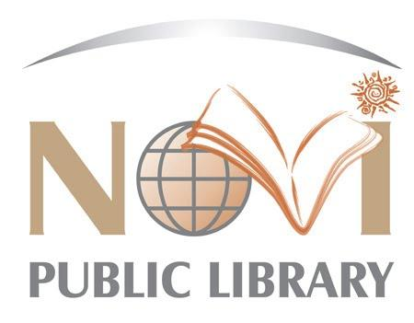
NOVI PUBLIC LIBRARY
JOB DESCRIPTION

The Novi Public Library is a vibrant, fast-paced class six library located within Oakland County. The Library was awarded the "Community Builder Award" in 2021 from the Novi Chamber of Commerce for its innovative approach to reaching its community by introducing the first self-service kiosk in Michigan, called Lakeshore Lending Library. We proudly serve a diverse community with a population of 65,000+. We are committed to serving our guests with exceptional customer service through innovative programming, cutting-edge technology in our iCube Makerspace, and expertly trained staff. In order to meet the needs of our diverse population, we have increased staff awareness and education of Diversity, Equity, and Inclusion initiatives through organizational-wide training. We have created NPL @ Your Door, a mail delivery service, to meet the needs of the Novi community who may have less access to the building, and advanced our ongoing commitment to "Inspire, Inform and Include" all individuals who walk through our doors. Join our team!

JOB TITLE: Youth and Teen Programming Assistant
REPORTS TO: Youth and Teen Services Supervisor

PRIMARY DUTIES & RESPONSIBILITIES:
- Assist in the planning, preparation, execution and evaluation of various programs and Grab and Go Kits for Youth, Tweens and Teens.
- Promote library services and programs by visiting schools, participating in community events, and partnering with community groups.
- Coordinate program supply inventory for Youth, Tween and Teen programs.
- Create displays the for Youth area that are of interest to children and their parents/caregivers, providing a welcoming and engaging atmosphere.
- Assist Youth Department staff with the maintenance of items in non-book collections, including verifying components after check-in, updating inventory binders and related tasks as assigned.

OTHER DUTIES & RESPONSIBILITIES:
- Ability to adapt and respond to multiple priorities, interruptions and demands, and resolve problem situations in a positive manner.
- Work positively and collaboratively across departments to accomplish department goals.
- Communicate effectively with guests and colleagues.
- Continue to develop professionally through the completion of early childhood development curriculum and/or through maintaining appropriate certifications.
- Perform other duties as assigned.

JOB QUALIFICATIONS:
- Associates or Bachelor’s Degree in Education or other child-related field preferred.
- Knowledge of youth, tween and teen literature.
- Experience in youth, tween and teen programming.
- Experience working with youth with disabilities or in a special education environment preferred.
- Dedication to public service.
- Enthusiastic, friendly, approachable, and creative.
- Strong obligation to confidentiality.
- Strong organizational skills and attention to detail.
- Knowledge of internet and computer related technology. Excellent oral and written communication skills.

WORKING ENVIRONMENT:
- Physical mobility, vision, hearing, and manual dexterity essential.
- Maintain physical condition necessary for sitting, standing, bending, and /or walking for extended periods of time; stooping; crouching; reaching; carrying books or boxes of books; pushing book carts; seeing; keyboarding; using the telephone; lifting, pushing, pulling or carrying objects weighing up to 50 pounds; push or pull with wheeled cart up to 500 pounds; operating assigned equipment; picking up litter; spreading ice melt.
- Evening and weekend hours are required.

Hours: This is a year round, part-time position with permanent shifts on the following days at these set times. Candidates must be available to work the shifts as posted.

16 hours per week

- Tuesdays, 5 pm – 9 pm
- Thursdays, 9:30 am – 4 pm
- Alternating Fridays/Saturdays, 9:30 am – 4 pm

Salary: $15.74 to $20.46 per hour

Benefits: Benefits are not offered with this position

Application:
- Resume, cover letter, and application required.
- Send to Nicole Williams, HR Specialist
Novi Public Library
45255 W Ten Mile Road
Novi, Michigan 48375
Email: nwilliams@novilibrary.org
Deadline: Open until filled.
This job description is intended to describe the general nature and level of work being performed by a person assigned to this job. They are not to be construed as an exhaustive list of all job duties that may be performed by a person so classified.

