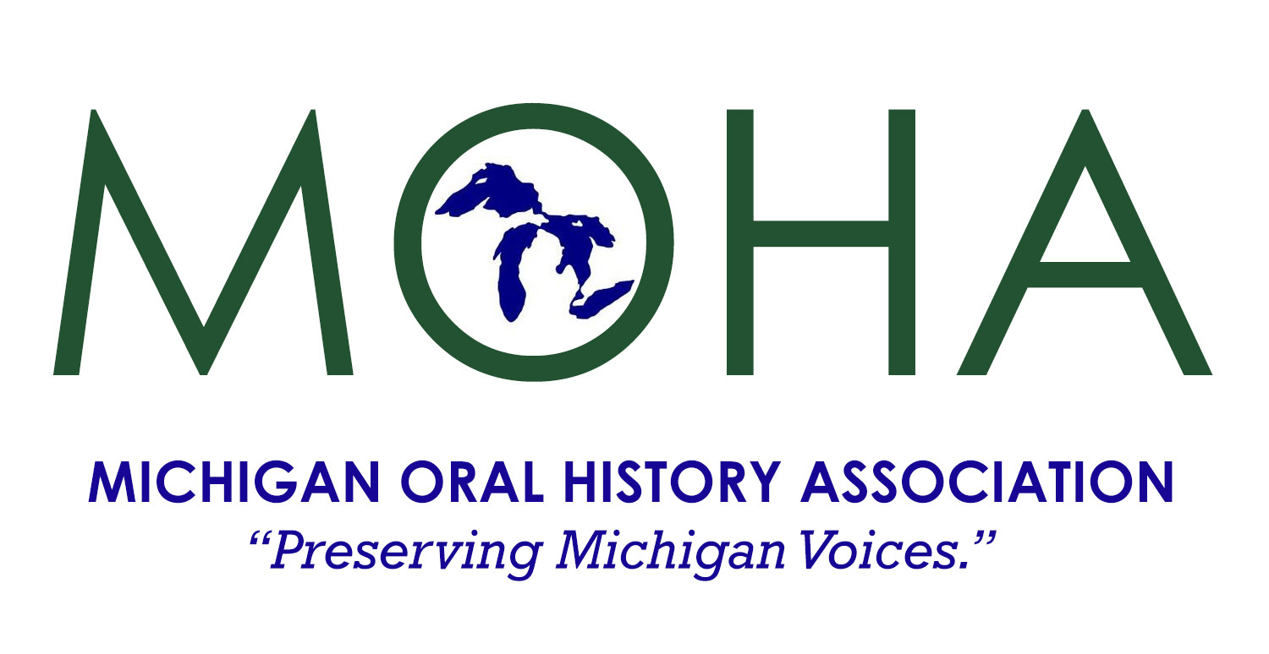
2022 Conference
October 22, 2022

Michigan Library and
Historical Center, Lansing

2022 Theme: “Everyone Has a Story”

* Oral History in the World of Librarians

*Creating, Promoting, and Growing a University Archives

*Oral Histories for Genealogists

*Enhance Your Museum exhibits with Oral History

*Incorporating Oral Histories in the Classroom

* Interviewing Politicians, Do’s and Don’ts

*Taking Oral History One Step Further

*Michigan State Police OHP: “No pain, no gain”

*The Stolen Narrative of the Bulgarian Jews and the Holocaust

*Language, Mobility, and Michigan Travelers to the Middle East

FREE TOURS INCLUDE
EMU Aerie Sound Room Michigan Library
Michigan Historical Museum Michigan Archives

Conference Registration: Includes tours and lunch
Registration Fees before October 1st after October 1st & Walk-Ins
MOHA member $35 ___ MOHA members $45 ___
Non-member $45 ___ Non-members $55 ___
College Student $20 ___ College Student $25 ___
1
Institutional Members send up to three people at the individual member rate.
Others at non-member rate.

To Register online go to
https://michiganoha.org/conference

To Register by mail see next page
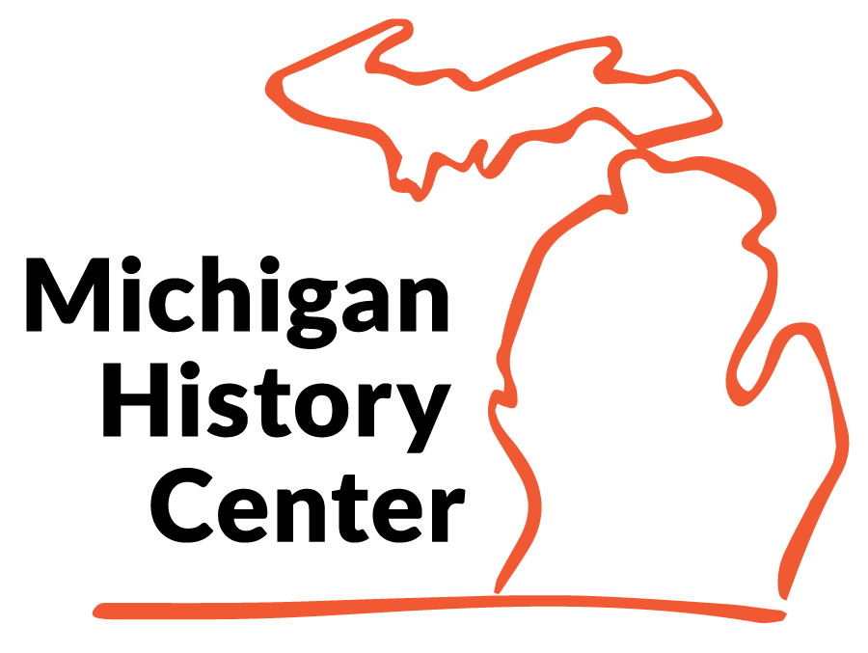
REGISTER NOW!
Michigan Oral History Association Conference
Michigan History Center, Lansing, MI
Saturday, October 22, 2022
Registration 9:00 a.m.
Conference 9:30 a.m.-4:30 p.m.

MOHA Conference Registration Form
Registration Fee includes morning snack, lunch and conference materials.
MOHA Member? Yes _____ No _____
Luncheon: I prefer vegetarian _____ Please notify us if you have special dietary needs.
Registration Fees before October 1st after October 1st & Walk-Ins
MOHA member $35 ___ MOHA members $45 ___
Non-member $45 ___ Non-members $55 ___
College Student $20 ___ College Student $25 ___
Name ______________________________________________ Title ____________________ Organization _________________________________________ ________________________ Mailing Address _______________________________________________________________ City ______________________________________State _____________Zip ______________ E-mail ________________________________________________ Phone _________________
Make check payable to “Michigan Oral History Association” and mail to:
MOHA Conference
210 Detroit St.
Saline, MI. 48176

Registration will be confirmed by e-mail.

