MOHA Conference
October 22
Michigan Library and Historical Center

Amazing collection of project information, with a diverse slate of presentations representing a variety of personal and institutional backgrounds, perspectives and voices.

These presentations offer practical experiences YOU CAN USE to enhance your organization!

* Oral History in the World of Librarians

* Creating, Promoting, and Growing a University Archives

* Oral Histories for Genealogists

* Enhance Your Museum exhibits with Oral History

* Incorporating Oral Histories in the Classroom

* Interviewing Politicians, Do’s and Don’ts

* Taking Oral History One Step Further

* Oral History and Detroit Autoworkers 1950s

* Michigan State Police OHP: “No pain, no gain”

* Language, Mobility, and Michigan Travelers to the Middle East
* The Stolen Narrative of the Bulgarian Jews and the Holocaust.

Program on Page 2-4.
Registration Form on Page 9.
Early Bird Reduced Registration Fee by October 1.

SHARE YOUR PROJECT!
Send information on YOUR project that would be of interest to MOHA members – either the particular topic or how you developed your project.
info@michiganoha.org
SPECIAL EDITION!!
What MOHA offers to YOU!

Check out –

- Conference Program (P.2-4)
- Support for student development (P. 5)
- Workshops specifically targeted to your organization’s needs (P.6)
- Up-to-date information on equipment and resources (P.7)
- Material to guide your project (P.7)
- Connections with institutional oral history professionals (P.8)
- Promote your project to recruit involvement or dissemination (P.8)
- MOHA Membership information (P.10)

ISSN 0887-6436
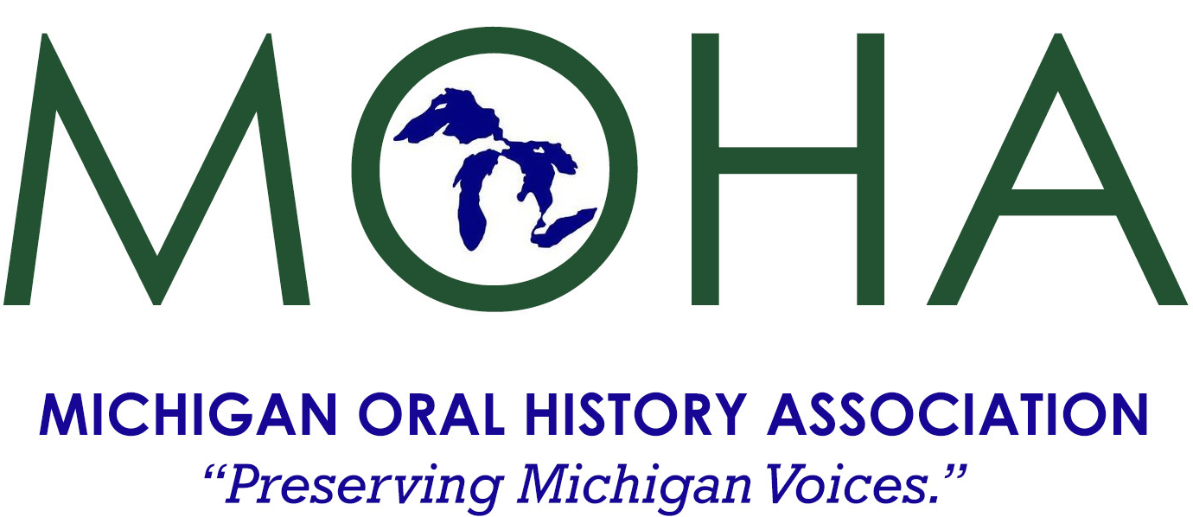
“EVERYONE HAS A STORY”
Conference Program
8:30 Registration, Coffee, Snacks, View Exhibits
9:30 Welcome Sandra Clark, Director of the Michigan History Center Awards: History Day Award, Emerging Scholars Award, Lifetime Achievement Award
10:15 Keynote Speaker Mike Laney, Manager, Vincent Voice Library. Michigan State University Libraries and Head, Gerald M. Kline Digital & Multimedia Center

10:45 BREAKOUTS Session One

Expanding Museum Exhibitions with Oral Histories
Billy Wall-Winkel, Field Curator, Detroit Historical Society
Expanding Museum Exhibitions with Oral Histories explores how oral history work can be utilized to enhance, inform, direct, and support museum exhibitions. The session will walk participants through where oral history practices and research can be inserted during an exhibition’s development to enrich the audience’s enjoyment, understanding, and engagement. The session also explores how secondary benefits of including oral histories in museum exhibitions like increased community interaction and community buy-in.

The Stolen Narrative of the Bulgarian Jews and the Holocaust
Jacky Comforty and Martha Bloomfield will discuss their book The Stolen Narrative of the Bulgarian Jews and the Holocaust (Rowman and Littlefield, Lexington Studies in Jewish Literature 2021) which shares a complex tapestry of voices of memories previously underrepresented, ignored and denied. It is an alternative perspective that includes stolen, silenced but now reclaimed Jewish narratives based on our peoples’ experiences. It contextualizes and personalizes the history, reconstructs the puzzle, praises those who helped the Jews and shares their exemplary acts of humanity for future generations. It fills a void in the Bulgarian Holocaust literature–specifically first-hand accounts of memory of survivors and eyewitnesses—which he gathered over thirty-five years—photographs, official publications, laws and newspaper articles. Jacky will talk about the “Stolen Narrative” and Martha will talk about the importance of oral histories in the social/historical context and their journey together of collaboration on such a complex subject to write this ground-breaking book. Jacky will also share an excerpt of the movie he is working on based on their book.

Voices Then and Now: Two Michigan Schools Re-Engaging Black Alumni to Create Oral History-Based Outreach Initiatives
Matt Jones - Eastern Michigan University Archives Lecturer and Oral Historian
Akaiia Ridley - Graduate Student with the Eastern Michigan University Historic Preservation Program
This session brings together two oral history projects and their resulting community outreach efforts in two separate Michigan communities to show the effectiveness of oral history-based outreach programming at the small and mid-sized institutional level. Akaiia Ridley will speak on identifying and filling the archival gaps of the Albion College Archives with her extensive oral history project on Black student enrollment and accompanying social movements, as well as the resulting online exhibit, "The Beginning of Belonging" and its effect on her understanding of oral history and its audience. Matt Jones will detail the EMU Archives' oral history project "Taking Great Risk," an examination of the EMU Black Student Association's takeover of administrative buildings in 1969, and the resulting public programming and participation stemming from the oral history project.
Lunch
12:30 BREAKOUTS Session Two

Incorporating Oral History in Your Classroom
Connor Ashley, Eastern Michigan University; Justin Waters, Oakland University; Robert Browning, Wayne State University

Language, Mobility, and Michigan Travelers to the Middle East
Professor Camron Michael Amin
There are many ways in which language signals a sense of agency around mobility in oral histories of travel and immigration experiences. Interviewees might demonstrate their command of a number of languages or make their level of familiarity with a language a key part of their narrative. Using interviews from two oral history projects - the Michigan Iranian American Oral History Project and the Michigan Middle East Travelers Oral History Project - I will illustrate how intertwined language is with narratives of mobility. If we think of mobility not just as a right to stay in a place or to move to a place, but the ability to move back and forth between geographical and cultural settings at will, the discussion of language (learning it, using it, explaining it) can become a telling part of an interviewee's reflections of navigating "regimes of im/mobility" in their lives.

Interviewing Politicians, Famous & Not-So-Famous
Bill Bellinger, Michigan Political History Association
How do you interview political figures and personalities? Is there a secret sauce for doing it? How do you get the truth out, and some interesting tidbits? Bill BALLENGER has been a state legislator and headed up a number of executive branch agencies at both the state and federal levels. He also has hosted radio talk shows for nearly 15 years and interviewed a number of famous politicians which can be seen on the Michigan Political History Society website.

Oral History for Genealogists

1:45 BREAKOUTS Session Three

Oral Histories in Academic Archives: Bringing Instruction to Life
Kim Schroeder – Associate Professor of Teaching and Coordinator of the Archival Administration Program, School of Information Sciences, Wayne State University
Meghan Courtney – Archivist for Academic Programs, Bentley Historical Library
This session will explore the full-circle path of oral histories in universities from training interviewers and developing collections to using oral histories as sources for primary source instruction with undergraduates. If you've ever wondered how oral histories become a part of academic archives or what unexpected uses archivists find for them, this is a session for you!

Michigan State Police Oral History Project: “No pain, no gain”
Phillip Schertzing, Michigan State Police, Retired
While still on active duty with the Michigan State Police, Sgt. Phil Schertzing began interviewing some of the department's oldest retirees in 1991-1992 to compile an oral history that could be used to help produce a historical documentary for the department's 75th anniversary on April 19, 1992. Later, as a retired inspector, he engaged in another round of videotaped oral interviews with retired directors of the Michigan State Police to make accessible for visitors at the Michigan State Police Museum and Learning Center at Headquarters for the department's 100th anniversary in 2017. Many challenges were encountered, including getting and preserving signed waivers from interviewees, getting resources to edit and store the original videotapes and later to transcribe them or convert them to digital format, constant turnover of department personnel involved with the project, an organizational culture inherently disposed to avoid public discussion of sensitive or controversial topics, and a reluctance to make the recordings accessible to a wider audience.

Taking Oral History One Step Further
Dean Rehberger, Director of Matrix and one of developers of the IMLS project, Oral History in the Digital Age.
The pandemic has made doing virtual oral histories a more acceptable form. It has its advantages and disadvantages and most are happy to get back to in-person oral histories. This presentation will focus on what we learned and what we should think about keeping as well as new technologies for doing oral history in the digital age.

Oral History in the World of Librarians
Adam Oster, Community Engagement Librarian, Library of Michigan
Come explore how Oral Histories fit within the world of Michigan Libraries. Uncover how these essential recordings are incorporated into a library’s collections and learn methods for partnering with your community library on oral history projects.
Oral histories are often an overlooked resource to include in a library’s collection. Explore methods for incorporating recordings into a library’s collection development process. See examples of current oral history projects of Michigan libraries throughout the state. Learn methods for partnering with libraries on oral history projects as well as how to leverage it for both programing and community engagement.

3:00 Tours
Michigan Historical Museum Tour
Michigan Library and Whisper Room Tour
Michigan Archives Tour
Aerie Mobile Oral History Recording Booth

Conference registration on Page 9

Support Student Development

Emerging Scholar Award
The Postsecondary Award of the Michigan Oral History Association recognizes a distinguished postsecondary scholar involved in education who has incorporated the practice of oral history in a project in an exemplary way. The next award will be made at the MOHA’s 2022 annual conference. The award-winning scholar will receive an award certificate, a one-year membership in the MOHA, a check for $250, and complimentary registration to the following year’s annual conference.
Criteria for the award are:
- The scholar has incorporated an innovative strategy for the use of oral history; and/or successfully implemented an existing strategy for doing oral history; and/or used oral history in print or other medium to enhance learning;
- The scholar’s work is a model for the use of oral history;
- The scholar has demonstrated familiarity with both oral history scholarship and the literature relating oral history;
- The project adheres to appropriate standards for historical research and interpretation, oral history interviewing, preservation of recordings (and transcripts, where applicable), and presentation;
- The oral history project has a civic or community component.

Michigan History Day
The James Campbell Award for Best Use of Oral History, sponsored by the Michigan Oral History Association, is presented to Youth, Junior and Senior participants in Historical Society of Michigan’s educational program, Michigan History Day.

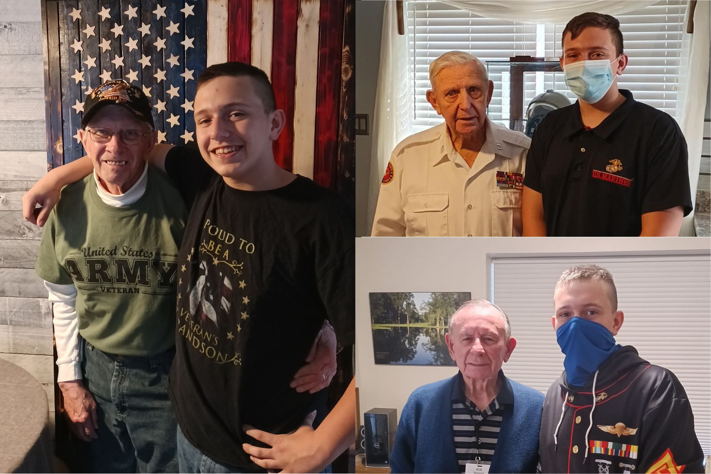
The documentary by Zachary Howey titled, “Tootsie Rolls and Ditty Bop: The Failures and Successes of Military Communication,” won the 2021 James Campbell Award. Zackary is shown with his three interviewees: Grandfather Bill Kloski, and Korean War veterans Harold Barber and Robert Simanek.

Workshops –
Specifically targeted to your needs
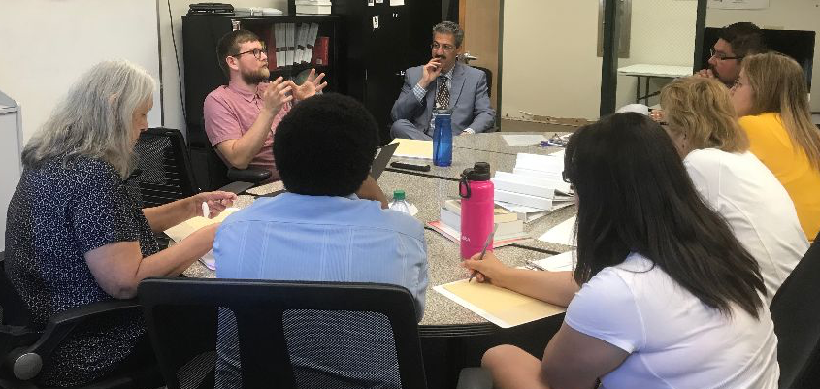
Ndbaajmowinaanin: “Our Stories”
To increase accessibility of traditional stories, oral histories, and culturally relevant children’s books, the Mzinigangamik (Cultural Library) at the Little Traverse Bay Bands of Odawa Indians (LTBB) received a Native American Library Services Enhancement Grant from the Institute of Museum and Library Services in 2018. The name of this project is Ndbaajmowinaanin, which translates to “Our Stories” in Anishinaabemowin.
In 2019, the LTBB Mzinigangamik hosted an Oral History workshop conducted by the Michigan Oral History Association, with presentations by MOHA Board members Billy Wall-Winkel and Cam Amin. Workshop participants were provided information on oral history interview skills and a great discussion on how to tackle a community oral history project.

Family Reunions – Enhanced with Oral Histories
Reunions held every other year bring the Cogswells family members together from around the country. This year’s reunion banquet, they contacted MOHA President Jim Cameron for a dinner speaker. From Jim’s presentation: Every Cogswell has a story. We need to get those stories recorded. We now have the technology to save not just words, but voices. The Cogswells have a family tree. They have a webpage. They have regular reunions. NOW we need to make sure we record the VOICES of Cogswells. As many as we can get. “This was terrific,” exclaimed one family member. “They were so engaged. It was great the way Jim incorporated Cogswells family into his presentation - they loved it.”

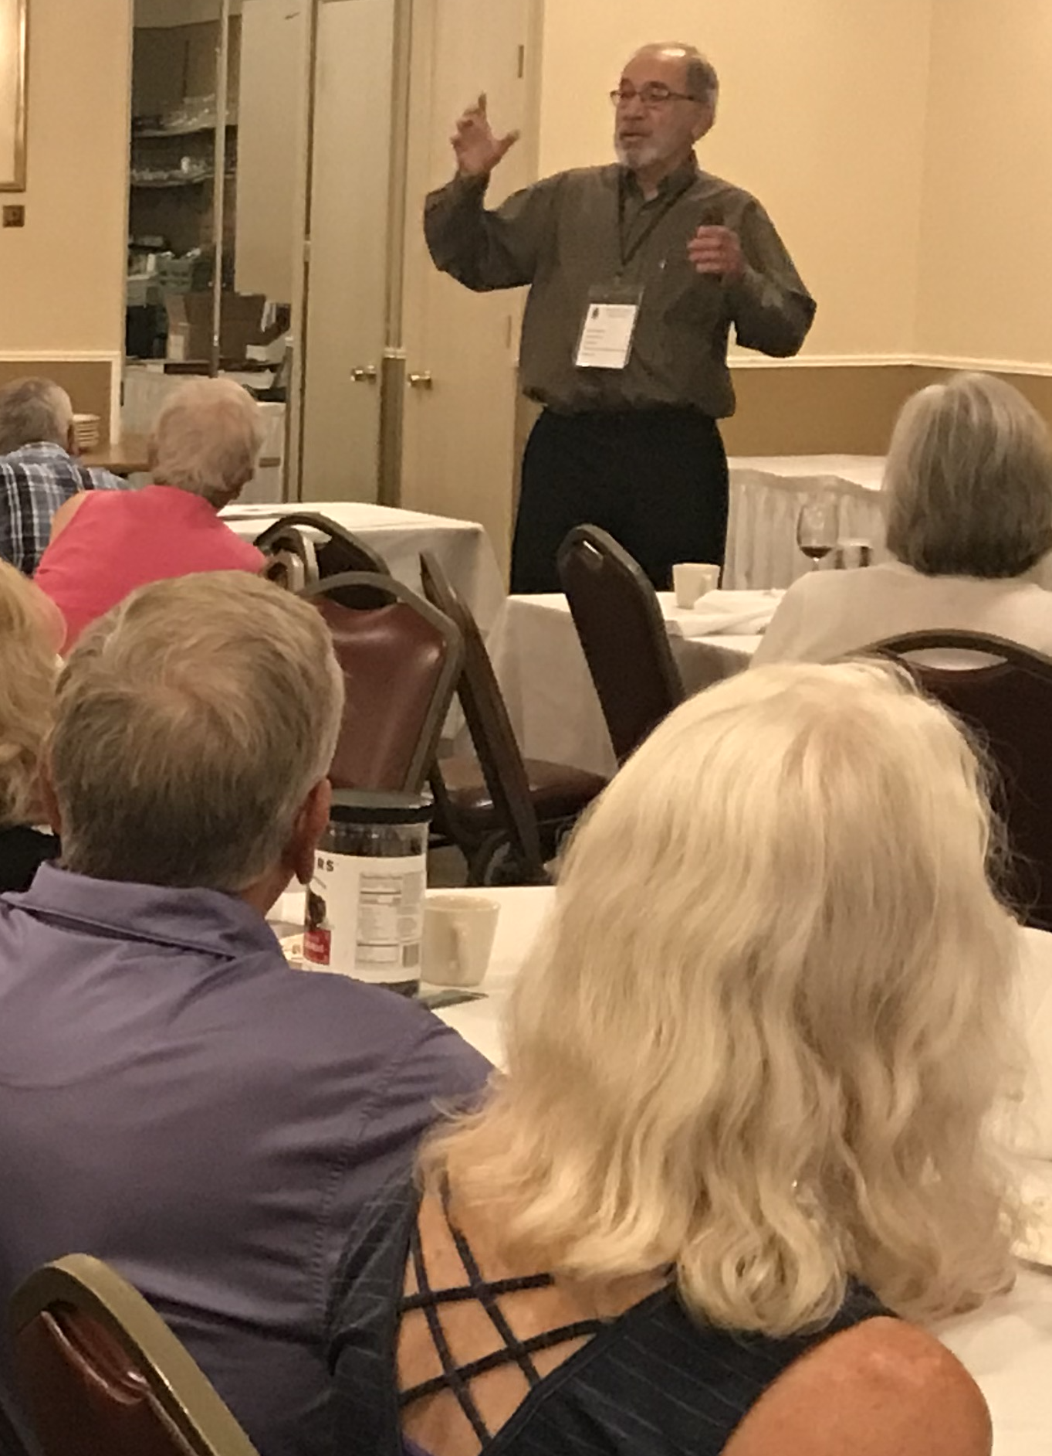

Other workshops: History classes at Saginaw Valley State University and Wayne State University (students preparing for teaching history, museum work), Historical Society of Michigan’s History Hounds and annual conference, Houghton Lake Public Library’s Family Luncheon Series – and yours!
Up-to-date information on equipment and resources
Examples:
Newsletter article Winter 2021:
Conducting Oral Interviews Remotely:
Recording Audio and Taking Photos on Your Smartphone
This timely article continues newsletter issues that have featured useful ways to conduct oral histories remotely: Spring 2020: “Conducting Remote Interviews”: Guidelines, Pre-Interview Practice, Equipment, Legal Considerations, Interviewer/Interviewee Relationship, Resources.

Newsletter article Summer 2022:
Informed Consent
By Brittany Bayless Fremion, Asst Professor of History, Central Michigan University
Information included:
Resources: Introduction to Release Forms
Consent Forms
Deeds of Gift
Release Agreements for Interviewers
Copyright

“A Guide For Doing Successful Oral Histories”
Updated version of MOHA Guide! Handy, easy-to-use for beginners and experienced.
Includes:
Starting an Oral History Project
The Plan
Preparation
Paperwork
Quality Questions Result in Quality Responses
Equipment
Creating the Setting
Materials Check List
Tips for a Successful Interview
The Interview Is Over: Now What?
Guidelines for Transcribing
Ethical Issues
Copyright and Oral Histories
IRB Considerations
Selected Oral History Resources
Recording Oral Histories
Using Oral Histories:
- In the Classroom
- For College Study
- To Enhance Museum & Library Exhibits
Sample Forms
Copy of Guide included FREE in MOHA Membership. Extra copies: $6
Connections with institutional oral history professionals
MOHA Board of Directors
Jim Cameron (President), retired Social Studies Consultant, Michigan Department of Education
Billy Wall-Winkel, (Vice President) Curatorial Asst., Detroit Historical Society
Brad Jarvis (Treasurer), Assoc. Professor, History, Saginaw Valley State University
Veronica Johnson (Secretary), Project Manager for Crain Communications
Geneva Kebler Wiskemann, Founder of the Michigan Oral History Council (parent title of MOHA), former MOHA President and long-time Secretary and newsletter production
Camron Michael Amin, Professor, History, University of Michigan-Dearborn
Marci Cameron, Editor, Gerontologist and Writer
Daniel J. Clark, Professor of History, Oakland University
Richard Cruz Davila, Research Specialist, Julian Samora Research Institute, Michigan State University
Brittany Bayless Fremion, Asst Professor of History, Central Michigan University
Philip Grumm, Senior Manager, Learning Services and On-Site Programs, The Henry Ford
Lindsay Hiltunen, Archivist, Michigan Tech. University Archives and Copper Country Historical Collections
Russ Magnaghi, Professor of History Emeritus, Northern Michigan University
Matt Pacer, Reference Librarian, The Library of Michigan
Elizabeth Ann-Berton Reilly, PhD student, Language, Literacy, and Sociocultural Studies program, University of New Mexico
Karen Schaumann-Beltran, Asst. Professor of Sociology, Schoolcraft College
Kim Schroeder, Coordinator, Archival Program, Lecturer and Career Advisor, Wayne State University
Tim Streasick, Electronic Resources Librarian, University of Michigan-Dearborn
Matthew Wilcox, Audiovisual Archivist, Michigan State University

Faculty connect students for internships and quality, existing oral history projects for study.
Contacts are made to glean information, advice and resources about conducting oral history projects.

Promote your project to recruit involvement or dissemination – Examples:
*The Michigan PBB Oral History Project gathers and preserves the stories of individuals as related to one of the largest but least known episodes of chemical contamination in U.S. history.
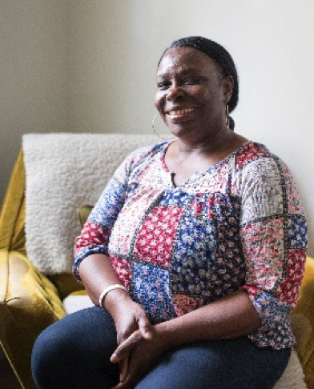
*Critical Lifelines: Portraits and Stories
of Home Care Workers
When families need help providing in-home care for
older relatives, they turn to paid help, most of which is
provided by Personal Care Aides (PCAs). A grant to
capture the stories of 30 PCAs across Michigan through
in-depth interviews, this oral history project is proving to be an important
be an important vehicle for raising public and legislator
awareness of a major public health issue and strategies
for addressing the issue.

*Michigan Political History Society’s James J. Blanchard Living Library of Michigan Political History. The goals are to record the stories, experiences and observations of major political figures and to make these interviews available online, giving everyone the opportunity to learn.
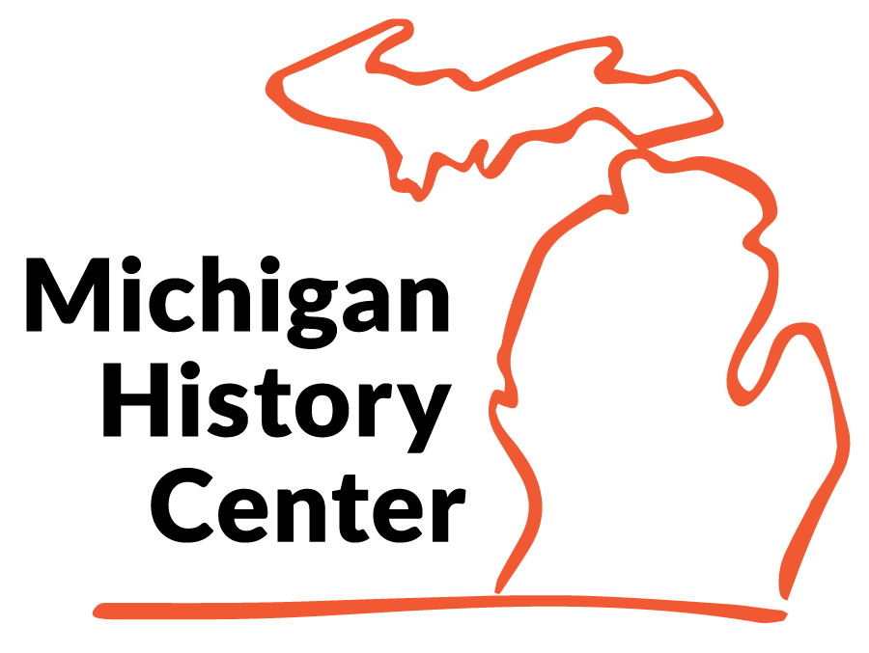
REGISTER NOW!
Michigan Oral History Association Conference
Michigan History Center, Lansing, MI
Saturday, October 22, 2022
Registration 9:00 a.m.
Conference 9:30 a.m.-4:30 p.m.
Registration fee includes tours and lunch

To Register online go to
https://michiganoha.org/conference/moha-2020-conference/

----------------------------------------------------

To Register by mail:
MOHA Member? Yes _____ No _____
Registration Fees before October 1st after October 1st & Walk-Ins
MOHA member $35 ___ MOHA members $45 ___
Non-member $45 ___ Non-members $55 ___
College Student $20 ___ College Student $25 ___
Luncheon: I prefer vegetarian _____ Please notify us if you have special dietary needs.
Name ______________________________________________ Title (if applicable)______________________________
Organization _________________________________________________
Mailing Address __________________________________________________ City ______________________________________
State _____________Zip ______________ E-mail ________________________________________________ Phone _________________
Make check payable to “Michigan Oral History Association” and mail to:
MOHA Conference
210 Detroit St.
Saline, MI. 48176
Registration will be confirmed by e-mail.
Don’t Miss THE Next MOHA Issue!

- The Detroit Muslim Storytelling Project
- Legal Concerns for Oral Interviews
- _{MOHA Conference Topics}
- _{Saving a Fraternity’s History}
- _{Oral History = Connection}
- History Day Best Use of Oral History Winners

About the Michigan Oral History Association
www.michiganoha.org

Who We Are
MOHA promotes and educates about oral history, as a resource for capturing on electronic media, attitudes and emotions not otherwise preserved. The pool of presenters includes experienced oral history practitioners, archivists, database managers, video producers, authors, professional transcribers, journalists and teachers. Presenters participate in history-related conference sessions, conduct workshops, and serve as facilitators for state and regional forums.

MOHA Membership
Individual ($25):
- MOHA quarterly newsletter
- “A Guide for Doing Successful Oral Histories” (first-time membership)
- Attendance at MOHA conference workshops
- Opportunity to promote and recruit participation in oral history projects

Institution ($50):
- E-copy and 2 hard copies of MOHA quarterly newsletter
- 3 cc “A Guide for Doing Successful Oral Histories” (first-time membership)
- Attendance at MOHA conference workshops
- Opportunity to promote and recruit participation in oral history projects
- Feature in 2021 newsletter issue

Student ($15):
- MOHA quarterly newsletter
- “A Guide for Doing Successful Oral Histories” (first-time membership)
- Attendance at MOHA conference workshops
- Opportunity to submit class or other project papers/summaries for
publication in statewide newsletter

How can MOHA help you? Workshops, information, assistance with projects, and resources are available to both beginning and experienced oral historians. Forums provide exchange with others who may have similar problems, obstacles, and opportunities. Established or in-progress oral history projects can benefit from MOHA’s ability to promote and publicize initiatives and resources.

Pay via PayPal at www.michiganoha.org
Or, send check to:
MOHA, 210 Detroit St., Saline MI 48176

The mission of the Michigan Oral History Association (MOHA) is to provide effective cooperation and communication among persons, programs, and institutions concerned with the techniques, uses, and promotion of oral history in Michigan. We serve those who are interested in methods and techniques of the oral history process as a means of preserving unique memory of people, places, events and ideas.

