August 22, 2022
FOR IMMEDIATE RELEASE

Oxford Public Library
Healing the Community
Fall 2022 Keynote Speakers

November 30, 2022 marks the one-year anniversary of the tragic shootings at Oxford High School. We strive to move forward to find a glimpse of hope and positive message in the profound grief experienced communitywide. To help heal from deep consequences of the loss and injuries sustained, the Oxford Public Library, located at 530 Pontiac Street, in Oxford, welcomes two keynote speakers to talk about what happened in Oxford, and how we can move forward with strength and resilience.

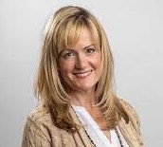
Mental wellness: Breaking the Stigma and Finding Solutions
Gretchen Moran Marsh, Ph.D., PLLC.
Thursday, September 8, 2022, 7 PM

Dr. Marsh is a clinical psychologist who is an expert on the topic of mental health. She has spent over 20 years working with individuals in private practice transforming their lives, improving life satisfaction and restoring a positive mind set. She received her undergraduate degree in Psychology from the University of Michigan and a Master’s Degree and Ph.D. in Clinical Psychology from Wayne State University. Dr. Marsh travels the county as a keynote speaker to large corporations and non-profit entities. Her daily practice is located in Franklin, MI.

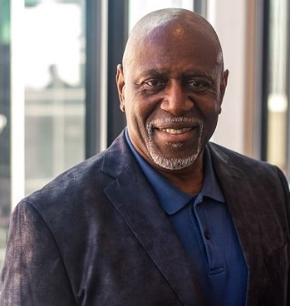
Tools of Civility: Restoring Trust
Lee E. Meadows, Ph.D.
Thursday, October 13, 2022, 7 PM

Dr. Meadows is an author, award winning speaker, global leadership consultant, and thought leader with over 30 years of experience in private and public sector consulting and educational leadership. Dr. Meadow holds an undergraduate degree in Telecommunications, a Master’s Degree in Counseling and Ph.D. in Higher Education, all from Michigan State University.

For additional information, or to register for these events please contact the library at (248) 628-3034 x222, or register online at https://miopl.evanced.info/signup.

Press Contact:
Jaema Berman, Head of Adult Services
jberman@miopl.org
248.628.3034 x212

Oxford Public Library
530 Pontiac Street
Oxford, MI 48371

