FOR IMMEDIATE RELEASE
July 20, 2022
Contact: Laura Mancini, Library Director
Northville District Library
212 W Cady St, Northville, MI 48167
248.349.3020, ext. 206
lmancini@northvillelibrary.org

NDL to host Law Professor, Dean and Author Eugene Milhizer

Northville, MI: Maybe you are familiar with the media coverage and subsequent book and movie release based on one of the most famous criminal trials of the 20th Century: the 1952 Upper Peninsula murder involving an Army Lieutenant (Coleman Peterson), his wife (Charlotte Peterson) and an ex-cop turned bar owner (Mike Chenoweth), in Marquette, Michigan. Temporary insanity was the defense’s argument and the jury acquitted the accused Lieutenant, who was admitted to the state asylum for just under a month before he was released. The defense attorney and Michigan local, John Voelker, subsequently published an account of the murder trial in 1957, which quickly sold 300,000 copies, fascinating readers enough that it was optioned for, and made into, a film by Otto Preminger. James Stewart, Lee Remick, Ben Gazzara starred, and Duke Ellington produced the score, in this 1959 drama in which Stewart won the Volpi Cup Award, Faro Island Film Festival Award, and more, for Best Actor. It was proclaimed as Preminger’s most popular film and went on to be nominated numerous times for various awards, winning half!

Enter Eugene Milhizer: Author, Law Professor and former Army Judge Advocate. Milhizer explores many ethical and legal issues that Voelker discretely raised in his novel and which were then featured in the film. Some of these include the impact of the community on the trial and verdict, the proper role of a jury, and to what capacity our criminal justice system is able to achieve real justice when it comes to our long-established legal precedents and rules of law.

Eugene Milhizer will present on the legal intricacies in Voelker’s account of this trial at the Northville District Library (NDL) on Tuesday, July 26 at 7 PM in the Carlo Meeting Room. Registration is required on NDL’s website at: https://bit.ly/MilhizerNDL. Books will be available for purchase and signing.

Milhizer’s career is a legal one; he is an alumnus of the Judge Advocate, University of Michigan, and Ave Maria School of Law, and participated in numerous appeals and tried criminal cases as an Army Judge Advocate. He then taught at the Judge Advocate General’s School at the University of Virginia and the Ave Maria School of Law. He is now the President and Dean at the Ave Maria School of Law. Milhizer has also been published in several prestigious law journals and presented at law schools, and now libraries, across the country.

For more information, please visit Northville District Library’s website at: northvillelibrary.org; or telephone the Library at 248-349-3020. We are also on Facebook, Instagram, Twitter, Spotify, Flickr, YouTube, and TikTok.

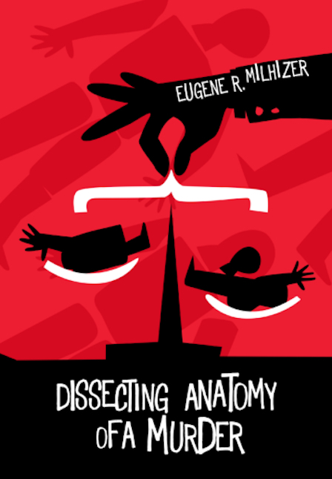
Image of the cover of Eugene R. Milhizer’s book, “Dissecting Anatomy of a Murder.”

Image of Eugene Milhizer

