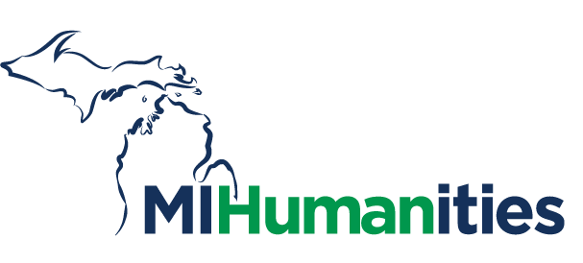
FOR IMMEDIATE RELEASE
February 14, 2022

CONTACT:
Estee Schlenner
2364 Woodlake Drive, Suite 100
Okemos, MI 48864
517-372-7770
eschlenner@mihumanities.org

Nominations for the 2022 Michigan Humanities Awards are Now Open

LANSING, MI—Michigan Humanities (MH) is pleased to announce that the nominations for the 2022 Michigan Humanities Awards are now open. Awards will be selected from three different categories, and a panel of current and former board members, MH staff, and Humanities professionals will vote on the winners for each category. The award categories are as follows:

Outstanding Humanities Organization: Recognizes organizations, corporate funders, foundations, and organizational partners that have made a lasting contribution over time (five years or more) to the cultural life of their communities or our state through their active support of and involvement in promoting public humanities.

Humanities Champion of the Year–Individual: The person whose contributions result in outstanding public humanities impact in their community and in our state. Examples are teachers, scholars, librarians, historians, and cultural leaders who have creatively and successfully brought humanities to the public forum.

Community Impact Partner of the Year 2021: Universities, schools, libraries, community centers, and organizations that made a significant impact in 2021. They may have brought to life a book, humanities project, historical project, discussion, or other humanities programs in an innovative or creative way, serving their community and our state. They have championed the value of public humanities and made a lasting contribution to the cultural life of Michigan in 2021.

“Last year we had an amazing turnout for awards nominations, and we honored four well-deserved recipients. We are looking forward to learning about the work this year’s nominees have done for their communities, and honoring them in their communities this summer,” said Jennifer Rupp, Acting President & CEO.

Each award recipient will receive a $2500 grant from Michigan Humanities and will be invited to work with Michigan Humanities to celebrate in their community. The deadline for nominations is March 1st. For more information, please visit michiganhumanities.org.

About Michigan Humanities
Michigan Humanities strives to bring people together through stories, histories, cultures, and conversations. In carrying out this mission, Michigan Humanities builds awareness and excitement for humanities in everyday life, achieves best practices and sustainability for all humanities programs and services in Michigan, and upholds the following key values: inclusion, diversity, and equity; discovery and understanding; authentic conversation; respectful collaboration; and meaningful experiences. Michigan Humanities’ vision is a more thoughtful, connected, engaged, and informed Michigan.

###

