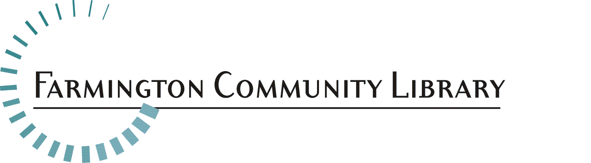

Part Time Para-Professional Children’s Services Department

Feb. 4, 2022

The Farmington Community Library is a District Library serving the communities of Farmington and Farmington Hills with two locations, 12 Mile and Liberty St. We are seeking a dynamic, community-minded individual to join our Children’s Services department as a Part-time Paraprofessional. The successful candidate is highly collaborative, creative, open-minded, and dedicated to providing excellent customer service and exciting programming for families of children ages 0-12.

The Farmington Community Library embraces diversity and promotes inclusion in its hiring and operations. The Library actively seeks individuals whose commitments and contributions will advance our mission to be a diverse and equitable organization. We seek applicants from all backgrounds to ensure we get the best, most creative talent on our team and reflect the families we serve.

Position Available: Part Time Para-Professional
12 Mile Children’s Services Department

Salary Range: Starting at $15.77

Part Time Position: 24 hours per week. This position requires some evening and weekend hours and would be ideal for a candidate who needs a flexible schedule due to family and/or school needs.

Fringe benefits: Paid time off, Employee Assistance Program, up to 2 professional memberships paid by Library, and paid continuing education/professional development opportunities.

Deadline for Application: Feb. 28, 2022 at 5:00 p.m.

Send your cover letter, resume, and application (find at http://history.farmlib.org/pdfs/Employment_Application.pdf) to:

Crystal Peterson
Crystal.Peterson@farmlib.org
Farmington Community Library
32737 West 12 Mile Road
Farmington Hills, MI 48334
Essential Duties/Responsibilities:
- Developing and providing events for children ages 0-12 years and their caregivers
- Providing quick and accurate reference and reader’s advisory services to the public
- Assisting patrons in using the online public access catalog, self-checkout stations, public computers, AWE early learning computers, and public iPads
- May participate in collection development in assigned areas, under the supervision of the Department Head

Required Qualifications:
- Excellent customer services skills, including phone, chat/email, and in-person interactions
- Effective oral and written communication skills, including excellent public speaking abilities
- Skilled at working with diverse audiences
- Associates degree (or currently enrolled in Associates program) OR 3+ years of experience working with children
- Proficient in using technology including Microsoft Office Suite, Outlook, and social media platforms
- Experience working with children
- Ability to work independently
- Ability to lift, push, and/or pull at least 20 pounds
- Ability to think critically in order to answer reference queries and troubleshoot problems

Preferred Qualifications:
- Passion for and/or experience with STEM learning for children
- Knowledge of local nonprofit and community organizations as opportunities for library partnerships

