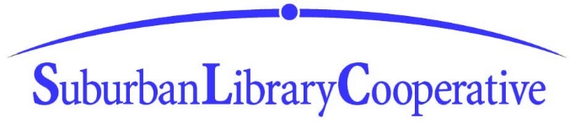
Suburban Library Cooperative Intern
$15.00/hr.
General: The Suburban Library Cooperative is seeking a student who is currently enrolled in a Library Science Master’s Degree program at an accredited college or university for a paid, part-time internship.
The Intern will complete service rotations at designated SLC libraries. The intern will learn to provide reference service/bibliographic instruction to adults, teens and children; assist patrons with library technology and mobile devices individually and in a classroom setting; assist with programming and collection development; and learn other aspects of Library operations, including Circulation, Technical Services, Community Engagement, Marketing, and Library Administration.
This unique opportunity will allow the student to gain practical library knowledge and skills, while working alongside professional librarians and staff, in a variety of library settings.
This position has a term length of 1 year, working 15 - 20 hours per week (including evening and weekend hours).
Applicants should be enthusiastic about public service, exhibit excellent written and verbal communication skills and have a working knowledge of library technology, preferably SIRSI and/or Polaris. Familiarity with mobile devices (including tablets and eReaders) is essential.
Minimum
Qualifications:
- Bachelor’s Degree
- Completion of at least 12 credit hours in an accredited Library Science Master's program
- Excellent communication and interpersonal skills
- Ability to work successfully with patrons of all ages
- Strong commitment to customer service
- Attention to detail
- Applicants must submit proof of educational attainment (latest transcript) at time of application.
- As a condition of employment, the successful candidate must pass a background check

Apply: Interested applicants should send a resume, cover letter, three references, and latest transcript to:

Tammy Turgeon, Director, Suburban Library Cooperative
44750 Delco Boulevard
Sterling Heights, MI 48313-1125

or email: turgeont@libcoop.net
*All questions regarding the application process should be directed to 586-685-5750

Application deadline is February 4, 2022
Expected starting date is March 1, 2022

AN EQUAL OPPORTUNITY EMPLOYER

