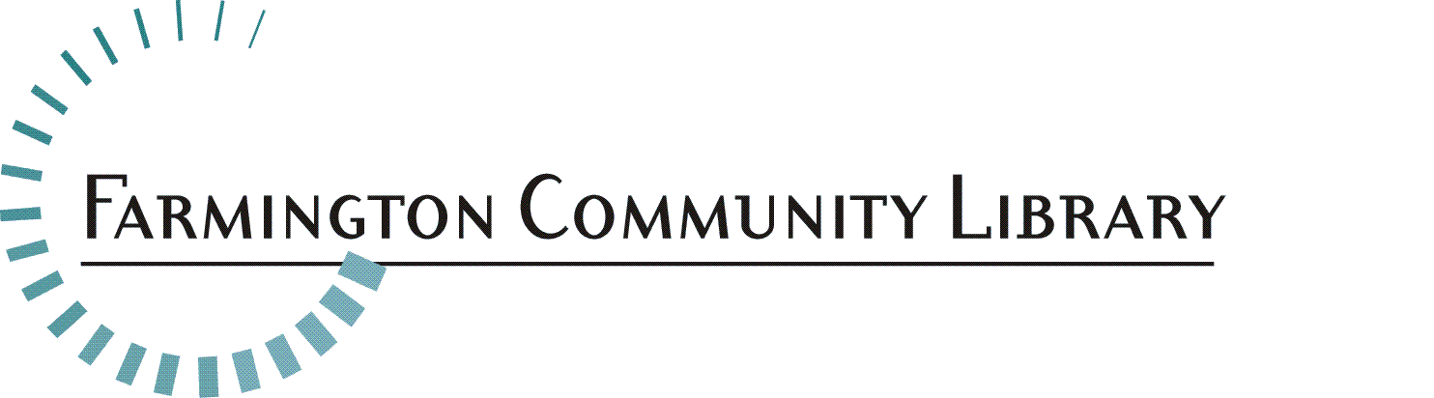

November 17, 2021

Position Available: Librarian II - Head of Adult Services
Full Time

Salary Range: $46,765 - $75,572

Fringe Benefits: Excellent

Deadline for applications: December 3, 2021

Please send a cover letter, resume and application for this position to:

Crystal Peterson
32737 W. Twelve Mile Road
Farmington Hills, MI 48331
Crystal.Peterson@farmlib.org

Essential Duties/Responsibilities May Include:
- Provides quick and accurate reference and reader’s advisory services to the public, using both print and electronic resources. Serves as referral by junior staff who are also responding to patron queries.
- Demonstrates knowledge of materials and library services, with a competency sufficient to direct and train both professional and assistant staff in these areas.
- Directs workflow; develops procedures; analyzes the effectiveness of a program, service, or collection; and makes recommendations for changes or improvements.
- Develops curricula and assists patrons in learning to use the Library’s various electronic resources, including the Internet.
- Develops the scope of and provides Children’s and Adult programming.
- Develops programming format most meaningful to a changing community.
- Participates in collection development in assigned areas with responsibility for selection, weeding and promoting use of the collection through creation of bibliographies.
- Trains other staff to effectively use the Library’s Reference Collection and special collections.
- Participates on the Management Advisory Committee (MAC) to assist the Director in the development of policies and procedures, analysis of public use of the Library services and collections and resolution of problems.
- Supervises junior staff, including mentoring, training, and evaluation of performance.
- Supervises a Library-wide service, program, or activity.
- Serves as the Librarian-in-Charge of the building, when assigned. Must be knowledgeable about and able to make decisions in situations dealing with Library security, emergency procedures and conflict resolution.
- Serves as the Library Representative for community organizations or at professional association meetings.
- Other responsibilities as needed

Minimum Qualifications:
- Master’s Degree in Library and Information Science from a school accredited by the American Library Association.
- Professional certification as a librarian from the Library of Michigan.
- Four (4) years of progressively responsible library experience with at least 2 years of supervisory experience preferred.
- Ability to convey, for purposes of training junior staff, the basic principles, concepts, and methodology of professional librarianship in carrying out basic assignments, operations, or procedures.
- Critical thinking skills, as applied to successfully answering reference inquiries.
- Knowledge of literature, current events, and general information found helpful in resolving reference inquiries.
- Effective oral and written communication skills.
- Professional attitude towards providing public library services to patrons.
- Familiarity with current technology, i.e., general computer literacy, knowledge of the Internet and other electronic sources of information.
- Ability to establish and maintain effective working relationships with other staff and supervisors, serving as a “model” of such behaviors for junior staff.
- Tactfulness and adaptability in dealing with other professional colleagues, the Board, staff, and the public.
- Capable of representing the Library or the Director at local or professional functions.

Physical Activity Requirements:
[Degree of physical demands (strength) usually associated with the essential functions of the job]
Light Work: Exerting up to 20 pounds of force occasionally, and/or up to 10 pounds of force frequently, and/or a negligible amount of force constantly to move objects.

Equipment Commonly Associated with this Job:
Computer equipment plus peripherals, scanner, computer projector, telephone reception system, microform reader printers and office machinery, among others.

