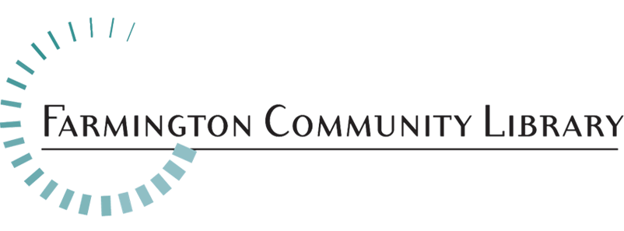

November 1, 2021

Marketing & Community Relations Coordinator

The Farmington Community Library is seeking a creative and energetic Marketing and Community Relations Coordinator.

Position Available: Marketing & Community Relations Coordinator
Salary Range: $42,788 – $62,898
Full-Time Position 40 hours per week, including some evening and weekend events
Fringe Benefits: Excellent

Please include your cover letter, resume, and application. Application available at: http://history.farmlib.org/pdfs/Employment_Application_3_2018.pdf

The deadline for application packet is November 23, 2021 to:
Crystal Peterson
Crystal.Peterson@farmlib.org
Farmington Community Library
32737 West 12 Mile Road
Farmington Hills, MI 48334

Job Summary
The successful candidate will be responsible for all aspects of communication through print and digital modes; website design and messaging; market surveys; data analytics; and collaborating internally to meet market demands. Responsibilities may include supervising staff; managing projects; and preparing marketing strategies.

Essential Duties/Responsibilities May Include:
• Sets and guides the strategy for all marketing efforts and messaging to consistently communicate the Library’s mission and brand on social media and website
• Writes and distributes news releases regarding programs, services, special events, etc.
• Manages internal print and electronic written and graphic communications to promote programs and reach intended audiences
• Manages the Library’s social media outlets, including creating relevant content and responding to comments and direct messages from the public
• Creates and disseminates surveys to capture interests in existing and potential markets; analyze and communicate results; prepare and deliver presentations to various audiences, and perform related marketing tasks
• Develops and maintains media and business partnerships that enhance opportunities for the library’s expanded success
• Plans major events, such as fundraising galas or community-wide events in collaboration with the heads of Adult, Children's, Young Adult, Outreach and Administration
•Runs Public Relations campaigns
• Is aware of emerging trends of library service and works with other staff to analyze library operations in preparation for addressing those trends
• Identifying funding opportunities, including capital fund drives, grants, gifts, sponsorships, corporate partnerships, etc.
• Manages assigned projects, including: setting project timelines; assigning project roles; and monitoring project progress. May include training, facility use, and other broad tasks
• Chairs Publicity committee; oversees work/goals of committee
• Participates in local, regional, and national organizations; may serve in leadership roles on committees and/or make presentations to large audiences
• Demonstrates knowledge of materials and Library services, with a competency sufficient to direct and train both professional and assistant staff in these areas
• May supervise staff, including mentoring, training, and evaluation of performance

This job description is intended to represent only the key areas of responsibilities; specific position assignments will vary depending on the business needs of the department.

Minimum Qualifications:
• Bachelor’s degree in Marketing, Business, or other related programs; 2+ years of progressively responsible experience in public relations and innovation; or combination of education and experience equivalent to perform the essential duties of the position.
• Some supervisory experience required.
• Valid driver’s license required.

Required Skills and Knowledge:
• Knowledge of marketing principles and processes
• Knowledge of electronic communication tools
• Experience with organizational promotion and branding
• Excellent written and public speaking communication skills

Physical Activity Requirements:
Light Work: Exerting up to 20 pounds of force occasionally, and/or up to 10 pounds of force frequently, and/or a negligible amount of force constantly to move objects.

