Suggestion Portal Compilation

We have both, although we have removed the physical box for now because of Covid considerations. Our portal is available to staff and patrons both, on our website and is java-script built in, it was built through a site called emailmeform, according to the script on the back end of our page.

The first link will show how it looks front-facing to our patrons, it is available on the about us section of our website. The suggestion form was created before I joined the staff but the form builder site where we made it says that it is free to use. I am also including the link to that site as well.

https://whitelakelibrary.org/Pages/Index/80999/suggestion-form

https://www.emailmeform.com/

We have a wooden comment box with paper forms and we have a Google Form on our website (https://www.gardencitylib.org/index.php/about-us/staff/). The Google form sends us an alert when someone submits a comment.

We have a physical comment/suggestion box on the first floor of our main branch. I thought we had one online also but I can't find it. We redid our site within the last few years and it probably wasn't transferred to the new site. We will accept suggestions from anyone, over the phone, through email and in person.
However, we do have several online forms that patrons can make book purchase suggestions, obituary requests, etc. that are part of our website. In the past, however, we used google forms and linked them to one of the pages on our website. If you are using Gmail already, it would be fairly easy to do this. The google form would collect answers in the google drive of whoever created the form.

In additional to a physical dropbox for written comments, we use a WordPress plugin called “Contact Form 7” to collect online comments. Your site appears to be running on WordPress as well, so I’d recommend it as it has worked very well for us:

https://wordpress.org/plugins/contact-form-7/

You can see it in action by clicking any of the links on our contact page as they all use it:
https://dexter.lib.mi.us/contact
Completed forms generate an email that it automatically sends to whatever address you specify. Our contact emails all get sent to a shared account that our staff routinely monitors. To cut down on how much spam gets through, I use another plugin called “Honeypot for Contact Form 7.”

https://wordpress.org/plugins/contact-form-7-honeypot/

The honeypot plugin allows you to insert false blanks into your contact forms that only bots will see, and if one of those gets filled out, it automatically purges the email. You could also implement a captcha to curb spam, but I’ve found that the honeypot plugin alone gets rid of the vast majority of it.

Both plugins are free.

We've had an old-fashioned suggestion box for a few years now. It sees very little use, though we have had a few good changes come around because of it. I honestly never even considered an online portal, that sounds like a good addition (I wouldn't get rid of the old-fashioned box though, still good to leave the option present).

TLN uses Survey Monkey as an online suggestion box:
https://www.surveymonkey.com/r/H663XG6

Our IT department is in-house so that may make a difference for you if yours is not.

Our contact us form on our website has a dropdown menu of choices of what the person is contacting us for. I'm attaching a screenshot of that menu. One of those choices is suggest a title, which will then prompt a question of what type of material you wish to suggest (that list also screenshoted for you). Once that is filled out, an email goes to the selector that is in charge of that collection and the patron gets a generic "Thank you for your suggestion" email. That system is for mostly patrons but staff can use it as well.

For staff, we have a "Collection alert" electronic form. It's a form used for many things - letting selectors know when the last copy of an item has been withdrawn or is missing, putting in suggestions for collection additions, alerting the cataloging staff if something's wrong in the catalog record but the physical item is fine (that way cataloging staff is not overrun with extra items on their desks), etc.

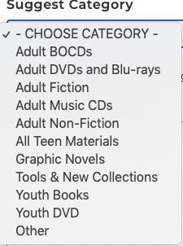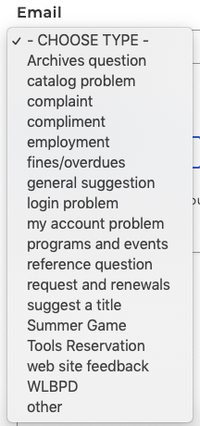

Old-fashioned box

