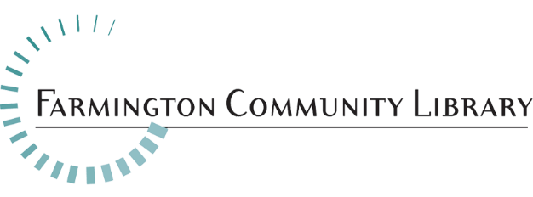
Office Assistant/Accounting Coordinator

Job Summary

The Office Assistant/Accounting Coordinator will be responsible for maintaining a filing system for accounting records, in order to assist in the timely process of payments. The Office Assistant/Accounting Coordinator will also prepare and produce reports, perform general clerical work, and other duties as assigned by the Director and Executive Assistant.

Essential Duties/Responsibilities May Include:
▪ Delivers monetary deposits to financial institutions.
▪ Assists in handling of incoming and outgoing mail, including UPS, FedEx, Amazon, etc.
▪ Assist with room reservations.
▪ Producing proper documentation for auditors.
▪ Acts as liaison with accounting firm.
▪Records and reconcile gift fund donations.
▪ Handles the proper steps of recording gifts and memorials for the Library.
▪ Determine and record completion of gift/memorial requests within each fiscal year.
▪ Maintains appropriate records of donors.
▪ Prepare reports, correspondence, and appropriate documentation at the request of the Director and
Supervisor.
▪ Assist with organizational events, including the Friends Gala.
▪ Create monthly deposit summaries for all charge slips.
▪ Files appropriate correspondence and reports.
▪ Handles account receivables and submits statements and documentation for timely payment.
▪ Performs other duties as assigned.

This job description is intended to represent only the key areas of responsibilities; specific position assignments will vary depending on the business needs of the department.

Minimum Qualifications:

▪ High school diploma or equivalent.
▪ At least one year of related experience required.
▪ Knowledge of accounting principles, and terminology preferred.

Required Skills and Knowledge:

▪ Knowledge of electronic communication tools.
▪ Tactfulness and adaptability in dealing with other professional colleagues, the Board, staff and the.
public.
▪ Excellent verbal and written communication skills.
▪ Excellent organizational skills and attention to detail.
▪ Excellent interpersonal and customer service skills.
▪ Excellent time management skills with a proven ability to meet deadlines.
▪ Proficient with Microsoft Office Suite or related software.

Please include your cover letter, resume, and application. Application available at: http://history.farmlib.org/pdfs/Employment_Application_3_2018.pdf
Deadline for application packet is May 17, 2021 to:
Crystal Peterson
Crystal.Peterson@farmlib.org
Farmington Community Library
32737 West 12 Mile Road
Farmington Hills, MI 48334

