FOR IMMEDIATE RELEASE

Contact: Wendy Mutch, Adult Services Librarian, Northville District Library
212 W. Cady St., Northville, MI 48167
248-349-3020 ext. 218; wmutch@northvillelibrary.org

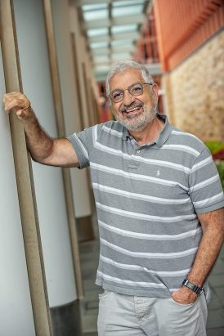
Northville District Library Recognizes Armenian History Month
April 8, 2021 – On the eve of World War I there were two million Armenians living in the Ottoman Empire. In early 1915, Ottoman Turks began deporting and killing Armenians in what is now considered by many to be the first major genocide of the twentieth century. Within a few short months, hundreds of thousands of Armenians had been slaughtered, driven into exile, or forcibly converted and assimilated into local Muslim communities. By 1922, 90% of the empire’s Armenian population had all but disappeared.
As a part of Armenian Heritage Month, and as a measure to honor those who were lost to this tragedy and to celebrate the strength of the survivors, the Northville District Library has invited Professor Ronald Suny from the University of Michigan to speak in a special virtual lecture to tell the story of why, when and how the genocide of the Armenians of the Ottoman Empire happened.
One of the aims of Professor Suny’s academic career has been to study and document this long-denied genocide of more than 1.5 million Armenians. His work is not only significant, but also deeply personal — Suny’s maternal great-grandparents were killed in the tragedy.
“Every year, on April 24, the anniversary rolls around whether the world remembers or not,” Professor Suny says. “Yet a small nation, constantly in fear of disappearing, does not forget. Armenians in their besieged homeland and in the diaspora cannot but remember the massacres, deportations, and forced conversions to Islam that annihilated a culture and people that had lived in eastern Anatolia for millennia.”
More than a century later, the Armenian Genocide remains somewhat unknown. “Official Turkey continues to deny that hundreds of thousands of innocent subjects of the Ottoman Empire were murdered, driven into the Syrian deserts to starve to death, or compelled to flee to other lands. They refuse to recognize the Genocide,” Suny explains. Indeed, in Turkey it’s often considered a crime — “insulting Turkishness” — to even raise the issue of what happened to the Armenians
“Historians have established that this greatest of atrocities in the First World War was genocide,” Suny says. “It’s the unrecognized crime against humanity whose unpunished legacy became an example, along with the dispossession of the native peoples in the Americas, for the Holocaust to come.”
Professor Suny, noted Scholar of European Studies from the University of Michigan, will present his virtual lecture on the Armenian Genocide on Friday, April 16 at 7pm. This program will detail an unforgettable chronicle of events that set a tragic pattern for a century of genocide and crimes against humanity.
To register or for more information, call the library at 248.349.3020 or visit northvillelibrary.org.

====

