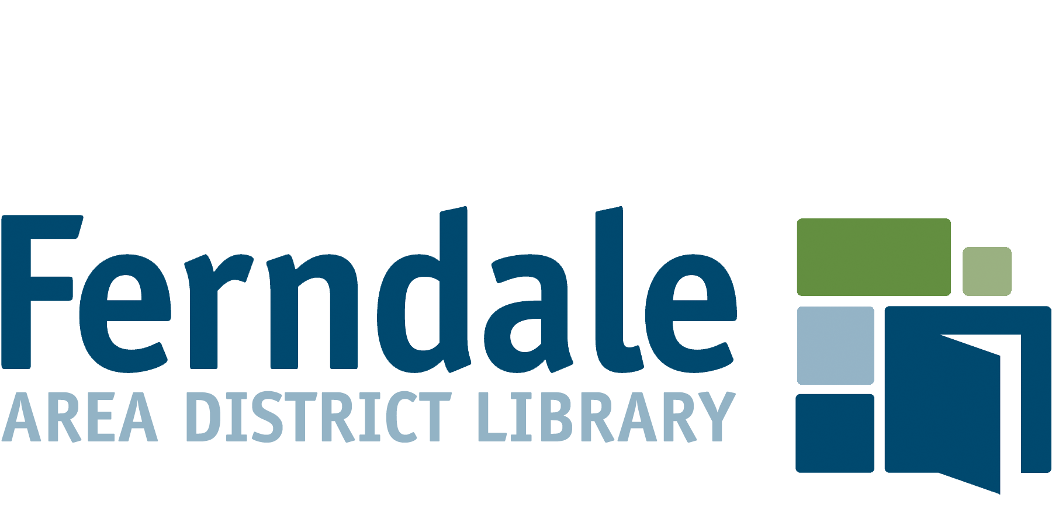
Youth Services Librarian, Full-Time

Hours: 40 hours/week, includes evenings and weekends
Salary: $42,000 to $47,000 annually, depending on qualifications and experience
Benefits: Blue Cross Blue Shield (medical, dental, vision, Rx), Life/AD&D, Short and Long Term Disability, 401(k) plan, PTO
Reports to: Head of Youth Services

The Ferndale Area District Library is seeking a creative and enthusiastic team player to join our Youth Services department. The ideal candidate should be passionate about children’s literature and programming, eager to build relationships with public schools and community organizations, and committed to equity and inclusion while serving a diverse community.

Responsibilities include, but are not limited to:
- Assist with youth desk duties and provide reader’s advisory to children and families
- Plan and conduct regular storytimes and early literacy activities
- Create and implement a variety of creative programming for children 0-12
- Select, order, evaluate, and weed juvenile collections
- Provide community outreach and build relationships with public schools and early childhood centers
- Supervise patron behavior and equitably enforce Library policies
- Serve as Person in Charge of the building, when assigned. Must be able to make decisions in situations dealing with library security, emergency procedures, and conflict resolution

Qualifications:
- Master’s Degree in library science from an ALA-accredited institution*
- 1-2 years experience working with children in a library setting (preferred)
- A passion for serving children and families, with strong focus on early literacy practices
- Broad knowledge of youth literature, media, and trends
- Strong public service orientation
- Strong computer skills and an understanding of the role technology plays in the everyday lives of library patrons
- Willingness to maintain a flexible schedule in order to implement programming
- Ability to lead virtual, as well as in-person programming
- This position may require the use of a personal vehicle on library business. Must possess/provide documentation of a valid driver’s license.
*Candidates nearing completion of their MLIS degree will be considered.

Physical Demands and Working Conditions:
The physical demands herein are representative of those that must be met by an employee to successfully perform the essential functions of this job. Reasonable accommodations may be made to enable individuals with disabilities to perform these essential job functions.
- Environment: Library environment; extensive public contact.
- Mobility: Sufficient mobility to work in a library setting; operate office equipment
- Vision: Vision sufficient to read small print, computer screens and other printed documents
FLSA status: Non-exempt

Please submit a resume, cover letter, three professional references, and a completed employment application to jordan@ferndalepubliclibrary.org by March 5, 2021. Only electronic submissions will be accepted.

Ferndale Area District Library
222 E. 9 Mile Rd.
Ferndale, MI 48220
www.ferndalepubliclibrary.org
248-546-2504

The Ferndale Public Library is an equal opportunity employer.

