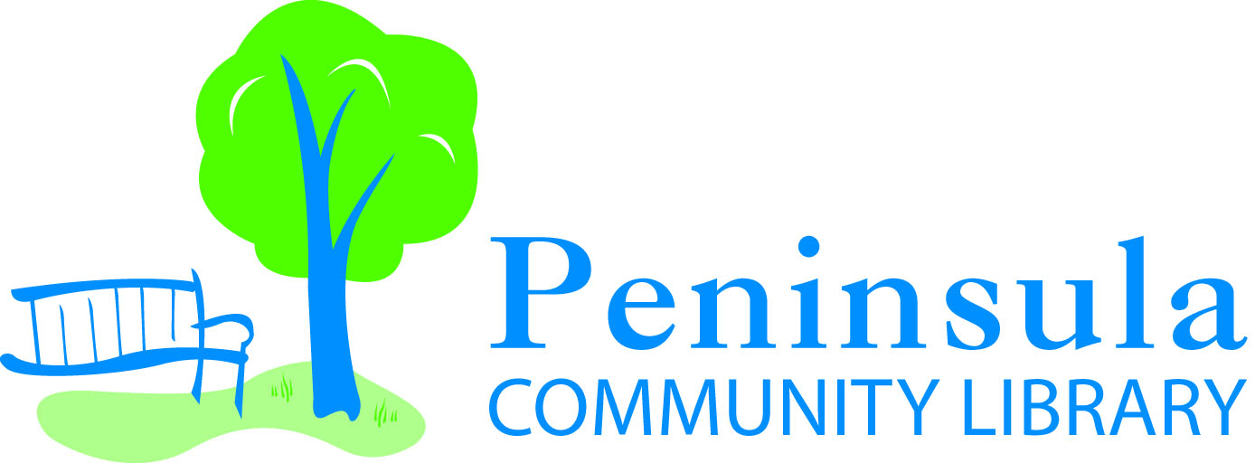 2699 Island View Road Traverse City MI 49686
PENINSULA COMMUNITY LIBRARY (PCL) – LOCAL HISTORY COLLECTION DONOR FORM
Date:
IDENTIFICATION OF DONOR
Name of Donor:
Address:
Telephone Number:
Email Address:
IDENTIFICATION OF ITEM BY DONOR
Immediately prior to the donation, who owned/owns the item?
Who owned or created it originally?
Is the item an original or a copy?
Describe the material and tell us what you know about the history of the item:

Age of the item:
Is the item under copyright, and if yes, who holds the copyright?
Are there any restrictions that are being placed by the donor on the gift, noting that PCL retains the right to decline the gift?
Do you wish your status as donor to remain confidential or may we use your name in relation to the item?
IDENTIFICATION OF ITEM BY LIBRARY STAFF
Condition of the item (Excellent –like new, Good – some wear but stable, Fair – worn or some parts missing or fading or tears, Poor – active deterioration is evident or major parts are missing or very faded and torn, Very Poor – only fragments of the original remain):
Describe the item in detail:

Are there any names or dates that are notable on or in the item?

DEED OF GIFT
- If the material is not relevant to Old Mission Peninsula and/or the surrounding area, it may be separated into different collections (i.e. photographs, manuscripts, artifacts, etc.) within PCL or shared with other institutions. If in the future it is determined that the materials do not meet PCL’s collection guidelines, the materials may be offered to another institution. All donations are made with the understanding that they may someday be sold or disposed of in the best interest of PCL. PCL cannot commit itself to housing an item in perpetuity.

- Access to non-artifact material will be via PCL finding aids which allow researchers to locate the materials with PCL’s collection online.

- There shall be no restrictions on PCL’s use of this gift unless noted under” Identification of Item by Donor.”

- I guarantee that I have full title to this material, that the gift is unencumbered and that I am fully authorized to make this gift and that the transfer of the material to the Library is permanent and non-conditional.

- I release and indemnify Peninsula Community Library, its staff, board, volunteers and representatives from any and all claims arising out of or in connection with this gift.

- This deed of gift becomes effective when signed by the donor.
The PCL Director has discussed the above bulleted items with me and I, the donor, understand and agree with the above conditions.
Donor Signature ________________________________________ Date: _________________
PCL Director Signature ___________________________________ Date: _________________
Name of PCL Director ____________________________________

