PRESS RELEASE: December 15, 2020
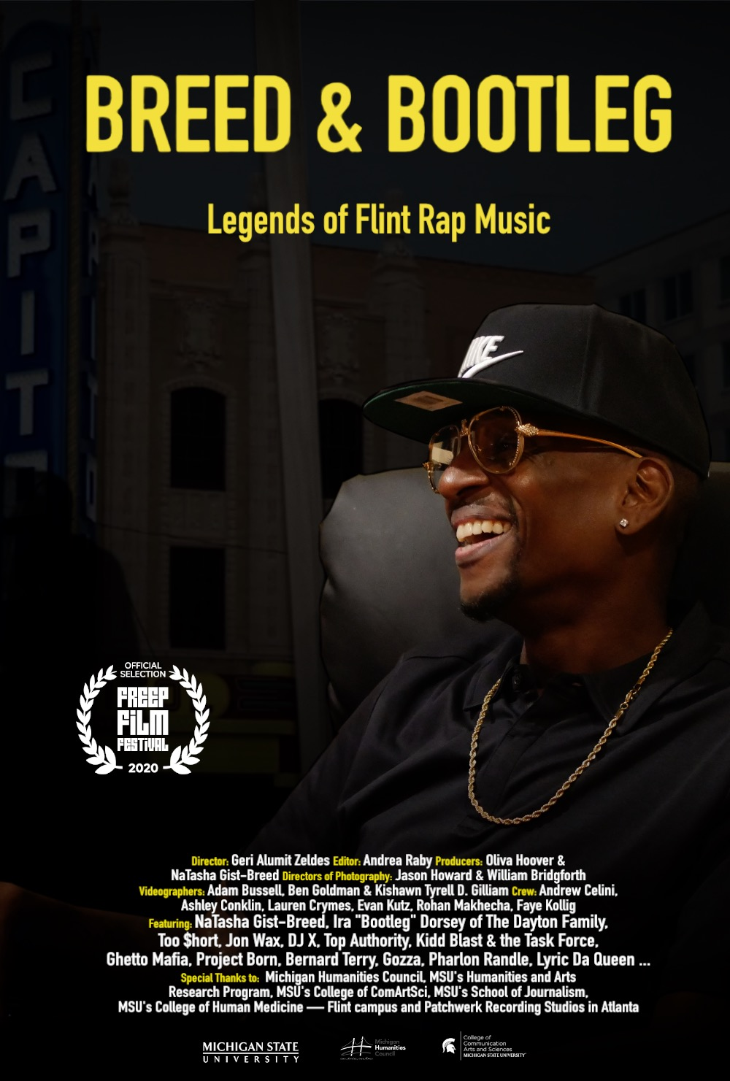
Documentary film: Breed & Bootleg: Legends of Flint Rap Music

Trailer
Media Kit Stills, Flyers and Poster
Website
Facebook
Media Contact: Geri Alumit Zeldes, Director: 248-910-0687 or alumitge@msu.edu
Available for interviews:
- Natasha Gist-Breed, MC Breed’s Partner: 770-285-6847
- Ira “Bootleg” Dorsey of The Dayton Family: 734-800-1833
- And crew … let me know if you’d like students/alumni

Recognition:
- Dec. 2-6, 2020 Official Selection: Detroit Free Press’ Freep Virtual Film Festival

Screenings (non festivals):
- Dec. 2, 2020 Private screening hosted by Gist-Breed and Curtis “Fritty Loc” Daniel, III, Patchwerk Studios in Atlanta

Media Coverage:
- Dec. 2019. “A peek at Humanities Grant project “Breed & Bootleg” Michigan Humanities News. See below the e-news article that was updated to serve as the presser for this film.
- Feb. 19, 2020. Robert Gold. “Flint rap movie kicks off UM-Flint’s push to grow local music collection.” Peter Hinterman. UM-Flint Now. News Happenings.
- Sept. 2, 2020. The Birth of the Midwest Style. The Rap on Flint Project. My City Magazine.
- Nov. 17, 2020. “Freep Film Festival reveals lineup for December virtual event, announces 2021 dates.” Detroit Free Press
- Nov. 22, 2020. Tia Scott. “12 years after his passing, MC Breed continues to inspire his hometown.” Flintside
- Wed., Nov. 25, 3 p.m. (Arizona time) Tia Scott interview of Flintside.com. Publication date?: TBD
- Sun., Nov. 29, noon. Khan Santori Davison, Detroit Metro Times Publication date?: TBD
- Nov. 29, 2020. Detroit Free Press Staff. Freep Film Festival virtual festival kicks off Wednesday. Here’s how to watch.
- Wed., Dec. 2, 2020 Lia Kamana, NBC25/Fox66. Film on Flint’s contribution to rap history to premiere at Detroit virtual film festival.
- Wed., Dec. 2, 12:06 p.m. WDET 101.9 FM NPR Station in Detroit
- Thurs., Dec. 3, Freep Film Festival Panel: https://www.youtube.com/watch?v=nM0O-_GRiAI
- Dec. 4, 2020 New Documentary is Love Letter to Flint’s Hometown Hero MC Breed WDET 101.9 FM, NPR station in Detroit

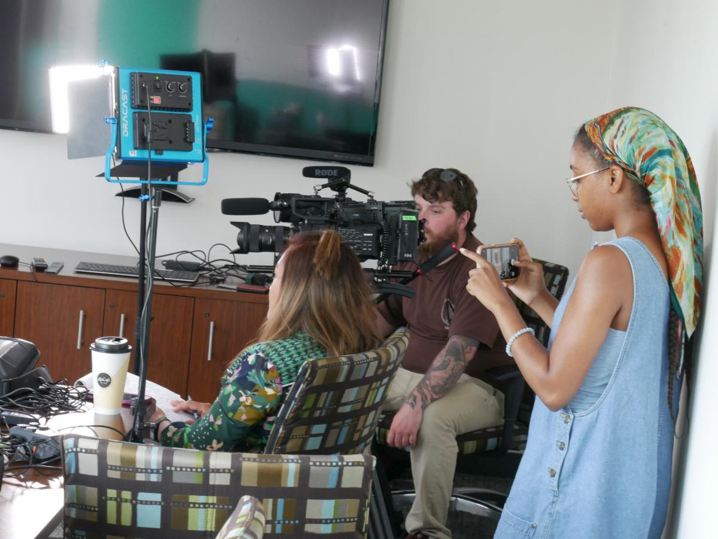
A peek at Humanities Grant project "Breed & Bootleg"
Director: Geri Alumit Zeldes, Ph.D., professor at Michigan State University’s School of Journalism

“Breed & Bootleg: The History and Future of Rap Music” is an hour-long film about the birth of rap music in the city in the early 1990s, beginning with the late MC Breed, known as the first commercially successful rap artist in the Midwest. “Ain’t No Future in Yo Frontin,’” a song by MC Breed and the DFC (Da Flint Crew), reached the Billboard Hot 100 and stayed there for more than six months, longer than any other song at the time. Meanwhile, the Dayton Family made up of Ira "Bootleg" Dorsey, Raheen "Shoestring" Peterson and Matt "Backstabba" Hinkle, started climbing the charts with their gangsta-genre lyrics.

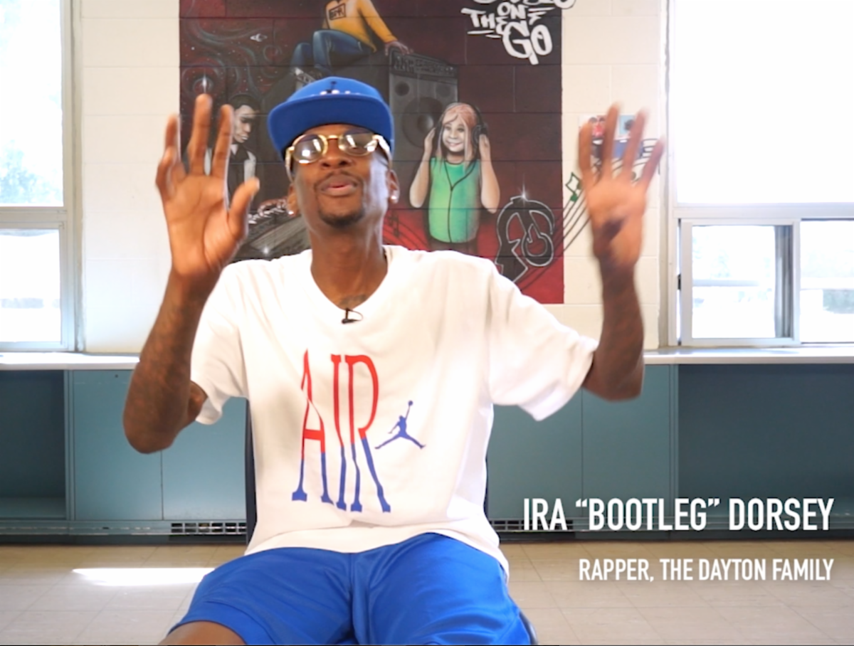
The film begins and ends with a Talent Show in Flint and in the middle traces the roots of hip hop back to talent shows held in high schools throughout the city. The Golden Age of rap music in Flint was the early 1990s, but the film shows that like the city of Flint that is going through a rejuvenation, music grows and Flint remains a font of rap music.

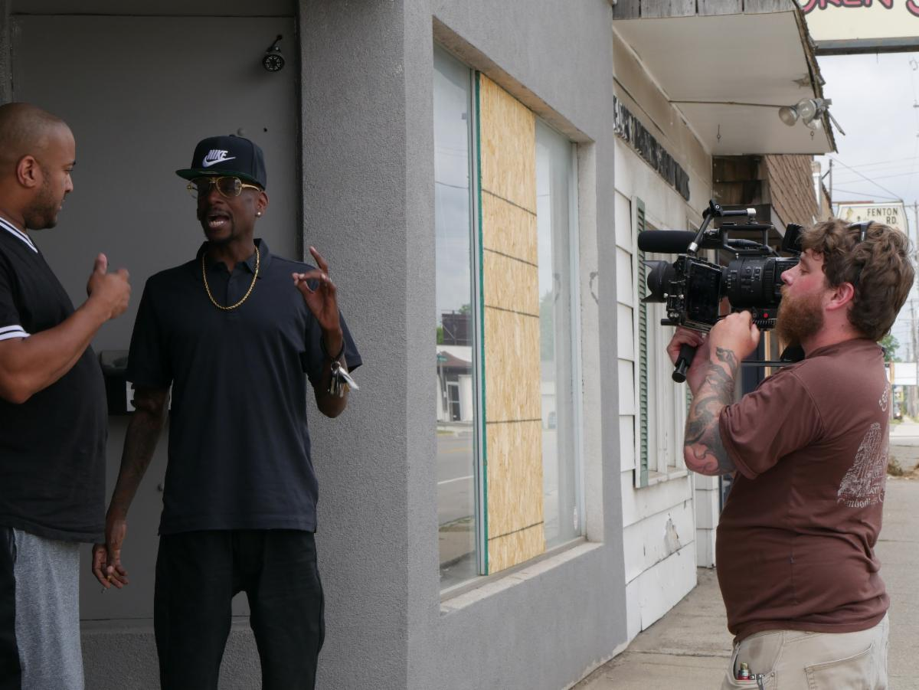
Another theme of the film is the friendship between Breed and Bootleg and the health issues each have suffered. They collaborated and remained close until Breed’s death in Ypsilanti on November 22, 2008 when he died of kidney failure. MC Breed was only 37. In 2013, Bootleg had a heart attack, which led to a heart transplant months later. He is also on kidney dialysis three times a week, something Breed had refused.

When a rough cut was screened in early October to the family of MC Breed and Ira “Bootleg” Dorsey, one suggestion gained traction in the audience: Interviewing famous rap artists who MC Breed influenced. Those artists were interviewed and the final cut of the film will debut in Dec 2020 during the Detroit Free Press’ Virtual Freep Film Festival.
Director’s Background
Geri Alumit Zeldes is a Professor in MSU’s School of Journalism and the Faculty Excellence Advocate for MSU’s College of Communication Arts & Sciences in which she tries to move the needle of “awesomeness” by recruiting and retaining physically and mentally diverse faculty. She received her B.A. from UM in English and Communication, an M.A. in Journalism from Indiana University and a Ph.D. from MSU in mass communication.
Geri has a dozen best paper awards from international communication associations and 100+ honors and screenings for her documentary films that include the Dr. Suzanne Ahn Award for coverage of social justice issues from the Asian American Journalists Association, Edward R. Murrow and Unity awards from the Radio Television Digital News Association, an ArtPrize award, four regional Emmys ® ...
She spends her days teaching virtually for MSU located in East Lansing and her evenings in West Bloomfield, where she lives, writing grants to support her work and shuttling her four kids to sports practices. Being a mom she said is her highest calling.
Geri's recent works include the Empathic Games Initiative that recently exhibited at the Science Gallery Detroit and will exhibit in spring 2021 in MSU’s Broad Art Museum. Five student-created games engage issues of body shaming, high school-er anxiety, social economic discrimination and transphobia. As part of the “Rap on Flint project,” she is working on the book “Flow & Flint Town” that examines mental and music flows experienced by rap artists in the city. Expected date of release by the Wayne State University Press? 2022. Many moons ago, in the early 1970s, her family immigrated from Baguio City in the Philippines to Flint town, a city she considers as her muse. Most of Geri’s work are exercises in self-discovery about her identities as a journalist, Filipino, woman and Flint stone.

