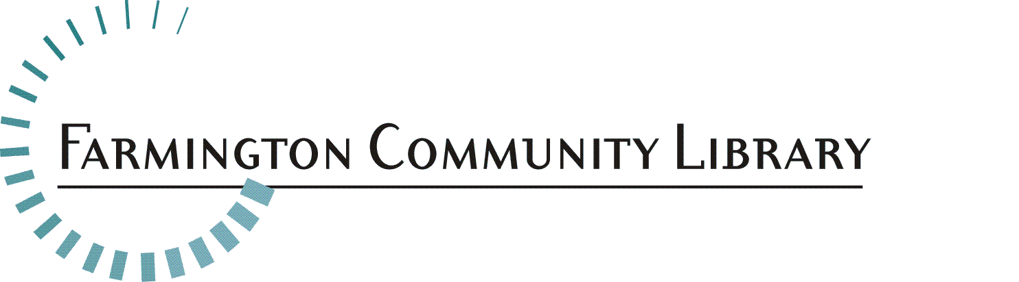
Part-Time Para-Professional Young Adult Department

As a Young Adult Para-Professional you will engage youth and their families at the library and beyond, by inspiring a love of learning and providing easy access to information and diverse ideas through our collections, technology, programs, and community connections. At FCL we plan programs, develop collections, provide school support. We have created welcoming youth and teen areas. We work closely with local organizations to serve families, tweens and teens throughout the community. We focus on creating a welcoming, inclusive environment, and elevating youth voices.
FCL is a District Library serving the communities of Farmington and Farmington Hills, with a dedicated staff which provides library service in two locations. Each building has a unique personality. Both locations offer excellent service
POSITION
Under the supervision of Librarians, employees will assist at the public service desks in the Adult, Teen, and Children's Services Departments. The ideal candidate will be passionate about serving a diverse community, empowering kids, parents, and teens to engage with and enjoy coming to the library. Paraprofessional duties include but not limited to;
• Assisting patrons with finding books and information in the Young Adult Department.
• Assisting families in the use of computers, iPads, digital books, printing, and other library
technology.
• Engaging with youth to help them feel welcome in the library.
• Assist with planning and participation in library programs
• Attending department meetings to help set team goals and develop new services to meet
community needs.
• Completing special projects as assigned.
• Forming and maintaining community partnerships to better serve families.

This job description is intended to represent only the key areas of responsibilities; specific position assignments will vary depending on the business needs of the department.

QUALIFICATIONS and SKILLS
• Associate’s Degree or equivalent. Formal training in a child-related field or experience working
with youth desired.
• Demonstrated ability to work with families and youth from diverse populations.
• Excellent oral and written communication skills and interpersonal skills.
• Strong commitment to providing quality customer service.
• Ability to function in a professional manner, work independently, and use good judgment.
• Enthusiastic and dependable team player.
• Creative problem solving skills and flexibility to adapt to changing community needs.
• Proficiency with technology.
• Strong desire to engage, nurture, and mentor
• Ability to organize, prioritize, and coordinate multiple tasks.
• Knowledge of children’s literature, youth development, and early learning concepts desired.

HOURS Part-time, 20 hours per week (including regularly scheduled evenings and weekends).

Position Available: Part-Time Para-Professional
Young Adult Department

Salary Range: $15.16 - $25.66

Part Time Position: 24 hours per week, to include nights and weekends

Fringe Benefits: Excellent

Please include: 1-2 pages describing your experience working with tweens/teens, ages 10-17. Include why you want to work with tweens/teens and your thoughts and ideas about engaging tweens and teens in this heavily digital age.

Please respond with a cover letter, resume and application. Application is available at http://history.farmlib.org/pdfs/Employment_Application_3_2018.pdf

Deadline for application packet is November 15, 2020 to:

Crystal Peterson
Crystal.Peterson@farmlib.org
Farmington Community Library
32737 West 12 Mile Road
Farmington Hills, MI 48334

Application packet will be evaluated when received

