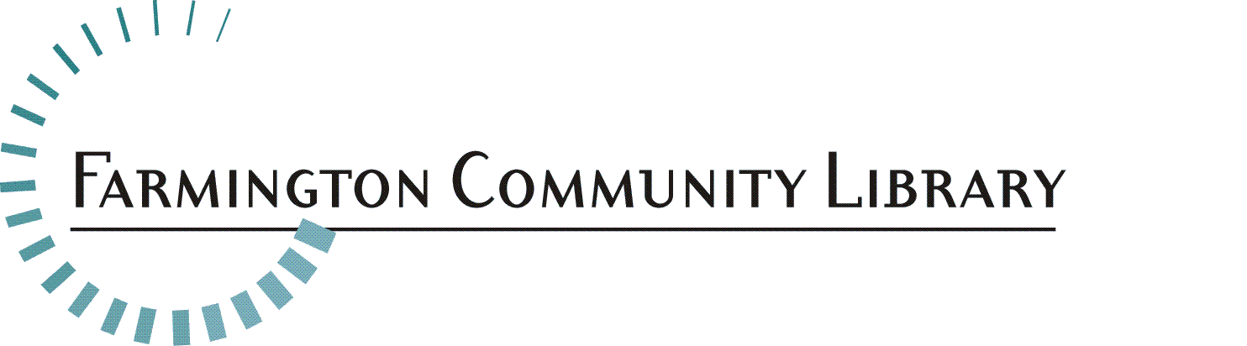

Full Time Adult Services Librarian
The Farmington Community Library is seeking a creative, energetic, ambitious and dedicated Full Time Adult Services Librarian. The successful candidate will possess excellent technology and instruction skills, be service oriented and excited to grow, learn and share knowledge with both peers and patrons. This candidate should have knowledge of best library practices, familiarity of reference materials for adults and students, an awareness of current reading, viewing and listening interests.

We are a District Library serving the communities of Farmington and Farmington Hills, with a dedicated staff which provides library service in two locations. Each building has a unique personality, and both locations offer excellent service.

Job Summary:
Under the supervision of Department Head, Librarians beginning their career focus on the Library’s philosophy, policies and procedures as they apply the knowledge gained in library school. New librarians provide public services to children, young adults or adults. Such services include reader’s advisory, reference in print and electronic formats, and programming.

Essential Duties/Responsibilities may include, but are not limited to:
- ​Provides quick and accurate reference and reader’s advisory services to the public, using both print and electronic resources.
- Assists patrons in learning to use the automated circulation system, electronic resources, and the Internet.
- Provides Adult programming, under the supervision of the Department Head. Participates in collection development in assigned areas with responsibility for selection, weeding and promoting use of the collection.
- Becomes familiar with the Library’s Reference Collection and all special collections, thereby serving as a resource for other Information Desk staff.
- May serve as the Librarian-In-Charge of the building, when assigned. Must be knowledgeable and able to make decisions in situations dealing with Library security, emergency procedures and conflict resolution.

Qualifications and Skills:
- Master’s Degree in Library and Information Science from a school accredited by the American Library Association.
- One year experience in public libraries.
- Professional certification as a Librarian from the Library of Michigan or ability to gain it within 1 year.
- Ability to learn new and emerging technologies.
- Excellent oral and written communication skills
- Strong organizational skills and the ability to set and modify work priorities independently with a high degree of initiative.
- Demonstrates creativity, flexibility, and a positive attitude.
- Critical thinking skills
- Excellent customer service skills and professional.

This job description is intended to represent only the key areas of responsibilities; specific position assignments will vary depending on the needs of the department.
Physical Activity Requirements:
- The ability to lift, push and/or pull up to 20 lbs., and push carts weighing up to 200 lbs.
- The ability to reach, crouch or stoop, also sit, stand and walk for long periods
- Sufficient vision, speech and hearing, which will permit employee to successfully perform the functions of this position.

Position(s) Available: 2 Full Time Librarian
Adult Services Department

Salary Range: $41,809 - $62,348

Full-time Position: 40 hours per week, to include nights and weekends

Fringe Benefits: Excellent

Please include your cover letter, resume, and application. Application available at: http://history.farmlib.org/pdfs/Employment_Application_3_2018.pdf

Deadline for application packet is November 15, 2020 to:

Crystal Peterson
Crystal.Peterson@farmlib.org
Farmington Community Library
32737 West 12 Mile Road
Farmington Hills, MI 48334

Application packet will be evaluated when received

