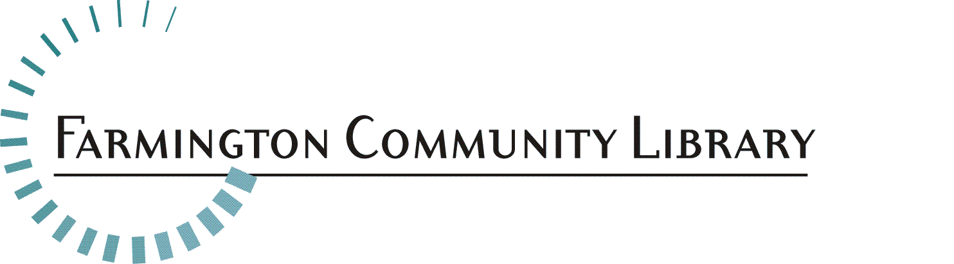

Part Time Para-Professional Children’s Services Department

The Farmington Community Library is seeking a creative, energetic, ambitious and dedicated Part Time Children’s Para-Professional. The successful candidate will be service oriented and excited to grow, learn and share knowledge with both peers and patrons. This candidate should have knowledge of child development and children’s literature, familiarity of reference materials for children and students, an awareness of current reading, viewing and listening interests, and possess technology skills.
We are a District Library serving the communities of Farmington and Farmington Hills, with a dedicated staff which provides library service in two locations. Each building has a unique personality, and both locations offer excellent service
Job Summary:
Under the supervision of Librarians, employees will assist at the public service desks in the Adult Services and Children’s Services Departments. Public services may include reader’s advisory, reference assistance, programming and training on electronic resources.

Essential Duties/Responsibilities:
- Assisting with developing and providing story time programs and other events for ages 0-12 years.
- Provides quick and accurate reference and reader’s advisory services to the public, using both print and electronic resources.
- Assists patrons in learning to use the automated circulation system, electronic resources and the Internet.
- Performs interlibrary loan services to fulfill patron requests for items not owned by searching online catalogs of other libraries and initiating MeLCat requests.
- Participates in collection development in assigned areas, under the supervision of Librarian. Assignments may include: selection, weeding and preparation of bibliographies.

Qualifications and Skills:
- Knowledge of basic principles, concepts, and technical methods to carry out tasks or implement services in the library.
- Some knowledge of literature published for children, and child development, for children ages 0-12 years.
- Experience working with children.
- Ability to work independently, making decisions within the authority ascribed to this position and seeking advice when required.
- Ability to establish and maintain effective working relationships with other staff, supervisors and the public.
- Familiarity with current technology, i.e., general computer literacy, knowledge of the Internet and other electronic sources of information.
- Effective oral and written communication skills.
- Critical thinking skills, which can be applied to successfully answering reference inquiries.
- Knowledge of literature, current events and general information found helpful in resolving reference inquiries.
- Demonstrates regular and predictable attendance, including attendance at required meetings.

This job description is intended to represent only the key areas of responsibilities; specific position assignments will vary depending on the needs of the department.

Physical Activity Requirements:
- The ability to lift, push and/or pull up to 20 lbs., and push carts weighing up to 200 lbs.
- The ability to reach, crouch or stoop, also sit, stand and walk for long periods
- Sufficient vision, speech and hearing, which will permit employee to successfully perform the functions of this position.

Position Available: Part Time Para-Professional
Children’s Services Department

Salary Range: $15.16 – $25.66 per hour

Part-time Position: Part Time Position: 24 hours per week, to include nights and weekends

Fringe Benefits: Excellent

Deadline for Applications: November 15, 2020

Put your knowledge of child development and children’s literature to work serving youth ages 0-12 and their adults in our Children’s Department. Help us deliver programs, build and manage collections, and make recommendations for reading and information sources in a diverse community which values education.

Please include your cover letter, resume, and application. Application is at:
http://history.farmlib.org/pdfs/Employment_Application_3_2018.pdf

Deadline for application packet is November 15, 2020 to:

Crystal Peterson
Crystal.Peterson@farmlib.org
Farmington Community Library
32737 West 12 Mile Road
Farmington Hills, MI 48334

Application packet will be evaluated when received

