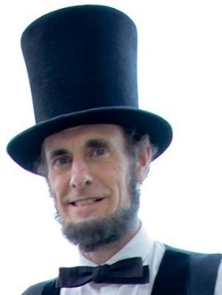
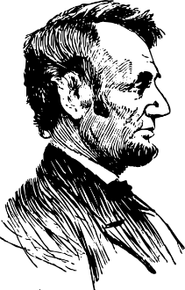
Kevin J. Wood
Portrayals of President Abraham Lincoln
333 S. Oak Park Ave., Unit #2N
Oak Park, IL 60302-3549
telephone: 708-948-7017 (home) / 708-979-3093 (cell)
e-mail: abe@mrlincoln.com
website/social media/blog: www.mrlincoln.com

“Abraham Lincoln: A New Birth of Freedom”
Program for General Audiences (Libraries, Museums, Senior Homes, Community Groups, Etc.)
The United States of America was founded in 1776 as a bold experiment in democracy, upon the ideals of liberty and equality, but by 1854 appeared destined to failure. Events of that year, however, compelled a retired – some would say ‘washed-up’ – politician from Illinois to re-enter the political fray and begin a long fight for the renewal and eventually an expansion of those great ideals upon which our nation had been founded.
Adults and children alike will enjoy hearing a first-hand account from Abraham Lincoln himself of the history of the USA from our establishment in 1776 through the end of the Civil War in 1865. This was a remarkable time of new ideas, tremendous change, and exciting growth in our young country. Yet at the same time, this period was also marked by great conflict and an uncertainty about our future as a people and a nation. All of this change, growth, conflict, and uncertainty would come to a head during the twelve turbulent years from 1854-1865 which nearly destroyed our young nation but instead eventually resulted in a “new birth of freedom”.
Abraham Lincoln was one of that latter period’s greatest protagonists, and today is one of our nation’s most beloved and esteemed historical figures. Mr. Lincoln quotes from his best-known speeches and writings, while also providing some surprising and interesting perspectives. He also talks about his own inspiring story, of how he rose from a humble background to the highest office in the land through self-study, hard work, ambition, and a strong moral character.
This program is most appropriate for adults and for children from six years old on up. It runs about one hour and is followed by additional time of Q&A, photos, and informal interaction.
Mr. Lincoln is portrayed by Kevin Wood, a professional Lincoln presenter who bears a remarkable resemblance to “the Great Emancipator” and who is extremely knowledgeable about his life and times. Mr. Wood also writes a blog – “Loath to Close… Still!” – which encourages others to reflect upon and learn from President Lincoln’s life and legacy. For more information, visit www.mrlincoln.com.

