**Library Locker Info – Michlib-l (April 2020) - responses**

Original Question

**From:** [michlib-l-bounces@mcls.org](mailto:michlib-l-bounces@mcls.org) <[michlib-l-bounces@mcls.org](mailto:michlib-l-bounces@mcls.org)> **On Behalf Of** Melissa Huisman via Michlib-l  
**Sent:** Tuesday, April 14, 2020 10:17 AM  
**To:** 'michlib-l@mcls.org' <[michlib-l@mcls.org](mailto:michlib-l@mcls.org)>  
**Subject:** [Michlib-l] outdoor electronic lockers

Hi!  Can anyone recommend a brand or vendor for lockers that patrons can use for pickup outside the building? Thanks!



Contact me: [mhuisman@hudsonville.org](mailto:mhuisman@hudsonville.org) :: 616-669-1255 x 5

Melissa,

We don’t have lockers yet, but we’ve been looking into them & have asked for a lot of recommendations. The two at the top of our list are D-Tech’s HoldIT! system and Bibliotheca’s Remote Locker. Both vendors were willing to provide references & quotes for a basic system, as well as a live virtual demo (we had D-Tech last week, Bibliotheca is today). I’d be happy to share any of that with you if you’d like.

Kevin Hawley, Circulation Supervisor, East Lansing Public Library, 517-319-6943 [khawley@cityofeastlansing.com](mailto:khawley@cityofeastlansing.com)

Hi Melissa,  
ELPL is looking into these as well.  We had a very good virtual demo by D-Tech.  A nice system.  We have another virtual demo by Bibliotheca tomorrow.

The D-Tech libraries we contacted have nothing but good things to say about them as a company for customer service, etc. They are pricey, though.

I think American Locker Co. has outdoor lockers that have been used at libraries. They do not talk to the ILS system.

Thanks, Kristin

Hi Melissa,

Thank you for your enquiry and interest in the D-Tech HoldIT™

To provide you with correct pricing information, are you looking for an indoor or outdoor kiosk

And what combination of units, please see information below,

The HoldIT connects via SIP2 we have many installs with many ILS

To provide you with correct  information,

Are you looking for an outdoor kiosk?

What quantities with the main screen are you looking for, I have provided the kiosk units available below:

The HoldIT™ kiosk is an expandable kiosk with three different units available,

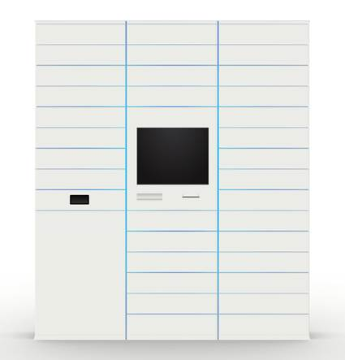

From left to right:

Return bin unit (has 8 usable spaces) a returns draw and a returns bin is housed in the bottom

Main screen unit ( has 9 usable spaces) the top locker holds electrical equipment and can only be opened with a key

15 locker unit all 15 spaces are usable,

The kiosk is flexible so with the main screen you can have any combination of units, so we have some customers who have the main screen and return bin units only ( 17 usable spaces) and others that have the main screen and 5 x15 lockers  (84 usable spaces) the kiosk can also be added to at a later date.

Trilly Roper ,Head of customer service



Unit 1, 251 Ranger Road, Cape May, New Jersey, 08204, Tel: 609-435-5846, [www.d-techinternational.com](https://linkprotect.cudasvc.com/url?a=http%3a%2f%2fwww.d-techinternational.com%2f&c=E,1,nuYpTP7kPUjvJQ5mbK9pX16HFaJtwcoS6f424gUmUlbl3RmLI5U8z3IrZYVD3blFFsTGn0uLC6MHQWolH2z7V3JbYx4ME6MBsAokLeh1w4MckJ3Ro7o,&typo=1)

**From American Locker**

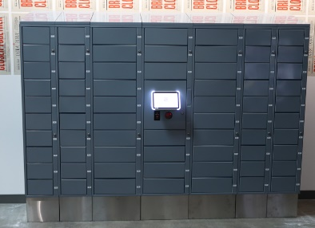 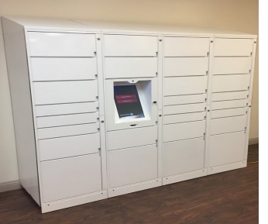

I have attached a few different configurations we have built for other applications.  We can mix sizes or do all the same size.  The software can be loaded and the database can reside on the local machine and can be set up to automatically send codes to the patrons via text or e-mail, or can be controlled by you and you send the codes to them.

Let me know what you are thinking as far as a quantity, if you think these sizes may work and how the delivery and pick process with be handled.  I can then send some budgetary information specific to your use case.  Thank you for reaching out via LiveChat, sorry for the glitch earlier.

Kind regards, Pete Collins VP Sales

American Locker

Hi Melissa,

I was also thinking of something really simple, like high school lockers, but we always ran into the same issue – how to you let patrons know how to unlock it? The easiest way would be to let patrons use their library card or account number, which keeps leading us back to electronic lockers.

The D-Tech system isn’t completely integrated with your ILS – it doesn’t let you place holds or checkout books, or anything like that. It has its own software on one of your terminals & you “check out” the book through their system. It tells you which locker to put the books in, and then patrons retrieve their books by scanning their library card from the terminal built into the locker. When they’re done, the patrons return their books in a book drop like normal.

From what I’ve seen, D-Tech and Bibliotheca are the only two systems like that. Envisionware & others make more complicated (and expensive) systems that let you browse books & check them out from the kiosk, sign up for library cards, return books, etc.

We had our D-Tech demo last week, and I checked with some of the libraries that are using their system. I’ve pasted their response to my emails below. I also attached a copy of the quote they sent me. They included space in part of the unit for a return bin, but we’d swap that out for a few more lockers for the same price.

Our Bibliotheca demo is tomorrow, so I’ll let you know what they have to say in a separate email later.

Kevin

Feedback from 3 public libraries that are using D-Tech’s HoldIT system

1. Chester Library, PA
2. Rogers Public Library, Arkansas
3. Grand Prairie Library, TX
4. Chester County Library, PA:

We have been really happy with the HoldIt lockers. They were just starting to gain some traction before we had to close. D-Tech was very easy to work with. They provided a lot of support, and still check in on occasion to see how we’re doing.

I have copied Barb Bailey, our head of Circulation, because she can give you more of the technical details. (note: I have not heard from Barb yet. - KH)

Good luck, and stay well.

Marguerite Dube

Director,

Chester County Library and Henrietta Hankin Branch

450 Exton Square Parkway

Exton, PA 19341

Phone: 610-344-4054

Fax:     610-344-6328

E-mail: [mdube@ccls.org](mailto:mdube@ccls.org)

[www.chescolibraries.org](https://linkprotect.cudasvc.com/url?a=http%3a%2f%2fwww.chescolibraries.org%2f&c=E,1,Kq6lgCvIXoknI7fEl5PuU_0uPceBp4VVgJLp54k_cmQSZJpMlicgPS36DlYsZ7CktuBcxw5aDCcKH6qjSQrMyhiZ0Tvsvb-PPlHK4BdI&typo=1)

1. Rogers, Arkansas Public Library

I felt the company offered good services and were responsive.  Our unit did not work out for us.  We thought we had put it in an excellent location but it was not used much and we had to have repairs made a couple of times.   Patrons also had difficulty seeing the screen in the bright sunlight.  We did do some protection that helped, but did not find a really good solution.

Judy F. Casey, Director

711 S. Dixieland Road

Rogers, AR 72758

479-621-1153

1. Grand Prairie, TX Public Library

Hi Kevin,

Please see my answers below.

The biggest challenge we had was our work flow. Let me know if you end up going with the Hold IT and maybe I can help you skip some of the learning curves we had.

The machine works well and D-Tech is great to work with.

Please don’t hesitate to let me know if you need anything else or have any other questions you think of.

Peter

1. How has D-Tech been to work with? Have you had any issues? No issues, just the opposite. The best part of D-Tech is their service. Marvin and his team have come personally to work on our Hold IT. We also purchased a Lend IT from them. I would have no reservations about working with them in the future. They are very attentive and requested enhancements come in days or weeks not months. They are the best vendor I have worked with in 20 years in terms of service and working hard to keep you coming back to them for other products. Any technology is going to have issues. The important thing is for the vendor to support you and its product after the sale. D-Tech does that.
2. Does it integrate well with your ILS (may not be relevant - we have Innovative Sierra) We use Horizon and there have been no issues with our SIP2 connection. The one issue we have had is the doors sticking but that seems to have been resolved with a hardware change they made.
3. How have your patrons responded to it? Do they use it often? Our customers love it and have continued to use it even if we had an issue with one of their transactions. Ours is placed in an area far from our brick and mortar buildings so that helps the usage as well.

Peter Sime, MLS

Library Services Supervisor of People

City of Grand Prairie

901 Conover Drive

Grand Prairie, Texas

75051

972-237-5705

[psime@gptx.org](mailto:psime@gptx.org)

[//www.gptx.org/library](https://linkprotect.cudasvc.com/url?a=https%3a%2f%2f%2f%2fwww.gptx.org%2flibrary&c=E,1,QtPU7nWcaJOicFNf3scIHCJ7e9VYQCQTuAm14pBfS-DMU9D5oDsn6FbH32yiBc7ZJllCLs9NLcbvxaoEcAEl8EpYyRmzVST8L-CAzra7UrD8&typo=1)

Hi!

Try Patti Engineering ([www.pattieng.com](https://linkprotect.cudasvc.com/url?a=https%3a%2f%2fwww.pattieng.com&c=E,1,3G_cjSRcDbOpZJUYZc5-jX9d0Mb_-XMkOYF1atCyF2b56j12wmggq7oxpmaa-Wi9LDjNDbkkcb0hoOQHDhfeNSLe1WVuV0hDyGj5LCWPrUFHpU97XuI,&typo=1) or [www.americanlocker.com](https://linkprotect.cudasvc.com/url?a=http%3a%2f%2fwww.americanlocker.com&c=E,1,syvo6l-4frAyvR02dXpQ56nVHZp9GLysZ0N7aoSJpe_6fIv4GHruVeETdgXdaTpYDhb3K9JBYpRGhkUDMk-nyEzEAurmUKScw_pRNvr2ZFbKcaQAyb4,&typo=1)). This company installed our lockers 12 years ago.

Oksana Urban, Library Director, Warren Public Library, One City Square, Ste. 100, Warren, MI, 586-574-4564 x 5001, [ourban@cityofwarren.org](mailto:ourban@cityofwarren.org)

Hi Melissa,

Here is another locker company that might work for you, too. My previous library system used this company after they switched from American Lockers.

[www.leidproducts.com](https://linkprotect.cudasvc.com/url?a=http%3a%2f%2fwww.leidproducts.com%2f&c=E,1,F12D-3T6L6k0erY7J34fndqa0ra4YiAcyHRCS6BplPenc241smAar0LcW1JrffCqtgduBu3k--KPSpigzecjy4jLPxrIxq73yhqD3Cq_&typo=1)

[jkormanik@leidproducts.com](mailto:jkormanik@leidproducts.com)

Thanks, Kristin

Melissa,

I think Worthington had problems with the doors when they first got them, but a lot of other e-locker systems (like D-Tech) fixed the designs over the years. I’m going to ask them for a price quote too.

Kevin

**From:** Melissa Huisman <[mhuisman@hudsonville.org](mailto:mhuisman@hudsonville.org)>   
**Sent:** Wednesday, April 15, 2020 8:48 AM  
**To:** Pete Collins <[pcollins@americanlocker.com](mailto:pcollins@americanlocker.com)>  
**Subject:** RE: LiveChat

Thank you!  Can you give me an idea of the total outside dimensions? The system I quoted you would be 78”W x 18”D x 80”H  Or, can I just calculate by the number and rows of drawers? The system is comprised of 2 columns of the small lockers, each column is 12”W and 2 columns of the larger lockers, each column is 18”W;  The user station would also be an 18”W column. Also – does it need to be anchored to the wall and what kind of wiring or hookup would it need from the unit into the network of the building?  (It would be on a brick wall).  Ideally anchoring to a wall is preferred, but it can be anchored to the ground if need be.  We have anchored systems to brick, cinder block, marble, concrete, etc.  We would need a standard 110V power outlet and either a network data port to plug into, a very strong WiFi connection or a cellular device for internet connectivity.

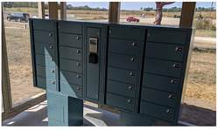

Greetings Melissa to a fellow Michigander organization almost on the  latitude! (We are in Auburn Hills.)

Your choice is exactly what 90+% of our customers select. The twin 10-door system with computer kiosk in the center will recognize a patrons’ bar or magnetic code library card or a pin and open only the door the door assigned to them by the library back at the home office.

What is your plan for usage?  Library holds for social distancing?  Temporary storage for pubic safety? Other?

Are you looking to purchase in 2020?

I look forward to hearing back from you.

|  |
| --- |
| Sincerely, **Peter M. Kujawski** President, Colonel, US Army (ret) |
| [**LEID Products**](https://linkprotect.cudasvc.com/url?a=http%3a%2f%2fwww.leidproducts.com%2f&c=E,1,K5hbtkdbC8ptnXDVsdm5c1TKKpeL_1zHE3WUTTf_b9Huk07atdT2GKFr_3-4xEdRuZgVKSOuIM342vnaKFz4dfHL02GbI4vXSz17fE27_zaEPlsHWdbnSs-8U8TH&typo=1) Office: (888) 884-LEID (5343) Mobile: (603) 289-6001 [pkujawski@LEIDProducts.com](mailto:pkujawski@LEIDProducts.com) |