Write Your Name in Braille!
Step 1: Place the slate in front of you with the window part of the slate up and the hinged side on your left. Open the slate. It opens from right to left, like a book. There is a small peg sticking up in each corner of the right-hand side of the slate and a little hole in each corner on the left side.​
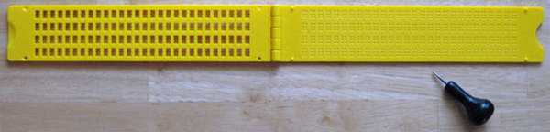

Step 2: Place a piece of paper over the right-hand part of the slate. The left side of the paper should be next to the hinges.​
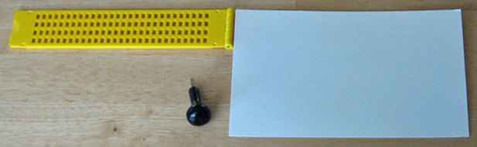

Step 3: Close the window part of the slate over the paper as if you were closing a book and push it down firmly. You will hear the four corner pegs poking through the paper into the corresponding holes to anchor the paper in place. The slate is now ready to use.
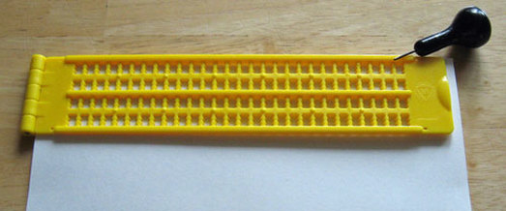

Step 4: A person writing braille with a slate and stylus must write from right to left and must form the braille characters in reverse. The raised dots appear on the back side of the paper. Start with the last window in the top row and punch your first letter. Move left to the next window and make your next letter. Continue this until your name is complete. That’s it! Remove the paper, turn it over and read your name in braille!
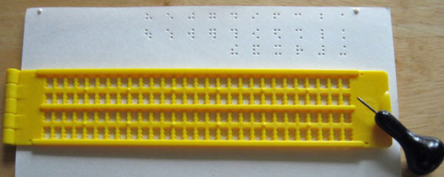
Braille Alphabet Chart in Reverse
for ​Slate and Stylus Users
