Instructions
A person writing braille with a slate and stylus must write from right to left and must form the braille characters in reverse. The raised dots appear on the back side of the paper.

- Start with the last window in the top row and punch your first letter. {REMEMBER to use the attached Reversed Alphabet}
- Move left to the next window and make your next letter.
- Continue this until your name is complete.
- That’s it! Remove the paper, turn it over and read your name with your regular Braille Alphabet card braille!

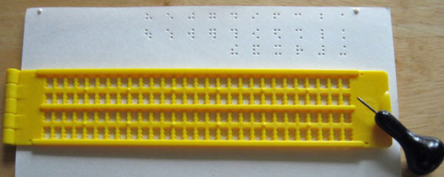
Start here and go backward!

Braille Alphabet Chart in Reverse
for ​Slate and Stylus Users
