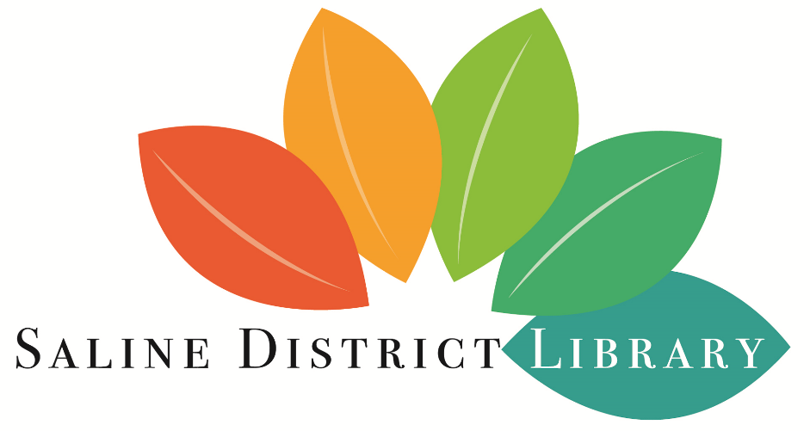

REQUEST FOR PROPOSAL

STRATEGIC PLANNING
for
SALINE DISTRICT LIBRARY
555 N. Maple Road
Saline, MI 48176
734-429-5450
www.salinelibrary.org

September 16, 2019

Section I: Introduction

The Saline District Library (SDL) is seeking consultant services to assist the Library Board, staff, and community in developing a comprehensive strategic plan. The plan will include priorities, goals, measurable objectives, timelines, and proposed activities to meet expressed community needs for library service over the next three to five years. The strategic plan will examine community growth patterns and demographics and identify the need for service with respect to future trends in collections, technologies, and services. It will also analyze funding needs to respond to service goals. This project will result in the creation of a widely-supported strategic plan that is aligned with resident and stakeholder input.

Section II: Background

Saline District Library is a Class V district library located in Washtenaw County, Michigan. The library district boundaries include the City of Saline and portions of six surrounding townships: Bridgewater, Freedom, Lodi, Pittsfield, Saline, and York, encompassing about 100 square miles and matching the boundaries of Saline Area Schools. The official service population as verified by the Library of Michigan is 26,376, though this number is expected to increase significantly with the 2020 census.
The library is an independent taxing authority that is governed by a seven-member Board of Trustees. Trustees are appointed by the City of Saline and Saline Area Schools to serve two-year terms. Tax revenue from two operating millages comprises approximately 90% of the library’s $2.25 million operating budget.
The community library was first created in 1900 and went through several changes before becoming a district library in 1991. The current library building opened in 1994; it was renovated and expanded to approximately 33,000 square feet in 2008. It currently houses a collection of nearly 120,000 physical items, including books, magazines, movies, music, and more. The library also provides access to a wide variety of electronic and online resources. There are approximately 15,000 library card holders, and that number continues to grow. The statistics for circulation of materials and attendance at programs are also on the upswing. There were 166,485 visits to the library in the last fiscal year.
Saline District Library is a member of The Library Network cooperative and participates in the statewide MeLCat interlibrary loan program. The Polaris integrated library system is operated internally, and the EnvisionWare RFID system was recently implemented to allow self-checkout and security of library materials.
The library publishes a weekly eNewsletter that is currently sent to about 2,800 subscribers and is funded by the Friends of Saline District Library. The Friends operate the Corner Book Shop, located inside the library, and use the proceeds from the sale of used books to provide generous funding for many other projects and programs each year.
In the spring of 2019, with the assistance of a University of Michigan graduate student, SDL completed a community survey, the results of which may be useful for the planning process. A workplace environment study was also completed by library staff in the spring of 2019.

Section III: Project Scope

Saline District Library seeks an experienced professional to:
- Design and facilitate a strategic planning process that is effective for public libraries and will:
- Gather data on and from library users, non-users, and stakeholders
- Create an up-to-date community profile and identify community markets
- Assess the library’s environment, including peer comparisons to other libraries of similar size and service population
- Review current trends in library service and technology and analyze user expectations regarding those trends
- Identify service priorities and needs
- Identify and address gaps between current library operations and service priorities
- Recommend measurable objectives and goals
- Define timelines and benchmarks for progressing
- Make recommendations for moving the library forward with short term and long term options
- Facilitate planning meetings and public input sessions
- Write and present findings and recommendations for moving the library forward to library stakeholders
- Prepare a final version of the strategic plan, including goals, objectives, and strategies

Section IV: Proposal Content Requirements

Responses to this RFP must include the following elements:
- Cover letter providing a brief description of the firm or individual, name, address of consultant, telephone number, and e-mail of the principal contact person
- Executive summary of the highlights of the proposal
- Summary of the consultant’s qualifications and relevant experience, along with a list of key personnel who would be involved in the process, with a description of their backgrounds and areas of expertise
- Work plan that contains a description of the methodology, tasks, timeline, and an estimate of the amount of time that would be spent on the project
- Project budget that includes consulting costs, clerical costs, and data analysis costs; estimate the number of facilitator hours to be provided and the rate per hour; indicate a “not to exceed” total cost
- Signature by an individual authorized to bind the proposer, with a statement that the proposal is a firm offer for a 90-day period
- References, including contact information for at least three organizations for which the facilitator has provided strategic planning services; include one sample of a complete report that the facilitator has prepared for a similar project

Section V: Selection Criteria

Submitted proposals will be reviewed and evaluated by the Library Director and the Strategic Planning Committee that is comprised of members of the Library Board and Staff. Evaluation criteria will include:
- Responsiveness of the written proposal to the purpose and scope of the project
- Demonstrated knowledge, skills, and experience in conducting strategic planning projects for non-profit organizations, preferably public libraries
- Methodology for carrying out tasks in the scope of work
- Proposed fees
- Performance record
- Ability to meet deadlines and operate within budget
- Written and oral communication skills
- References
The Committee may, at its discretion, ask any of those responding to this RFP to make a brief presentation and answer questions posed by the Committee.
SDL reserves the right to select a strategic planning consultant based directly on a proposal or to negotiate with one or more respondents.
SDL reserves the right to reject any and all proposals.
SDL reserves the right to cancel the award of contract at any time prior to the execution of the contract by both parties.
Respondents bear sole responsibility for costs incurred in the preparation and delivery of proposals. The library will not reimburse costs associated with the responses.
All information submitted shall be public record and subject to disclosure pursuant to the Michigan Freedom of Information Act.
No Library Board or Staff member shall respond to this RFP or have a financial interest in any proposal.

Section VI: Submission Information and Timeframe

“STRATEGIC PLAN BID PROPOSAL” must be on the envelope or in the subject line.
Respondents shall submit completed proposals to:
Mary Ellen Mulcrone, Director
Saline District Library
555 N. Maple Road
Saline, MI 48176
Electronic submissions should be sent to maryellen@salinelibrary.org
Proposals are due by 5:00 p.m. on October 11, 2019.
Any requests for clarification of information in this RFP must be submitted in writing to the Library Director before the due date. Interpretations may be given orally or in writing, depending on the nature of the inquiry. An interpretation of this RFP given by anyone other than the Library Director shall be invalid.
The Strategic Planning Committee shall make a recommendation to the Library Board at its regular meeting on November 19, 2019.

