LIBRARIES WITHOUT WALLS 2019
Opening Doors to the Future

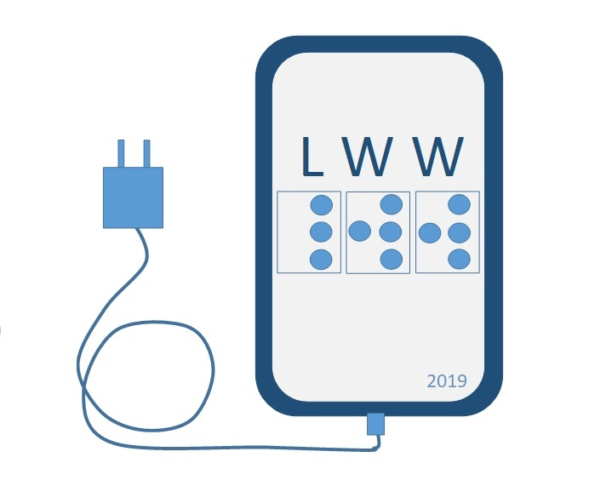

REGISTRATION

The Bureau of Services for Blind Persons Braille and Talking Book Library is hosting the Libraries without Walls Conference on Tuesday, June 4, 2019. This conference will be held at the Lansing Community College West Campus located at 5708 Cornerstone Drive, Lansing 48917. The purpose of this one-day conference is to introduce, demonstrate and provide to librarians, educators, and patrons instruction on how adaptive technology meets the information needs of persons with visual or physical impairments via the Internet, online catalogs and electronic media.

Keynote Speaker
Professor Emeritus, Paul Ponchillia will discuss Indoor Wayfinding utilizing mobile devices and other adaptive technologies.

Break-out Sessions
Attend up to 3 sessions from an array of topics including the latest in low-cost magnifiers, NVDA and Narrator free open source screen readers, Apple iOS, and more!

To Register
Fill out the form on the reverse side. Enclose $15 check per registrant paid to State of Michigan. Return by May 24th. For more information contact Scott Norris1-800-992-9012, norriss5@michigan.gov
Mail to:

Braille and Talking Book Library

Libraries w/ Walls

P.O. Box 30007

Lansing, MI. 48909

LIBRARIES WITHOUT WALLS 2019

REGISTRATION

Name________________________________

Address______________________________

City ____________________________ State______

Zip_____________

Phone________________________

Email (include if you would like an emailed confirmation of receipt- allow 10 business days for processing)_____________________

Please enclose your $15 registration fee. Lunch will be provided.

