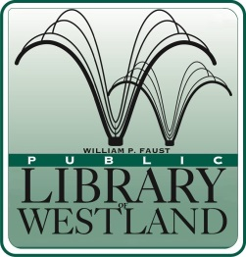
WILLIAM P. FAUST

Public Library of Westland

6123 Central City Parkway • Westland, Michigan 48185-9118
(734) 326-6123 • FAX (734) 595-4612 • www.westlandlibrary.org

POSITION ANNOUNCEMENT
TWO MAINTENANCE ASSISTANTS (Part time)

Date: January 16, 2019 Closing Date: Until position is filled
Reports to: Head of Maintenance Position Available Immediately

Summary: Under supervision performs cleanup and maintenance of the library building and grounds to ensure the comfortable, clean, convenient, and safe operation of the library for both its patrons and staff.

Performs year round upkeep of library grounds through picking up trash, cutting grass, raking, pickup of litter, shoveling of snow, salting of walks, and care of shrubbery and plantings.

Experience:
This position requires a high school diploma or GED equivalent.
Three years of facilities/maintenance experience in a related building.
Possession of a Michigan motor vehicle operator’s license.

Schedule: 25 hours per week including days, nights and weekends
Union Position: Yes
Salary: $9.25-$24.00 per hour depending on qualifications and experience
Benefits: Vacation, Personal time and paid holidays. Employer contribution
toward retirement benefits.

Applications will be found at our web-site @ www.westlandlibrary.org

Mail or e-mail resumes attention:
Diane Mehl
Maintenance Department Head
6123 Central City Parkway
Westland MI 48185
diane.mehl@westlandlibrary.org
Fax: 734-595-4612

