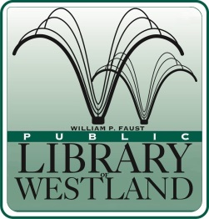
WILLIAM P. FAUST

Public Library of Westland

6123 Central City Parkway • Westland, Michigan 48185-9118
(734) 326-6123 • FAX (734) 595-4612 • www.westlandlibrary.org

Position Announcement

TEEN SERVICES LIBRARIAN (Part time)

External Applicants

Date: December 7, 2018 Position open until filled
Reports to: Head of Youth Services Position Available Immediately

SUMMARY:

Under the direction of the Head of Youth Services, the Teen Services Librarian will plan, promote and implement library collections and programs with a primary focus on teens. Maintains relationships with schools to promote teen programs and collections. Works closely with other Youth Services staff on implementing programs and services for children and young adults. Provides reference and readers’ advisory services utilizing print, A/V and electronic resources. Works with staff throughout the library to develop and implement programming, partnerships and other projects that enhance the library’s image in the community.

EDUCATION AND EXPERIENCE:

- ALA accredited Master’s Degree in Library or Information Science.
- 1-2 years of experience serving teens and young adults in a library setting.
- Bachelor’s Degree from an accredited college or university.
- Knowledge of teen literature and media – both current and classic.
- Successful experience presenting appropriate programs for teens.
- Excellent customer service attitude.
- Familiarity with social, pop, cultural and technological trends which impact young people’s lives.
- Good working knowledge of Windows-based computers, the Internet, database searching, automated library systems, downloadable/streaming resources and social media.

Schedule: Part-time 25 hours per week including days, nights and weekends.
Union Position: Yes
Salary: Starting at $19.23 per hour.
Benefits: Vacation, Personal time and paid holidays. Employer contribution toward retirement benefits.

Applications are available at our web-site @ www.westlandlibrary.org
Please submit a completed application, along with a cover letter, resume and three references to:

Caryn Bartone
Head of Youth Services
6123 Central City Parkway
Westland MI 48185
Caryn.bartone@westlandlibrary.org
Fax: 734-595-4612
This library is an EEO Employer.

