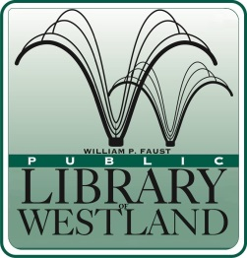
WILLIAM P. FAUST

Public Library of Westland

6123 Central City Parkway • Westland, Michigan 48185-9118
(734) 326-6123 • FAX (734) 595-4612 • www.westlandlibrary.org

Position Announcement

YOUTH SERVICES LIBRARIAN (Part time)

External Applicants

Date: December 7, 2018 Position open until filled
Reports to: Head of Youth Services Position Available Immediately

We are currently accepting applications for two part-time positions of Youth Services Librarian committed to providing high quality library service to children and their families.

Summary:
Under the direction of the Head of Youth Services, the Youth Services Librarian develops programs, services and collections focusing on the importance of reading, storytelling, and the Library as a learning resource. Presents and leads a variety of programs, services and activities for young people including babies, children, tweens, their caregivers, teachers and adults who work with them. Provides reference and readers’ advisory services utilizing print, A/V and electronic resources. Collaborates with staff throughout the library to develop and implement programming, partnerships and other projects that enhance the library’s image in the community.

Education and Experience:
- Master’s Degree in Library or Information Science from an ALA-accredited program.
- 1-2 years of professional library youth services or equivalent experience.
- Successful experience presenting developmentally appropriate programs for young people
- Bachelor’s Degree from an accredited college or university..
- Good working knowledge of Windows-based computers, the Internet, database searching, automated library systems, downloadable/streaming resources and social media.

Schedule: Part-time up to 25 hours per week including days, nights and weekends.
Union Position: Yes
Salary: Starting at $19.23 per hour
Benefits: Vacation, Personal time and paid holidays. Employer contribution toward retirement benefits.

Applications are available at our web-site @ www.westlandlibrary.org
Please submit a completed application, along with a cover letter, resume and three references to:

Caryn Bartone
Head of Youth Services
6123 Central City Parkway
Westland MI 48185
Caryn.bartone@westlandlibrary.org
Fax: 734-595-4612
This library is an EEO Employer.

