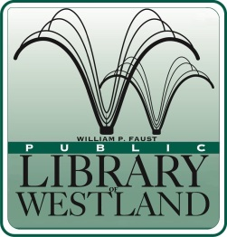
WILLIAM P. FAUST

Public Library of Westland

6123 Central City Parkway • Westland, Michigan 48185-9118
(734) 326-6123 • FAX (734) 595-4612 • www.westlandlibrary.org

Position Announcement

LIBRARY ASSISTANT (CIRCULATION) - 2 Positions

For Internal and External Applicants

Date: November 16, 2018 Closing Date: November 26, 2018
Reports to: Head of Circulation Services Position Available Immediately

SUMMARY:
Under the direction of the Head of Circulation Services, the Library Assistant directly serves patrons by checking-in and checking out materials, registering patrons, collecting money for fines and fees, scheduling meeting rooms, and answering simple patron queries. Performs a wide variety of routine and occasionally complex clerical and computer work. Works with staff throughout the library on projects that enhance the library’s image in the community.

EDUCATION AND EXPERIENCE:
- High School Graduation or GED. College coursework preferred.
- 1-2 years of customer service experience, preferably in a public library.
- Valid Michigan driver’s license.

Schedule: 25 hours per week including days, nights and weekends
Union Position: Yes
Salary: $9.25-$17.39 per hour depending on qualifications and experience
Benefits: Vacation, Personal time and paid holidays. Employer contribution toward retirement benefits.

Applications are available at our web-site @ www.westlandlibrary.org
Please submit a completed application, along with a cover letter and resume to:

Diane Mehl
Head of Circulation Services
6123 Central City Parkway
Westland MI 48185
Diane.mehl@westlandlibrary.org
Fax: 734-595-4612
This library is an EEO Employer.

