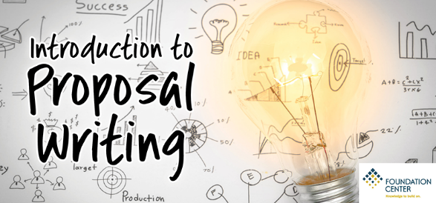
Are you new to proposal writing or want a quick refresher? If so, you don’t want to miss one of our most popular classes!

This class will provide you with an overview of how to write a standard project proposal to a foundation. It will include:

- The basic elements of a proposal
- The “do’s” and “don’ts” of writing and submitting a proposal
- How to follow up whether the answer is yes or no

Registration required; (248) 553-6880.
Speaker: Teleange’ Thomas Director, Foundation Center Midwest
Main Library Auditorium: Monday, July 30, 1 p.m. .
_________________________________________________________________________________________________
Farmington Community Library Main Library 32737 W. 12 Mile Road Farmington Hills, MI 48334

