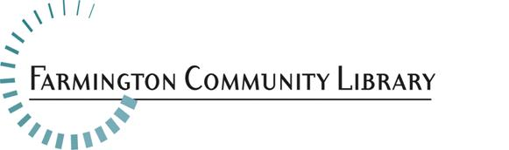

**July 10, 2018**

**Position Available:** Information Services Intern, Adult Services Department

**Wage:**                                    $12.73 per hour with no benefits

**Hours:**                                    16-19 hours per week, including evening and weekend hours

**Application Deadline:**Thursday, July 19by 5:00 p.m.

**Please include your cover letter, resume, and application** <http://history.farmlib.org/pdfs/Employment_Application_3_2018.pdf> to:

                                                Diane Serresseque, Executive Assistant

32737 W Twelve Mile Road

Farmington Hills, MI 48334

[Diane.Serresseque@farmlib.org](mailto:Diane.Serresseque@farmlib.org)

**General Information**

This position offers paid, practical library experience for students currently enrolled in a School of Information/Library Master’s program. Students are responsible for providing evidence of enrollment and satisfactory progress toward completion of their degree.

**Essential Duties and Responsibilities**

* Provides information, reference service and readers’ advisory service to patrons of all ages in person, over the phone, and via email
* Performs collection maintenance duties as assigned
* Develops, plans, implements, or assists with library programs for all ages as appropriate
* Attends meetings as appropriate
* Assists patrons on public computers
* Other tasks as assigned

**Minimum Qualifications**

* Current enrollment in a School of Information/Library Science Master’s program
* Successful and relevant work experience in a public service setting
* Ability to work successfully with diverse patrons of all ages, ethnicities and backgrounds
* Positive attitude and approach to problem-solving, customer service and public service
* Excellent communication and interpersonal skills

**Preferred Qualifications**

* Experience working in a public library
* Experience or class work in reference or research services