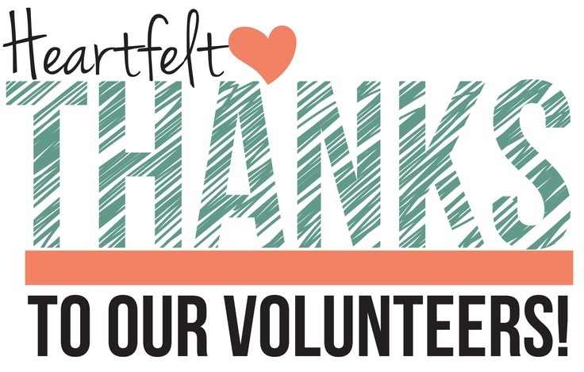  May 15th 10:00am-3:00pm  Friends of the Library Workshop  Free Workshop sponsored by Superior District Library  Come spend an informative and fun day at the Curtis Library with friends and colleagues. Gain new knowledge about library law, and share new ideas for fundraisers and events.  This workshop is open to all library personnel and volunteers in the state of Michigan. Light breakfast and lunch provided.  Please RSVP to Lisa Waskin, Director of the Superior District Library, at lisaw@uproc.lib.mi.us; or Linda Blanchard, Manager of the Curtis Library at curtislib@uproc.lib.mi.us | Volunteer Appreciation  ────  Network with members from other Friends of the Library groups  ────  Speaker Roger Mendel, Northland Cooperative Director  ────  Speaker Clare Membiela, Library of Michigan, Law Librarian  ────  Lunch provided by Chamberlin’s  Curtis Library  N. 9220 Portage Ave.  Curtis, MI 49820  (906) 586-9411  curtislib@uproc.lib.mi.us  Dates and Times

