Sleeping Bear Press…
Celebrating 20 Years with Michigan: The people, the history, and the legend

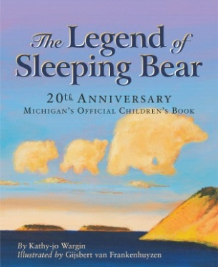
This year marks the 20th anniversary of Michigan-based Sleeping Bear Press. This once small, regional publisher has grown internationally, but plans to continue giving back to the community that has supported them from the very first book—The Legend of Sleeping Bear.

The fully-developed children’s publishing program includes board books, award-winning picture books, beginning reader series, middle-grade novels, and eBooks.

Even though the press now publishes books with international authors and illustrators, they pledge to stay committed to Michigan. “Our remarkable community always supported us and that’s why we are still publishing award-winning picture books about Michigan,” says Publisher Heather Hughes. “We thank our partners; our authors and illustrators, the many booksellers, retailers and wholesalers, educators, librarians, parents, editorial review board, and readers of all ages who have supported our growth. In appreciation we’ve planned a year-long celebration filled with giveaways in multiples of 20; including free school visits, tote bags filled with books for libraries and schools, and more!”

The press carefully nurtures its regional titles and is humbled with the opportunity to preserve Michigan’s natural landscape and history by publishing beautiful children’s books. Each book is a keepsake. “Michiganders want to explore and re-experience the wonders of Michigan when they read our books,” says Sleeping Bear Press owner Ben Mondloch. “When you are at home reading about your favorite Michigan tourist spot—the Dunes, or Mackinac Island—you want to go back. And when you are visiting, you are enriched by what you read and become inspired to read more.”

This year will bring forth two special releases. Sleeping Bear Dunes has previously been voted as the most beautiful place in the United States by ABC’s Good Morning America viewers, so the Press is releasing The Legend of Sleeping Bear 20-year anniversary edition with extra content. The second special release, Nature’s Friend: The Gwen Frostic story is a picture book biography that tells the story behind the life and famous work of an inspiring Michigan woman.
To schedule interviews or for additional information contact: julia.hlavac@sleepingbearpress.com

