Volunteer Handbook
We make a living by what we get, we make a life by what we give.
-Winston Churchill

Welcome
Welcome to the Orion Township Public Library. We are delighted that you have chosen to join our volunteer team! By your donation of time, energy and talents, you will be helping to enrich not only the Library, but your community as well.

Why Volunteer at the Orion Township Public Library?
As a volunteer, you will have an opportunity to learn more about the Orion Township Public Library and its collections and possibly even gain new skills and experience. You will make important contributions to Library programs and the community and help us promote literacy and education. Volunteers enable us to do things we would otherwise be unable to do, such as programming.
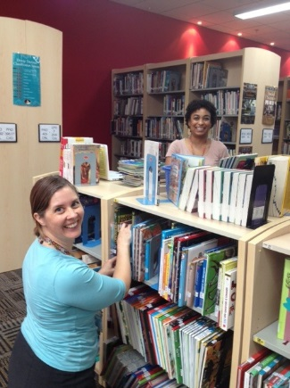

Volunteer Mission Statement
The Orion Township Public Library shall utilize the services of volunteers to supplement the efforts of library staff in meeting our goal of quality public service. Volunteers assist the library in making the best use of fiscal resources and contribute to our relationships and partnerships with community groups and organizations. Volunteers are role models for our library patrons and community and advocate for support of the Orion Township Public Library. The library and its volunteers work together to meet the goals and mission of the organization.

Definition of a Volunteer
A volunteer shall be considered as an individual, twelve years of age or older, who contributes time, energy and talents directly or on behalf of the Orion Township Public Library and is not paid by Library funds.

A Brief History of the Orion Township Public Library
The Lake Orion Library, established by the Lake Orion Women’s Club (General Federation of Women’s Club-GFWC), was first located on the second floor of what is now the Village Hall. In 1929, Orion Township residents ratified a proposition to levy taxes in support of the Lake Orion Library, renaming it the Orion Township Free Public Library.

In 1940, it moved to the Hemingway House on Lapeer Street in the village of Lake Orion and grew until the floor boards sagged.

In 1964, the first formal library was built on M-24 where the Michigan Catholic Credit Union now stands. Opened in 1965, this building met the community needs for the next 24 years.

In 1986, the Orion community passed a bond to create the new Orion Township Public Library to serve the next generation of Orion residents. The 29,000 square foot building opened in its current location on Joslyn Road in February, 1989.

The Governance & Funding of the Library
The library’s greatest revenue source is property taxes, funded through a voter-approved millage that was passed in 1924 and renewed in perpetuity in 1996 and is annually adjusted. Residents are represented by an elected six member Board of Trustees, consisting of six voting residents of Orion Township. The Board members are selected at each quadrennial election and serve four years. The Board governs the library and is responsible for its budget and policies.

The Friends of the Library are a 501©3 non-profit organization whose main purpose is to fundraise on behalf of the library. Friends act in cooperation with the library board and staff, serving as a liaison between the community and library. All money raised by the Friends, except for minimal administrative cost such as postage and printing, is donated directly to the library in the way of program funding, material purchases and monetary contributions.

Policies & Procedures

Attendance & Punctuality
The staff with whom you will work with will rely on your presence during your scheduled hours. We expect you to be on time and ready to work. If you are going to be late or absent, please contact the department you are assigned to and let them know as soon as possible.

In Case of Emergency…
In the case of a weather or building emergency, you will be contacted directly by the Volunteer Engagement Specialist or you may check our website (orionlibrary.org), for updates.

Name Tags
Your name tag must be worn at all times when you are volunteering. The identification is for security purposes and will allow access to certain non-public areas. It is also helpful for our staff to recognize volunteers and be able to direct them if need be.

Volunteer Log Books
It is important to document your volunteer hours on your Volunteer Log Sheet which is filed alphabetically in the Volunteer Log Book. At the end of your volunteer shift for the day, please remember to complete the date, what you assisted with, hours for the day and YTD (year-to-date) total. It is important to keep track of how many volunteers we have, the number of hours utilized and what our volunteers are helping with, so we can plan for the future.

Dress Code
We ask that you please dress neat and appropriately while volunteering. Comfortable and casual clothing is fine, but please refrain from wearing shorts or skirts with inappropriate lengths. Closed-toed shoes are a good idea, since you may be working with materials on shelving units that may fall unexpectedly.

Conduct
We expect the same level of service and professionalism from our volunteers as we do from our staff. You will be interacting with the public as part of your position, so please remember that you are representing the library.
Any reference questions or requests for information about collections or library policies, should be directed to the librarian on desk and any problems or concerns should be reported to your immediate Supervisor or the Volunteer Engagement Specialist.

Volunteers with Disabilities
In accordance with the Disability Act (ADA) of 1990, the Orion Township Public Library does not discriminate against qualified individuals with disabilities in the recruitment or placement of volunteers.

Substance Abuse
Substance abuse in the workplace is not and will not be tolerated and will lead to dismissal of a volunteer.

Sexual Harassment
Sexual Harassment is unacceptable behavior and will not be tolerated. Sexual conduct or conduct with sexual overtones that creates an offensive or hostile environment should be reported immediately to the Volunteer Engagement Specialist or staff Supervisor.

Library Hours
Monday-Thursday
9:30am-9:00pm
Friday and Saturday
9:30am-5:00pm

Library Holidays
- New Year’s Day
- Easter
- Memorial Day
- Independence Day
- Labor Day
- Thanksgiving
- Christmas
- New Year’s Eve

Contact Information

Volunteer Engagement Specialist
Lori Morris, CVA
Phone: 248.693.3000 ext. 333
Email: lmorris@orionlibrary.org

Library Address:
825 Joslyn Road
Lake Orion, MI. 48362
248.693.3000
Youth Department ext. 315
Adult Department ext. 306 & 307

Volunteer Confirmation:
We are so happy you will be joining us as a volunteer at the Orion Township Public Library! For your convenience, listed below are the details regarding your volunteer position:

Date (s): ____________________________
Time (s): ____________________________
Program/Event helping with (if applicable): ____________________________
Department Assigned to: ____________________________
Contact Person:
____________________________
Contact Phone Number: ____________________________

Vision
Be known for more than books.

Mission
To serve and engage a thriving community of lifelong learners.

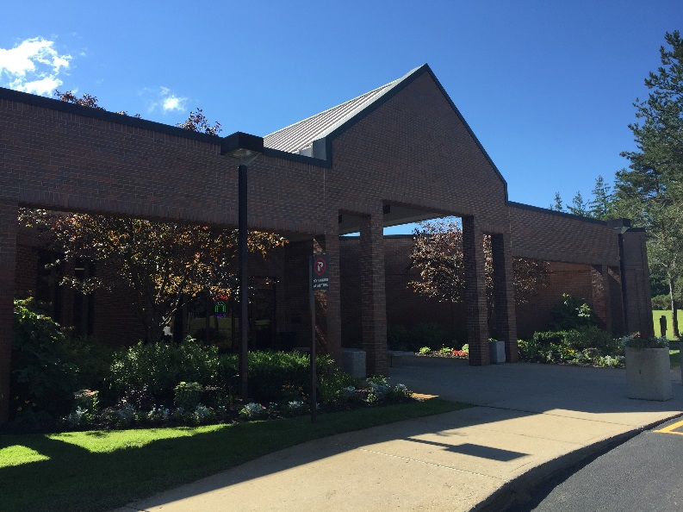

Orion Township Public Library
825 Joslyn Road
Lake Orion, MI. 48362
248.693.3000
www.orionlibrary.org

