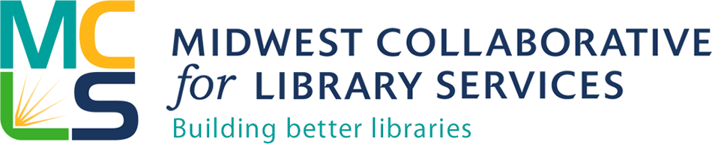

Contact: Michelle Bradley
Manager, Member Engagement
MCLS
800-530-9019 ext. 125
bradleym@mcls.org

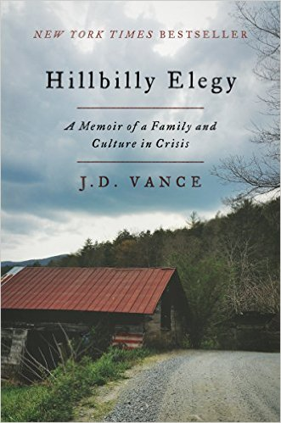
Libraries Read: 1 Book title and events announced
"You will not read a more important book about America this year."—The Economist
Hillbilly Elegy, a memoir by J.D. Vance, has been selected as the title for Libraries Read: 1 Book 2017, capturing 40% of the votes. MCLS invited library staff across Indiana and Michigan to submit titles for consideration, then to place votes for one of four titles to select the book that we will all read and discuss together for professional development. Vance’s book received the most votes.
One of the two librarians who submitted the title suggested that it be our 1 Book choice because, “This book covers issues that would appeal to public, school, and university libraries. It would be interesting to discuss these problems and problem-solve how the library community could help.” The second librarian submitting this book added, “Many of the (residents of Indiana and Michigan) are descendants of those who migrated to the Midwest from Appalachia and southern poverty for the promise of industrial jobs, which have since disappeared. Gaining a better understanding of their story will give insight into issues that are currently occurring in the states, such as the heroin epidemic, rural poverty, changes in political identity over the past 30 years, etc. By gaining a better understanding of this population, libraries can design services and programs that better speak to their needs and interests, ultimately building stronger connections to their community.”
MCLS encourages library staff to read the book throughout the summer, then join us in a Twitter chat and regional discussions about the book.
This will be the third year of the Libraries Read: 1 Book program. By reading one book together, across library types and state lines, we aim to create deeper connections among libraries that span geographic and other boundaries. We hope you’ll join us and add your voice to the conversation.

Book Discussions
- Thursday, Jul 20, 2 - 3pm Eastern (1-2pm Central), online, Third Thursday Twitter Chat; Use the hashtag #mclschat
- Tuesday, Aug 8, 5:30pm Eastern (4:30pm Central), Lansing Brewing Company, Lansing, MI
- Wednesday, Aug 16, 10am – 12pm Central (11am – 1pm Eastern), Lake County Public Library, Merrillville, IN
Credit: 1 general LEU for Indiana staff for in-person discussions
Discussion questions will be available to libraries who would like to host their own discussions. Email Jan Davidson at davidsonj@mcls.org.
Register for a book discussion:
- Register for an in-person book discussion using the online Libraries Read: 1 Book Registration form on our website at mcls.org/engagement/libraries-read-1-book/. Registration is not necessary for the Twitter chat, although we’d love to know to expect you.
For more information, visit our website (mcls.org/engagement/libraries-read-1-book/) or visit our Facebook page (facebook.com/mcls.org).
Questions regarding Libraries Read: 1 Book or the discussions should be sent to Michelle Bradley, MCLS Manager, Member Engagement, at bradleym@mcls.org or 800-530-9019 ext. 125.

