Detroit Public Library

Quicken Loans Author Series
Presents

So, You Want to Be a Writer...Now What?

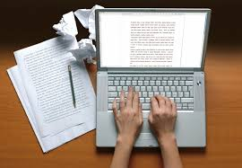

Come see how the experts do it! Published authors share their experiences and advice on taking your book from concept to publication.

Scheduled authors and topics include:

Monica Lynne Foster - How to Attract and Keep your Reader
Sylvia Hubbard - E-Books and Internet Marketing
Michele’ Moore - How to Get Your Book on Bookstore Shelves
Victoria Christopher Murray. -Keynote from NAACP Image Award winner and national bestselling author

Saturday, May 20, 2017 11am to 4pm

Detroit Public Library, Skillman Branch 121 Gratiot, Detroit, MI 48226

This event is free, please call Skillman Branch at (313) 481-1852 to RSVP or register at
EventBrite: https://www.eventbrite.com/e/so-you-want-to-be-a-writer-tickets-33670780210

Refreshments will be served.
