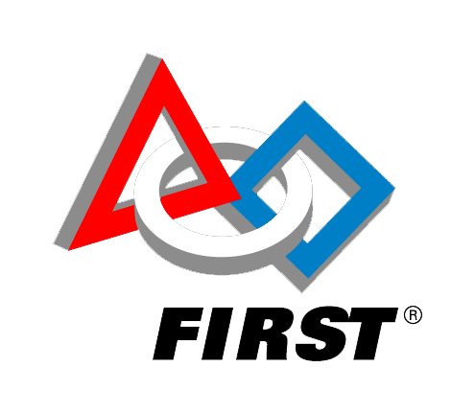

Date and Time of Event (May 6th to May 13th) Free Event to all Ages

Come drive [optional] (Robot Name) and learn about (Team Name), a FIRST Robotics team.

Your local library offers the following STEAM Programs – Come learn how much fun STEAM can be.

Your robot picture here

Name and Location of your library

Robots @ The Libraries