Good morning/afternoon,
Today is a good day for engaged citizenship in Michigan. The Center for Michigan, a nonprofit and nonpartisan organization, is releasing the findings of our most recent public engagement campaign in a citizens’ agenda, titled “Fractured trust: Lost faith in state government, and how to restore it.” Will your library help us spread the word? You can order print copies for public display by contacting us at hzureich@thecenterformichigan.net. And we’d be delighted if you shared the electronic copy in your email newsletters and social media.

In 2016, the Center for Michigan led a statewide dialogue about public trust in state government. And in 125 statewide Community Conversations and large-sample polls, more than 5,000 diverse Michigan residents told us, loud and clear: State government is not living up to their expectations. Michigan residents do, however, identify several actions state leaders can take to improve public trust in state government, namely reform of the emergency manager and campaign finance systems. The report’s major conclusions:
LOW PUBLIC TRUST: The majority of Michigan residents said they had either “low” or “very low trust” of state government’s ability to deliver on all five major areas we explored: 1) Oversight of K-12 and higher education; 2) Protection of public health; 3) Environmental protection; 4) Services for low-income residents; and 5) Fostering economic growth.
URGENT MANDATE TO IMPROVE: More than 80 percent of all participants said it was either “important” or “crucial” for state government to improve in these five service areas. Improvement of public education is a particular public priority, with the largest percentage of poll and conversation participants choosing it as the policy area most in need of attention.
FIX THE EMERGENCY MANAGER SYSTEM: Sixty-five percent of all participants have “low” or “very low” trust in the state emergency manager system to effectively balance the competing needs to solve local financial crises, deliver basic public services, and provide local and representative government. To improve trust, participants suggest providing more checks and balances in the law so that decision making is balanced between state-appointed emergency managers and locally elected officials.
PROVIDE TRANSPARENCY IN CAMPAIGN FINANCE: Eight in ten Michigan residents reported “low” or “very low” trust in the campaign finance system’s ability to balance free speech rights to contribute to candidates with the need to protect elections from undue influence by special interest groups. The most popular solution to improve trust in the campaign finance system is to strengthen transparency and reporting requirements to provide better public information about who donates to our state leaders.
OTHERWISE, A LACK OF PUBLIC CONSENSUS: The Center tested a range of other options to improve state government accountability, such as reforming term limits and reforming the once-each-decade process for drawing legislative districts. No such reform proposal received consistent majority support across both Community Conversations and polls.
In our Community Conversations, the Center for Michigan provides opportunities for Michigan residents to learn about and discuss important public issues in thoughtful ways. The Center then serves as a bullhorn for the Michigan public, amplifying the citizens’ agenda to our state’s leaders. You can read Bridge Magazine's in-depth analysis of the top priorities of this report at http://bridgemi.com/. Bridge Magazine is the Center for Michigan’s online publication, which provides free, in-depth, nonpartisan reporting about the issues most important to our state. Subscribe for free to Bridge, the Michigan Press Associations 2016 and 2017 Newspaper of the Year, at http://www.bridgemi.com/subscribe.
Thank you for your help in sharing this report with your community. Please contact the Center with any questions about this citizens’ agenda and its findings.
Sincerely,
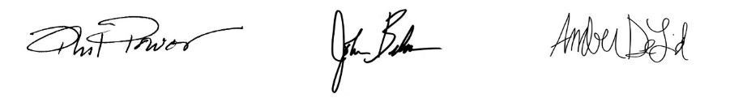
Phil Power John Bebow Amber DeLind
Chairman President & CEO Engagement Strategy Director

