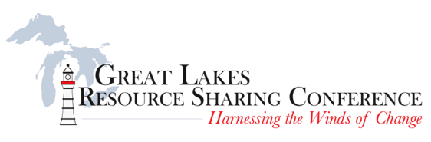

(Please excuse any cross-posting)

[**Registration is now** **OPEN**!](https://members.mcls.org/w/glrsc/register.cfm) **Reserve your space for the** [**4th Annual Great Lakes Resource Sharing Conference**](http://glrsc.org/) **at the** [**DoubleTree by Hilton**](http://doubletree.hilton.com/en/dt/groups/personalized/C/CHIOADT-GLR-20170607/index.jhtml?WT.mc_id=POG) **in Oak Brook, IL on June 8–9, 2017**.

**Schedule in brief:**

Thursday, June 8, 2017

* 12:30 to 1:30 p.m.—OCLC Update
* 1:45 to 3:15 p.m. (including break)—Lightning rounds
* 3:30 to 4:30 p.m.—The Contemporary Academic Library Resource Sharing Mission: Fragmentation or Evolution?
* 5:00 to 6:00 p.m.—Opening reception and trivia contest
* 6:00 p.m. and later—Dine-arounds or dinner on your own

Friday, June 9, 2017—8:00 a.m. to 3:45 p.m.

* Keynote address
* Three tracks of concurrent sessions
* Breakfast, lunch, and breaks included

**Keynote Address:** Corey Seeman, Director of Kresge Library Services (Ross School of Business at the University of Michigan, Ann Arbor) and manager of [A Library Writer’s Blog](http://librarywriting.blogspot.com/), will speak on History Has Its Eyes on You: Lighthouses and Libraries Weathering Storms of Change.

**Concurrent Sessions:**

* Strength in Numbers: Demonstrating Value During Times of Change
* Strengthening Workflows: Developing an Improved Staffing Model to Weather the Winds of Change
* Trying to Jump-Start Collaborative Collection Development: Finding Simple Methods for Effective Cooperation
* And many more! See the [conference website](http://glrsc.org/) for a full list.

**Conference Rates:**

The conference registration fee is $95 ($125 for registration after May 26) and includes all sessions, as well as the reception on Thursday and breakfast and lunch on Friday.

Join your resource sharing partners in harnessing the winds of change!

For hotel reservations and other information, visit the [conference website](http://glrsc.org/).