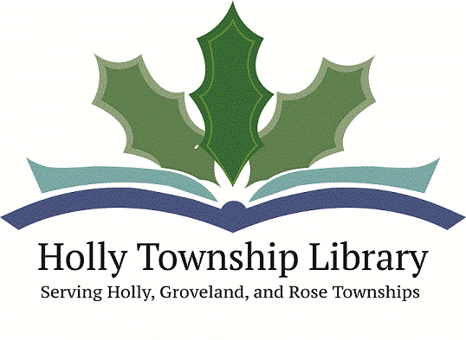

Employment Opportunity
Holly Township Library
Circulation Assistant/MeLCat Administration
30 hours per week

The successful candidate for this position will be able to deliver excellent customer service, be familiar with library services and technology and be able to learn to administer MeLCat services to patrons. Candidates should have a minimum of an Associate’s or Bachelor’s degree, be organized, outgoing, energetic, and feel confident in using various technologies. Library experience is desired. A full job description for each position is attached. Weekend and evening hours will be required.

Wage Range: $10.75-$12.75 commensurate with experience.
Posting Date: 11-21-2016
Closing Date: 12-02-2016

If you are interested in applying for this position please send a cover letter, resume and completed application (attached) to Kate Scheid at kscheid@htlibrary.net or 1116 N. Saginaw, Holly, MI 48442

