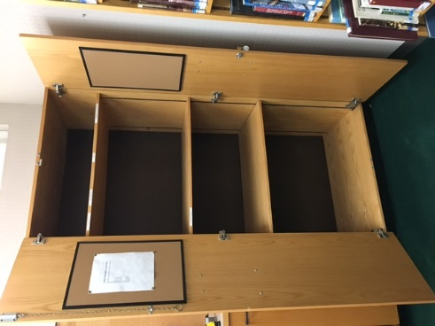
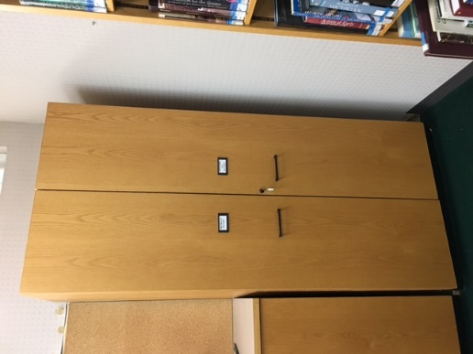

(2) Oak Cabinets 82” tall x 35 ½” wide x 23” deep, $100/each

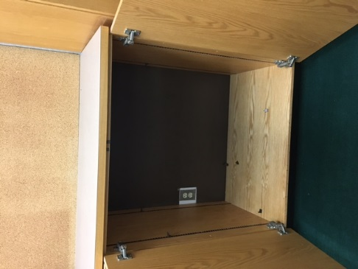
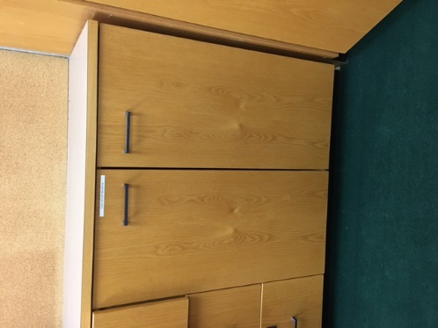

(2) Oak Cabinets 42” tall x 35 ½” wide x 23” deep, $50/each

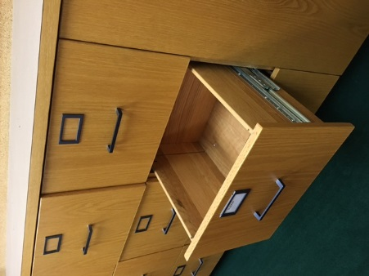
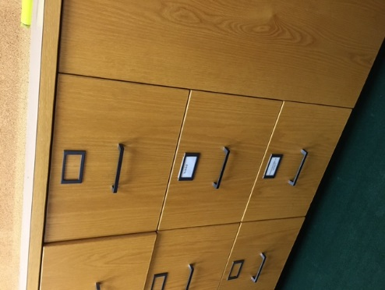
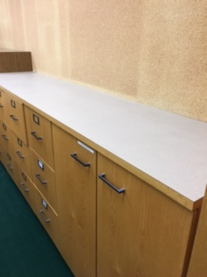

(6) 3-drawer Oak Unit, 42” tall x 18” wide x 23 ½” deep, $50/each
(2) Laminate countertops 90” long x 23 ½” deep, $20/each

