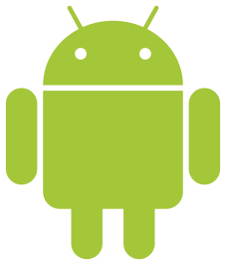
How to borrow titles from your library using an Android or Nook device

The OverDrive app is a great way to quickly find and get eBooks, audiobooks, streaming videos, and periodicals from your library.
Nooks that have the Google Play Store may use these instructions. All other Nooks must refer to the “How to borrow titles from you library using an older device that does not support apps” handout.
Contents:
A) First Time Setup………………p1
B) Getting to the Ohio Digital Library Catalog………………p2
C) Signing In………………p2
D) Finding an Item in the Catalog………………p2
E) Checking Out an Item………………p4
F) Downloading an Item………………p4
G) Reading/Listening To/Watching an Item………………p5
H) Return an Item/Delete an Item………………p6
I) Placing a Hold/Checking Out a Hold………………p7
J) Renewing Items………………p8

First Time Setup
- Install the OverDrive app by opening the Google Play Store app on your device , tapping the search bar at the top that says “Google Play”, and typing in Overdrive. Then tap the first result that comes up on the list with this icon: 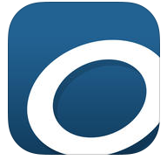
  - Tap the green INSTALL button
  - Tap the green ACCEPT button in the pop-up window
  - Wait for the app to download; it will say what percentage is currently completed, and then say “Installing…”
  - When it is done, tap the green OPEN button.
- Once the app opens you will be asked to sign up for (or sign into) your OverDrive account. You may follow the on-screen instructions to get an account, or if you do not want an OverDrive account, you may click “Continue” at the bottom instead. A benefit of having an OverDrive account is that you may download the same item onto multiple devices.
- Tap the icon in the top-left corner to open the Home menu to see your library list.
- If you do not see “Ohio Digital Library” at the top of the menu, tap Add a Library. Then tap the first white search box/button, type Way Public Library, tap the grey Search button, scroll down and tap Way Public Library from the list, and then tap the star next to “Ohio Digital Library” to make the star turn yellow to finalize the process to add our catalog to your library list. Then tap Ohio Digital Library.

Getting to the Ohio Digital Library Catalog

If you just finished the “First Time Setup” section and are already at the Ohio Digital Library, skip this section.
- Open your OverDrive app; it should be listed with the other apps on your device.
- Tap the menu button in the top left-hand corner.
- Tap Ohio Digital Library.

Signing In
- Go to the Ohio Digital Library (Section B), tap in the top right-hand corner (if it already says Sign Out it means you are already signed in, and you may skip this section).
- If this is the first time signing in on this device you will be asked to tap 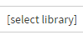 , tap Way Public Library from the drop-down menu, and then tap .
- On the next page you are taken to, tap the blank space under Library Card Number and type in your card number, and do the same for the Pin field (Note: If these fields are already filled in, make sure the numbers correspond with your library card and proceed to step 4, because this means you have signed in from this device before and have it setup to remember your information).
  - Your library card number is the full list of numbers on the back of your library card, without the spaces.
  - Your pin number is the last four digits of the phone number you provided when you applied for your library card. If your pin does not work, call the library to have a staff member look it up for you or change it.
- See if there is a checkmark in the box next to “Remember my login information on this device.” If there is not a checkmark, you may want to tap the checkbox to add a checkmark so that the next time you sign in on this device, the library card number and pin fields will already be filled in for you.
- Tap 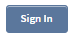 to finish the process and be taken to the catalog homepage.

Finding an Item in the Catalog
Before you starting browsing, always make sure you are signed in (Section C).
- To look for an available title you can:
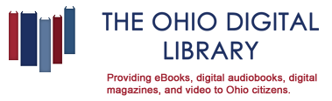
  - Check out Featured Collections: From the Ohio Digital Library homepage, scroll down to see the featured collections or the “Recommended for You” section that OverDrive changes frequently depending on the latest holidays, trends, popularity, etc. (if you are not on this page, you may tap to be taken there.

  - Browse: Tap at the top of the page (make sure it is the menu button next to the ”Account” button and not the menu button in the very top-left corner) to browse categories (on some devices the menu is already open, so tapping Menu may actually close the Menu; tapping Menu again will re-open it). This may look like the picture below, or may be more condensed.
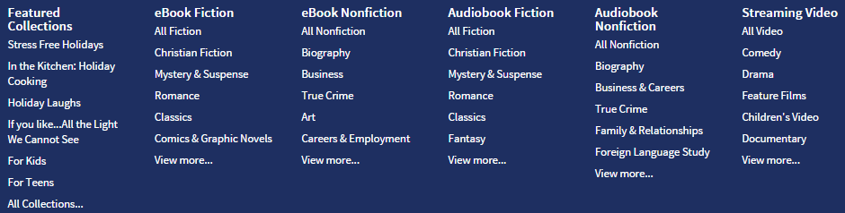
    - Note that if you select “View more…” at the bottom of any column, it will take you to a page with all of the books in that general section listed, and at the page it takes you to, you may tap the drop-down menu 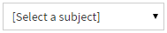at the top of the page to get the full list of catagories. Tap one of these categories to be taken to the page with only those items.
  - Run a search: Tap the white search box 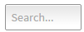in the top right-hand corner (on smaller devices you must first tap ) and type in a title, author, or keyword/subject

- All items have an icon in the top right-hand corner of its cover.
  - Item Type: This icon means the item is an ebook
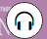 This icon means the item is an eAudiobook you listen to
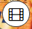 This icon means the item is a movie you watch
  - Availability: If the icon is black it means the item is available. If the icon is grey it means the item is checked out. If you are interesting in placing a hold on the item read Section I below.
- While you are looking at item results while browsing or searching, use the and buttons at the top and/or bottom of pages to flip forwards and backwards through pages of results. The button takes you to the last page in the results.
- Sorting results: You may want to sort items you are browsing or searching for by most popular, publication date, date added to the library, or alphabetical by title or author. To sort items, tap the drop-down menu 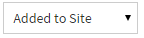 at the top of your results page and tap your selection. Most Popular is usually a good way to sort items, to get the obscure, non-relevant results more likely to be at the end of the results.
- Filtering results: You may want to narrow down browsing/search results by removing items that are checked out, selecting a certain subject, or other options. You may do so by looking at the options on the left-hand side of the screen (for larger devices), or tapping Filter search by… at the top of the screen (for smaller devices).
    - Note: Tap Available Now from the filter options to remove items that are checked out
- Find out more about an item: To read more about an item, tap its cover once and then tap to be taken to a page about the item. Then tap 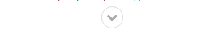 to read the full description. You may read a sample from the book by tapping under the book’s cover.

Checking Out an Item
- When you find a title that looks interesting, tap the item cover and then tap 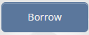. If you have not already signed in, you will be asked to do so at this time (Section C step 2 of this handout) and after signing in you will be taken to your Account/Checkouts Page and may proceed to Section F.
- In the pop-up window, tap 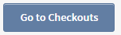and proceed to Section F.
- If the box disappears before you have a chance to tap it, scroll to the top of your screen and tap .

- Downloading an Item
After you checkout an item, it still must be downloaded to your device to read it. A title may only be downloaded on one device unless you have an OverDrive Account, so be sure to use the device you want the item on to complete the download process or else get an OverDrive account. For example if you are using your computer to browse for books but would rather read the item on your tablet, use your tablet to complete this section. If later you change your mind and want to download the item to a different device, you will need to delete it off of the first device you downloaded it to before attempting to download it to the other device (see Section H option 1).
- Go to your Checkouts Page if you are not already, by tapping at the top of any page from within the Ohio Digital Library.
- Find the cover of the item you want to download and tap the button that should be one of the following:
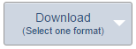 - If it is an ebook
- if it is an audiobook, certain ebooks, or a movie
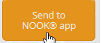 - if it is a periodical/magazine
  - If the button said Add to App, proceed to Section G.
  - If the button said Download and it is an ebook, a drop-down menu will appear and you must tap which format you want. For ebooks the format you need is most likely EPUB book or Open EPUB book or PDF. But, if you have an Amazon account and prefer to use the Kindle Reading App on your Android device or send it to your Kindle tablet, select Kindle Book. Once there is a checkmark next to the format you need, tap . A window should pop up that says Loading for a few seconds and then it will say A title has been added to your bookshelf. You may now proceed to Section G.
  - If the button said Send to NOOK app, after the button has been tapped, if this is the first time you have ever checked out a magazine you will be taken to the Barnes and Noble website to login to or create a Barnes and Noble account. After following the on-screen instructions you will need to go to the Google Play Store app and download the free Nook app on your Android device to read the magazine. In the future, whenever you press the Send to NOOK app button, you can then immediately go to your Nook app, tap the magazine, wait a couple minutes for it to download, and then start reading.

Reading/Listening To/ Watching an Item
- Within the OverDrive app, tap in the top left-hand corner and tap Bookshelf.
- The first time you do this a tutorial will pop up; click OK, Got it! after reading the information.
- Tap the title you wish to read/listen to/watch. Then:
  - For ebooks – Tap/swipe the left or right side of the screen to turn the page. Tap the middle of the screen to display read options and the menu button. From here, to change the size of the font/words, tap at the top of the screen, tap Font Size from the drop-down menu and then tap the size you wish. To see Table of Contents tap in the top right-hand corner. Tap the middle of the screen again to make the buttons go away so you can flip through pages again.
    - If you ever see blue text with a blue line underneath, this is a “Link.” When you hold your finger down on a link for several seconds, you will be taken to that link. Usually links are used to take you to different parts of the book. For example, when you are looking through the pages in the book before the Introduction or Chapter 1, you may see a few pages of Table of Contents that have links to take you to different chapters.
    - To get the definition of a word in your book, hold your finger down on the word for several seconds until a little box pops up, and then tap the 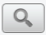 button. Tap Close in the bottom right-hand corner when you finish reading the definition.
  - For eAudiobooks – Once you tap the title it should start playing automatically. If it doesn’t, tap the play button at the bottom of the screen to play the item. Then hit the pause button at the bottom to pause the book. It will always save the spot you left off when you re-open the OverDrive app on the same device.
    - To fast-forward to another chapter, tap the Table of Contents icon in the top right-hand corner and tap the chapter you want.
    - To fast-forward during the current chapter to another spot in the current chapter, press and drag the blue dot to the right, or drag left to rewind.
    - You can skip ahead to the next chapter by tapping or back a chapter by tapping , or 15 seconds forward 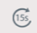 or backward 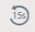.
  - For videos – Once you tap the title it should start playing automatically. To pause, tap the center of the screen and then hit the pause button at the bottom of the screen.

Return an Item/Delete an Item
- Titles you've borrowed from the library will automatically be returned at the end of their lending periods. However, if you finish eBooks, audiobooks, or streaming videos before then, you can return them using the OverDrive app to free up space on your library account and allow another patron to check out the item. There are three options to do this, that each depends on the file type of the item.
Option 1 – For items you downloaded to your Bookshelf on your Overdrive app (such as EPUB eBook, PDF eBook, and OverDrive MP3 Audiobook)
  - From your app bookshelf (if you are not there, tap the menu button in the top left-hand corner and tap Bookshelf), tap and hold a title to display its return options.
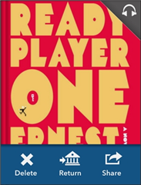
  - You can Return a title to the library, which also deletes it from your device.
You can Delete a title from your device, but you will still have it checked out to your library account. You will then have the ability to re-download it to the same device or a different device.

Option 2 (For items never downloaded, including books only read via Overdrive Read or listened to via Overdrive Listen on your internet browser)

- Go to the Overdrive catalog and login (Sections B and C).
- Go to your Account by click the icon of the little person at the top of the screen. 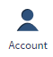
- Scroll down until you see the item you want to return, and then click 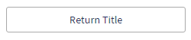as listed below the item. If you do not see this button, it means the item was already downloaded (in which case go to back to Option 1) or, if it is a Kindle book, it was already added to your Amazon account (in which case go to Option 3).

Option 3 (For Kindle books that have already been added to your Amazon account and/or downloaded to a Kindle device or added to the Kindle Reading App or Cloud Reader).

- Go to www.amazon.com and click “Log In’ in the top right-hand corner, unless you see “Hello, [your name here]!” in the top right-hand corner, in which case you may proceed to step B.
- Put your cursor over “Hello, [your name here]! Your Account” in the top right-hand corner, and you should see a menu drop down.
- From the drop-down menu, click “Manage Your Content and Devices” (listed about halfway down the list).
- Scroll down until you see the title of your item.
- Click the small square of three dots , located just to the left of the title of the item (in the “Actions” column).
- In the box that pops up, click “Return this book”.
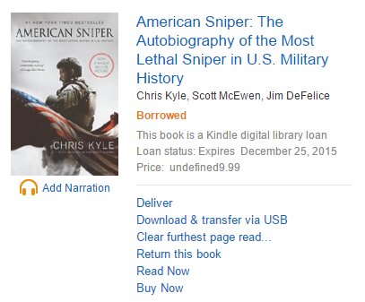
- In the box that pops up, click “Yes.”

Placing a Hold / Checking Out a Hold
- As you are browsing the catalog you may find items that are checked out. You may tap the item and then tap 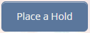, where you will be taken to a page that asks for your email address. Once the item becomes available you will receive an email letting you know the hold is available.
- When you placed the hold if you selected the option to automatically checkout the item when it becomes available, you can find the item under your Checkouts page once the hold becomes available, and it just needs to be downloaded. See Section F on how to do this.
- When you placed the hold if you did not select the option to automatically checkout the item when it becomes available, you will first need to go to your Holds page. Go to the Ohio Digital Library (Section B), go to your Account by clicking at the top, and then tap Holds. Then tap Borrow next to the available item.
- Go to your Checkouts page to download the item (see Section F).

Renewing Items
- You may only renew an item when it is within three days of its due date. Go to the OverDrive catalog and login (see Sections B and C) and click Account at the top. If an item is eligible for renewal there will be a Renew button under the item.
- Once the first loan period expires, the item will be re-checked out to you. Visit your Checkouts page by repeating step 1 to re-download the item. If you do not see the item (meaning you did not set it up to automatically check out once the item is renewed), visit your Holds page by repeating step 1 above and then tapping Holds. Tap Borrow next to the item you want to check out, and you should be taken to your Checkouts page where you can download the item (see Section F).

Do you have additional questions?
Stop in the library or give us a call! We are happy to help.
For questions call the Technology Department at (419) 874-3135 menu option 4
You can also make a “Mondays with Kara” appointment, which is a 30-minute session with our Technology Specialist Kara Prielipp. Bring your device to your appointment or use one of our computers and ask technology-related questions, including information on accessing OverDrive materials.
To make an appointment call the Information Desk at: (419) 874-3135 ext. 119

Way Public Library
101 E. Indiana Ave.
Perrysburg, OH 43551

