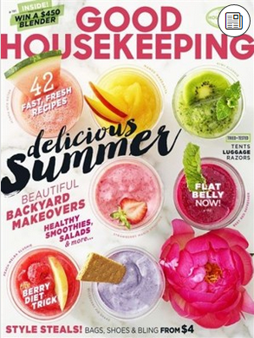

How to get library periodicals/magazines on your smartphone, tablet, or computer

- Download the “NOOK” app from your device’s app store. For Windows 10, this is in the “Windows Store;” for Android devices and Nooks it is the “Play Store;” and for Apple devices it is the “App Store.” Unfortunately no other devices will work with magazines.
- Open the NOOK app. The first time you use the app it may ask you to sign in to your Barnes and Noble account. If you do not have one it will let you create a new one. After you create an account, write down your username and password because you will need to enter it in later.
- Go to the Ohio Digital Library to view our periodicals. You can do this with the OverDrive app on a mobile device or by using your browser to go to www.waylibrary.info, click on “Catalog” at the top, and then click “eBooks and Downloadables”
- Find a periodical. You can search for periodicals by name click Advanced Search in the top right-hand corner (you may have to tap the magnifying glass first if you are using a smartphone), click the “All Formats” menu, click “NOOK Periodicals” from the drop-down menu, and click “Search” at the bottom.
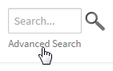
- Once you've found a periodical that looks interesting, mouse over it (or tap it, on a mobile device) and select Send to NOOK app.
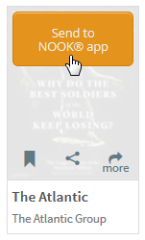
- A pop-up window will open, explaining what happens the first time you send a periodical to NOOK. Select Accept to Continue.
Note: Check Don't show this message again if you don't want to see this pop-up every time you get a periodical from your library.
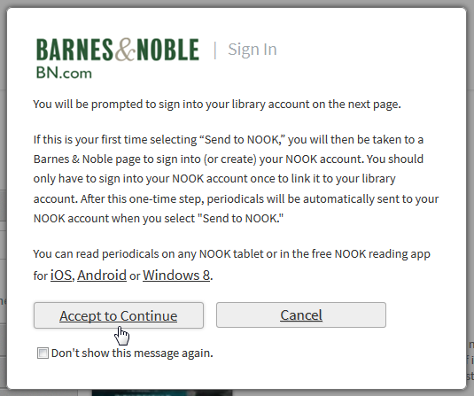
- If you're not already signed into your library account, you'll be prompted to do so now.
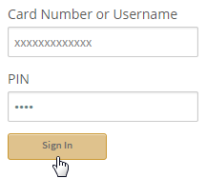
If this is your first time getting a NOOK periodical, continue to step 6. If you've sent periodicals to your NOOK account before, skip to step 8.
- The first time you send a periodical to your NOOK account, you'll be taken to a Barnes & Noble page to sign into your NOOK (BN.com) account. Enter the sign-in information you entered earlier when you got the NOOK app.
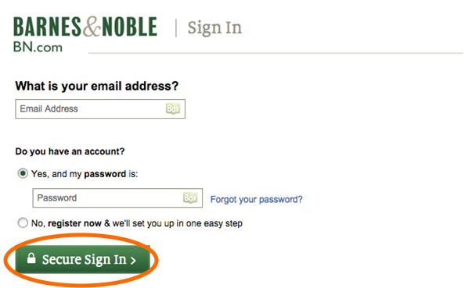
- After you've signed into your NOOK account, select Grant Access. This is a one-time step that allows periodicals in your library account to be sent to your NOOK account.
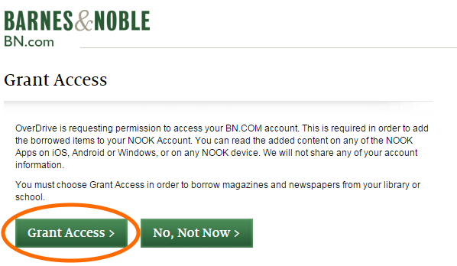
- Your periodical is now sent to your NOOK account. On your library's OverDrive website, you'll be taken to your Periodical History page, where you can see a complete list of periodicals you've successfully sent to NOOK.
- To read your periodical, open the NOOK app on the device you wish to read it on. Your periodical should automatically be on your NOOK app.
Periodicals that you send to NOOK will stay in your NOOK account forever (unless you manually remove them). You don't have to worry about returning them to your library, and you'll never be charged for them.

If you get an error when you try to send a periodical to your NOOK account
If the periodical wasn't successfully sent to your NOOK account, you'll find it waiting on your Bookshelf (located under your Account on your library's OverDrive website). From here, you can select Re-send to NOOK app to try again, or Clear from Bookshelf to remove it from your library account.
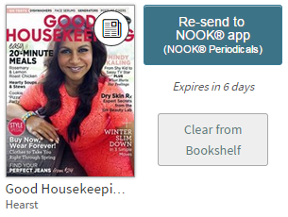
Do you have additional questions?
Stop in the library or give us a call! We are happy to help. You may call the Technology Department at 419-874-3135 option 4
You can also make a “Mondays with Kara” appointment, which is a 30-minute session with our Technology Specialist Kara Prielipp. Bring your device to your appointment or use one of our computers and ask technology-related questions, including information on accessing OverDrive materials.
To make an appointment call the Information Desk at: (419) 874-3135 ext. 119
Way Public Library
101 E. Indiana Ave.
Perrysburg, OH 43551

