From the President
• • •
Happy Fall! This newsletter should have been sent out sooner but the summer just flew by before I knew it. The Board met at the end of September in Indianapolis for its annual retreat and discussed CSLP’s future and made a few decisions that we hope will help guide us in the coming years. Some of these decisions include looking into hiring an organizational coordinator, who will report to the Board and oversee project management. We also agreed that CSLP needs to continue to work on, and update, CSLP’s strategic plan and to hire a project manager to work on projects as needed. We are also working on the agenda for the Annual Meeting in Charleston, SC, April 10 – 13, 2017. More details to come in future newsletters!
~ Sharon Rawlins

Kwame Alexander is the 2017 National Summer Reading Champion
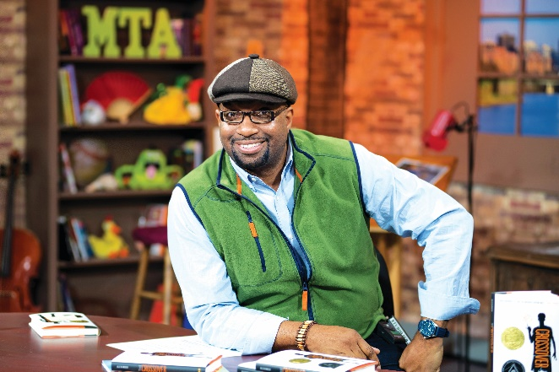

Photo credit: Donnie Biggs
Kwame Alexander, 2017 CSLP National Summer Reading Champion, is a poet, educator, and New York Times Bestselling author of 21 books, including BOOKED and THE CROSSOVER, which received the 2015 John Newbery Medal for the Most Distinguished Contribution to American literature for Children, the Coretta Scott King Author Award Honor, The NCTE Charlotte Huck Honor, the Lee Bennett Hopkins Poetry Award, and the Paterson Poetry Prize. Kwame writes for children of all ages. His other works include SURF'S UP, a picture book, and HE SAID SHE SAID, a YA novel.
A regular speaker at schools and conferences, he travels the world planting seeds of literary love (Singapore, Brazil, Italy, France, Shanghai, etc.). Each year, Alexander leads a delegation of writers, educators, and activists to Ghana, as part of LEAP for Ghana, an International literacy program he co-founded that builds libraries and provides literacy professional development for teachers.

CSLP is a Library of Congress Literary Awards 2016 Best Practice Honoree

  - 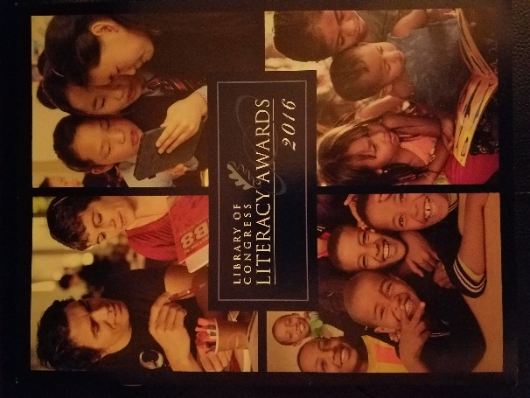Each year, in addition to the three major Library of Congress (LOC) Literary Award winners, 12 to 15 organizations are recognized for their implementation of best practices in literary promotion. This year CSLP was one of 14 Best Practices Honorees selected for successfully using theory in real-world context by discovering ways to apply research-validated practices to promote literacy and for modeling their programs for other organizations seeking to create evidence-based literacy programs. LOC highlights five practices in its Literacy Awards. CSLP was selected as an example of outreach to rural communities focusing on literacy promotion. CSLP’s Honoree Award comes with an honorarium of $2500. CSLP member Lesley Mann (DC) submitted the application on behalf of CSLP. Lisa Donovan, CSLP Vice-President, and I will be attending a Library of Congress reception in DC on Oct. 27th as one of the Best Practice Honorees to present a brief presentation about CSLP.

Happy Fall!

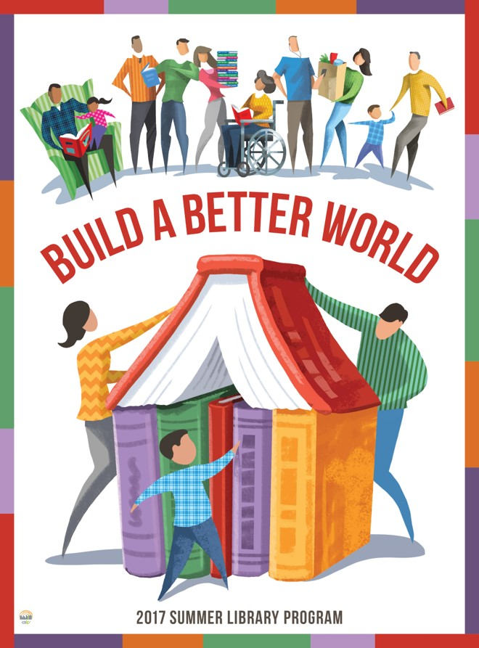

CSLP ROU

(Rules of Use)

With the start of the 2017 program year, changes have been made to the CSLP Rules of Use (ROU).

Using social media is so important to our jobs and using social media responsibly is important to CSLP, it is a permitted use to display all activity pages and manual resource lists from the manual on a member’s website. Please note they must be removed by the end of the program year. In the event member’s use any type of social media in conjunction with the CSLP slogan or artwork, credit must be given to CSLP. Attribution must be given as “Image copyrighted by CSLP” or “Idea curated from CSLP manual” and use of the slogan must include the TM symbol.
Changes have been made to the artwork process and the current program year artwork is owned by CSLP. This allows members to use the art after the program year with more flexibility. The rules

now state: Members can continue to use for internal library purposes after the program year, but not promote publicly. Members must request use of CSLP owned art to be used digitally, printed on paper and non‐paper items. Costs will be determined by the purpose of the item. Non‐members can request use of CSLP owned art, costs will be determined based on purpose of item and amount printed. Fair use permission will be given, if requested.
Rules regarding custom items not supplied by the exclusive vendor have changed slightly. Please consult the rules of use as to your need or contact the CSLP national office for information.
Third parties that support libraries and the libraries mission in regards to summer library programming have been identified more clearly and a printable partnership agreement is located within the ROU document.
For more information, please email contact@cslpreads.org or call (866) 657-8556.

Welcome New CSLP State Representatives!
Gail Sheldon – Alabama State Library
Jean Jansen – Illinois (Villa Park Public Library)
Carrie Sanders – Maryland State Department of Education
Kristin Byram – North Dakota State Library
Kate Green Smith – Tennessee State Library
Jennifer Johnson – Vermont Department of Libraries

We hope to see all of you at the CSLP Annual Meeting in Charleston April 10 - 12, 2017.
If you have any questions, please contact Sharon Rawlins, CSLP President at srawlins@njstatelib.org, 609-278-2640, or the CSLP office at contact@cslpreads.org, (866) 657-8556.

The Teen Video Challenge
The TVC files have been added to the CSLP website. There is a gold banner on the home page which, when NOT logged in, will give participants the information and when you are logged in, will provide state reps with all of the needed information to conduct the program. Jana Fine has been working very hard to get all of the forms restructured and ready to go. The files are also available under PROGRAMS > TEEN PROGRAMS > 2017 TVC Materials. The link is:
http://www.cslpreads.org/programs/teen-program/2017-tvc-materials/

From Karen Day
• • •
The FAQs have been added to the website under the ABOUT tab and Bermuda has been added to the membership page.
Proprietary Downloads has been restructured slightly. We have added the 2017 program logos (slogans) in both English and Spanish. The 2017 poster art has been added to this section since the manuals and discs have not been widely circulated yet. The 2017 fonts are listed.
Please remember that the paper manual only comes with one DVD this year, but libraries will also have on-line access with every version of the manual that is purchased.
We are making progress on the 2017 manual shipments. The states that did not have USBs went out recently. The USBs have arrived in the plant, so they are working full steam ahead to ship them out.
The webmaster is making progress on loading the on-line manual. Once that’s done, the Board will do a test run on the product. The announcement should go out in the next couple of weeks that the on-line version is available.
Upstart is working together with our webmaster to make sure any on-line manual orders through Upstart work correctly.

CSLP IN THE NEWS

You may know that Kate DiCamillo, the 2015 and 2016 National Summer Reading Champion, is the finalist for the National Book Award for Young People’s Literature for her book Raymie Nightingdale. The announcement from Publisher’s Weekly also included the information that Kate was the CSLP Summer Reading Champion.

If you see CSLP in print, let us know!

The link to shop for the 2017 summer reading program is now live! You can view all of the items in available in the print catalog here: http://shopcslp.com/cslp/

The illustrators for the 2017 program are:

Early Literacy & Children’s program: David Macaulay
Teen program: Scott Sosebee
Adult program: Larry Jones

This is our first catalog that reflects the same slogan for every age group. In addition, there are several new items from previous years including those for volunteers and for programming.
Please keep these dates in mind when planning to purchase items for your program (s):
Order by December 1, 2016: receive your order by March 1, 2017

Order by January 1, 2017: receive your order by April 1, 2017
Order by March 1, 2017: receive your order by May 1, 2017
If you order after March 1, 2017, please contact Demco for an estimated shipping date at 1-855-255-2757.
Please note that all orders will be invoiced through Demco.
Also note that the print catalog reflects that 3 DVDs will be provided, as in previous years. Now only one DVD is being provided. Please share this message with your libraries so that they are aware of our error.

