Local YA Author Panel!
Saturday, July 9, 2016
4:00 PM
Summer Reading for Teens at the Addison Township Library!
Come meet Michigan YA authors:
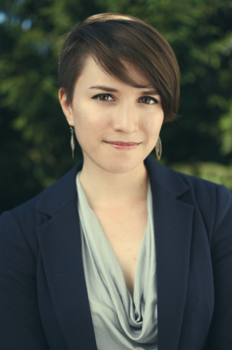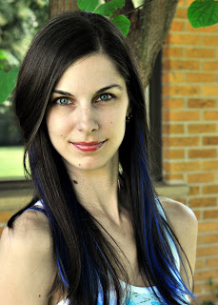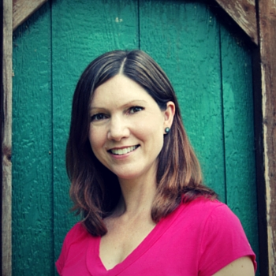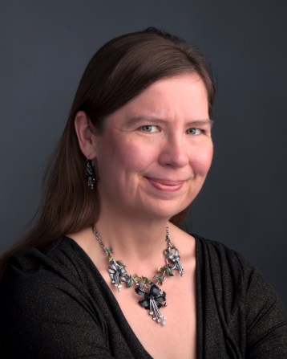
Ava Jae, Bethany Neal, Laura Wolfe
& Sarah Zettel
The authors will participate in a panel, followed by Q&A with the audience and a book signing.
Books will be available for purchase, or you can bring your own to be signed.
Registration recommended
Addison Township Public Library
1400 Rochester Rd.
Leonard, MI 48367
(248) 628-7180

