BookFlix MARC Records Walkthrough: Sent on 6.15.16
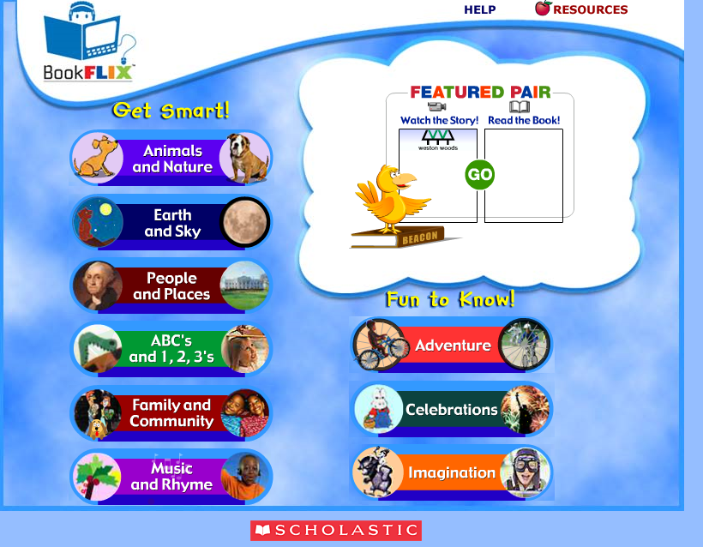
On Main Page of BookFlix: Go to upper right hand corner and click “Resources”
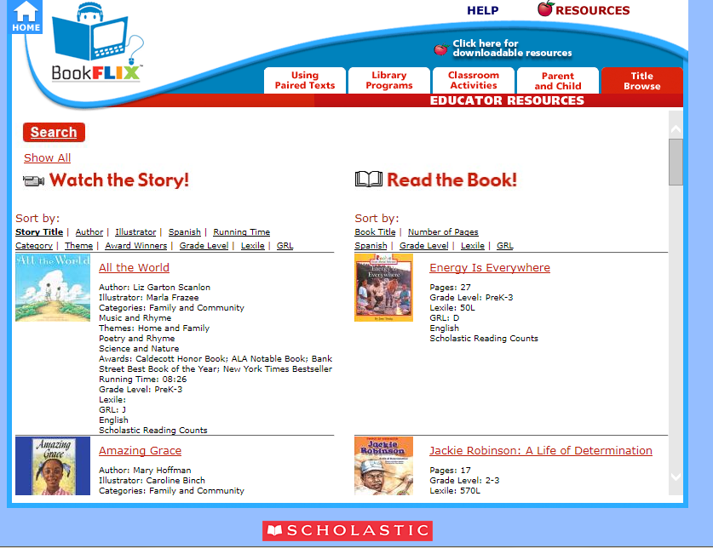
On Resource Page: “Click Here for Downloadable Resources” is located beneath the HELP button in the top right hand corner of the screen. Click It
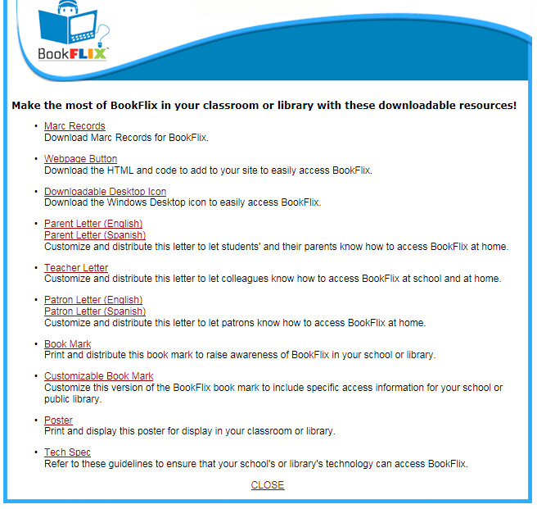
On Downloadables Page: The first option in the list of downloadables is “MARC Records”
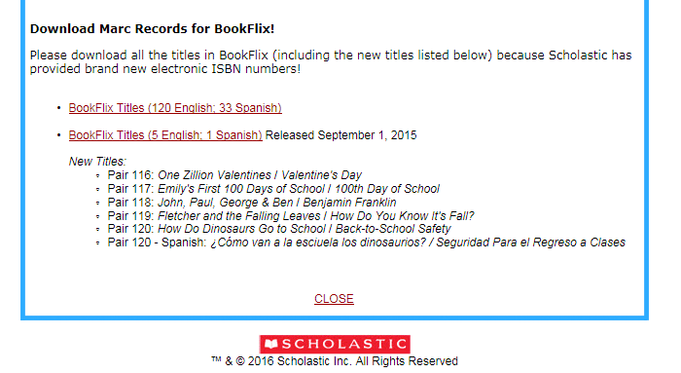
On Download MARC Records for BookFlix: Since you have not added any titles you’ll select the first option, which is “BookFlix Titles (120 English, 33 Spanish)”
- You would use the “BookFlix Titles (5 English; 1 Spanish) when new titles are added each year. This allows you to just download the new titles to your Cataloging system without having the re-add all PAIRS.

I always recommend using an IT person to handle your download, once clicked the process will begin.

