Introducing Academic OneFile’s Newest Feature “Browse by Discipline” (For internal use only)

Gale is committed to improving user experience and enhancing the research experience. Starting April 28th, Academic OneFile will feature “Browse by Discipline” on its homepage. This new feature is the perfect way to differentiate AONE from our competitor’s products focusing our superior subject indexing and delivering relevant content results.
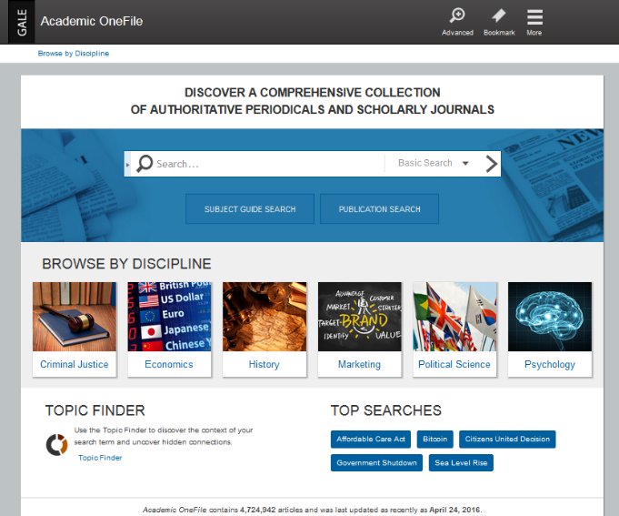
Why the change?
The two major issues we heard from students was that search results are overwhelming and that users are often unsure of what term(s) they should search for. Designed with undergraduates in mind, this unique new browsing experience addresses students’ primary searching needs, with curriculum aligned topics and focused and relevant results.
What happened to the other search methods?
This new browsing feature adds to the current Academic OneFile experience. All the familiar searches--like Basic, Advanced, Subject, and Publication--are still available options.
How do results from Browse by Discipline differ from Basic Search results?
Within the Browse by Discipline feature, each discipline is comprised of a list of related publications hand-selected by subject matter experts. Gale combined their superior subject indexing with Cengage Learning’s background in creating learning objectives to create topics with discipline focused results.
- A “Basic Search” for Memory will result in thousands of articles related to various memory topics such as Alzheimer’s disease, computer memory, and Psychology.
- The Memory topic within the Psychology discipline will result in a smaller list of articles related to Psychology and cognition.

Are the discipline topics static and will the results be updated?
- Discipline topics will not change but as new content becomes available in the product, the topic results will be updated to include these additions.

Is the browsing experience available on other InfoTrac Products? Are there only going to be six disciplines available in Academic OneFile?
We are currently evaluating and analyzing the next InfoTrac product where this feature will provide the most value along with what disciplines we will add next to Academic OneFile.

Additional enhancements and changes to InfoTrac products.

- “Related Resources” a recommendation tool, offers additional content. At the bottom of article, users will be recommended similar articles of interest.
- “Did you mean” spell suggestions offer possible search terms after a misspelling renders few or zero results. Helping the user overcome one of the biggest obstacles to a successful search.
- Based on the success integration of Google Apps for Education, we will be retiring the Gale Account feature for all InfoTrac products. Users can still access their content through August 2016, but new documents cannot be retained within Saved Documents. View the Gale Blog for additional information.
- Based on customer feedback, we have made InfoTrac products more engaging by adding a splash of color to the homepage and hyperlinks.

Questions? Contact InfoTrac Product Manager Christina Brown

