Join Us

For Author

Kelly Fordon

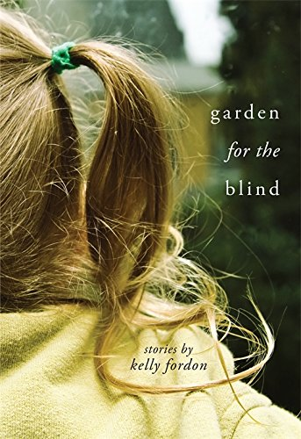

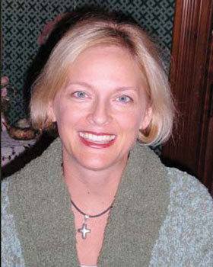

“*Garden for the Blind*”

On Saturday May 21, 2016

At 1:00pm

At the Alcona County Library

Harrisville Branch

(312 W Main St., Harrisville, MI 48740)

*Books will be available from Great Northern Books and Hobby in Oscoda*

 ***The 2016 Michigan Notable Books program and tour are made possible thanks to the generous support of the Library of Michigan, the Library of Michigan Foundation, Michigan Department of Education, the Michigan Humanities Council, Meijer, and the Michigan Center for the Book*.**