Accessing Britannica School Just Got Easier!

As several of you may know, Michigan eLibrary (MeL) recently added the exciting content of Britannica School. In particular, Michigan residents have access to the following databases from Britannica: Britannica School, Elementary, Middle, High, and Learning Zone. Within each database, teachers have access to lesson plans based on current Common Core standards, and have the ability to search based on standard.

There is now fast, easy, and obvious access to Britannica School! Sharing Apps are now available for both iOS and Chrome devices. These apps place an icon on the user’s device that links them directly to Britannica School. Here is how to get the App:

For iOS:
- Open mobile Safari browser on the iOS device
- Go to school.eb.com using the browser
- Tap on the share icon
This icon is a blue square with an up arrow located next to the web address bar at the very top of your screen.
- Tap on Add to Home Screen
- Tap on Add (in blue)
- Shortcut to the site is added to home screen
- The first time you access Britannica School through this app, you will be taken to the log in screen. You will only need to log in one time. Any future access will then take you directly to the database. Please add the following information to get access:
Username: melportal
Password: access

For Chrome:
- Go to the Chrome Web Store (https://chrome.google.com/webstore) using the Chrome browser
- Search for “Britannica School”
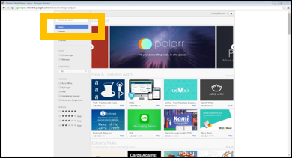
- Click “Add to Chrome” at the right
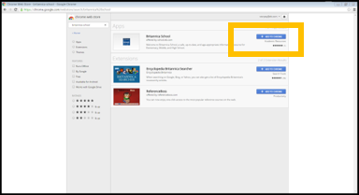
- When prompted, click ‘Add’ to confirm
- Britannica School will now be added to your Chrome Apps page
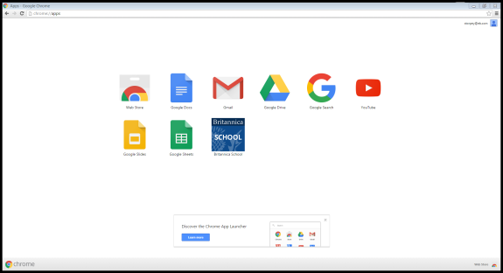
Note: To access your Chrome Apps page, click on the rainbow colored Apps button just below and to the left of your web address bar at the top of your screen.

If you have any questions about MeL, please email either Deb Renee Biggs, MeL & Library Outreach Coordinator at: biggsd@michigan.gov, or Christine Schneider, MeL Education Specialist at: CSchneider.mel@gmail.com.

You may also access any of Britannica School’s complimentary webinars! Find dates and topics here: http://info.eb.com/professional-development/free-training-webinars/

