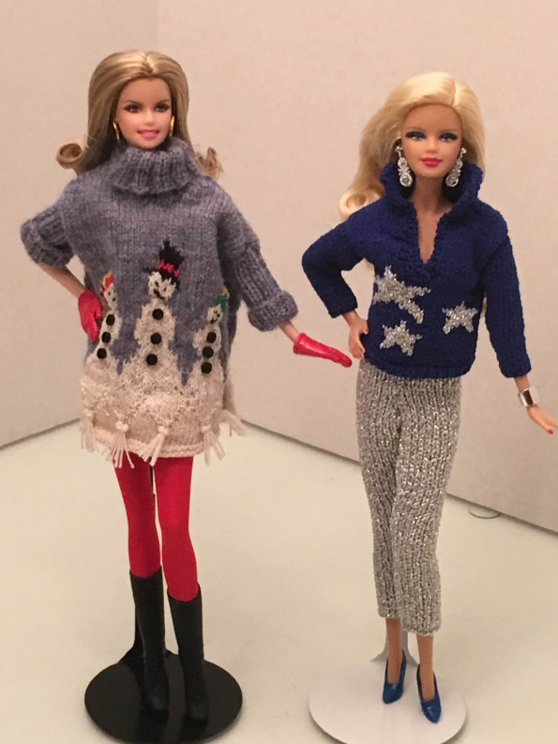 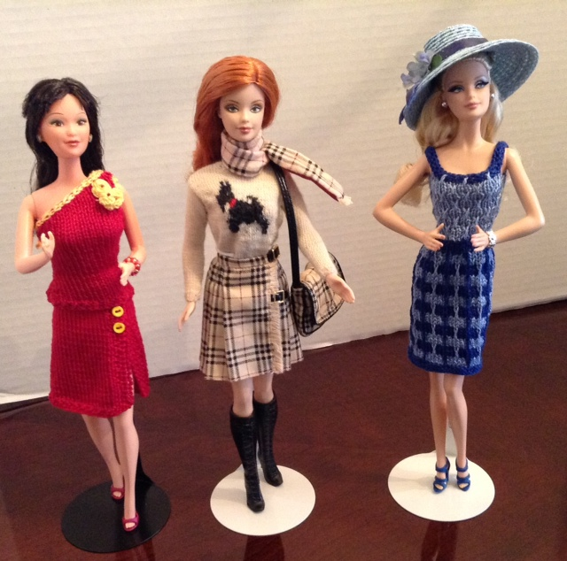

The Barbies Are Here!!!

Warren Civic Center Library

1 City Square

Warren, MI 48093

586-574-4564

On January 4th, 2016 , Maribeth Regnier will bring her fashion doll exhibit to the Warren Public Library – Civic Center Branch. The “Oh You Beautiful Doll Show” will feature 170 fashion dolls shown in hand knitted designs. To replicate adult fashion knitwear to scale the designs are knitted on miniature needles – sometimes called lace pins. This is a fashion doll retrospective showcasing our American experience! A “must see” for knitters and crafters, fashionistas, art enthusiasts, and doll lovers of all ages.

Ms. Regnier’s collection has been shown in public libraries, at knitting and craft fairs, at retirement communities, tea parties, fiber fairs, and at The Howell Opera House. Recently the Detroit News featured the Doll Show in an article. The dolls will be on display for the whole month of January. Please come and enjoy this exhibit!